

Aston University

MSc Business Analytics

Supervisor: Dr Gary Simpson

September 2019



**Affectively Visualising the**

**Gender Pay Gap in the UK**

**Education Sector**

**Testing Dashboard Theory**

Ahmed Kadri

# Acknowledgements

Throughout the writing of this dissertation, I have received a great deal of support and assistance. I would like to first thank my supervisor, Dr Gary Simpson, whose expertise was vital. First for piquing by interest in the topic of visualisations in the first few weeks of my

Aston University Master’s course and, secondly, for framing the research topic and guiding me through the methodology and structure of this research project.

Secondly, I am indebted to all those people, both known and unknown to me, who participated in my research through either the pilot study, main experiment web-survey or both. Without those individuals, the research project would have been much harder to conduct, and the conclusions much less meaningful.

Finally, I would like to express my gratitude to those who gave their assistance by listening to my musings on the subject matter or through proof-reading this document; in particular my mother Helen Kemp.

# Contents

Acknowledgements 1

Contents 1

Table of Figures 3

Abstract 4

Introduction 6

Data Visualisation 6

Gender Pay Gap 6

Objectives 7

Route Map 7

Literature Review 8

Data Visualisation: Key Historical Moments and Theories 8

Formative Visualisations 8

Early Infographics 8

The Development of Rules 8

Technology and Emerging Theories 10

Notable Visualisation Experiments and Findings 12

Experiment Methodologies and Additional Research of Interest 13

Research Methods 13

Pilot Study 14

Spatial Visualisation 15

Academic Conclusion 16

Commercial Usage 16

Gender Pay Gap 18

Expectations 19

Demographics 19

Visualisations 19

Pilot 20

Methodology 20

Which Visualisations? 20

Original or Secondary Visualisations? 21

Questions 21

Creating the Pilot 23

Running the Pilot 23

Analysing the Results 24

Findings and Considerations 24

Consent and Demographics 24

Visualisations 26

Likert Questions 27

Discussion 28

Main Experiment 30

Methodology 30

Data Collection and Preparation 30

Which Visualisations? 31

Software Packages 32

The Visualisations 32

Creating the Visualisations 32

Differences from the Pilot 41

Method behind the Questions 41

Forming the Questions 41

Question and Answer Types 45

Choosing a Survey Provider 46

Designing the Survey 46

Testing the Survey 49

Launching the Survey 49

Running the Survey 52

Analysing the Results 52

Findings 53

Demographics 53

Visualisation Collections 63

Additional Research of Interest 83

Survey Feedback and Performance 96

Discussion 99

Demographics 99

Visualisations 104

Survey Performance and Limitations 113

Conclusion 114

Further Research 115

Bibliography 117

Appendix 1 – Graph Selection Matrix 126

Appendix 2 – Consent and Disclaimer 127

Appendix 3 – Pilot Study Presentation 128

Appendix 4 – Pilot Answer Sheets 135

Appendix 5 – Likert Questions 137

Appendix 6 – Pilot Visualisation Results 138

Appendix 7 – Web-Survey 139

Appendix 8 – Complete Results Confidence and Use of Numbers, Statistics and Visualisations 163

# Table of Figures

Figure 1 – IBCS Standards .............................................................................................................. 17

Figure 2 - Pilot Demographics ......................................................................................................... 25

Figure 3 - Statistics Education Question Feedback ........................................................................... 25

Figure 4 – Downloading full annual dataset ..................................................................................... 30

Figure 5 - Downloading by Sector; Education .................................................................................. 30

Figure 6 - Pie Chart ......................................................................................................................... 33

Figure 7 - Bar Chart......................................................................................................................... 34

Figure 8 - Diverging Bar Chart ........................................................................................................ 35

Figure 9 - Diverging Bar Chart with Target ..................................................................................... 36

Figure 10 - Time Series Line Chart .................................................................................................. 38

Figure 11 - Bar Chart with Target .................................................................................................... 39

Figure 12 - Pie Chart with Target ..................................................................................................... 40

Figure 13 - Instagram post with "Link is in my bio" ......................................................................... 50

Figure 14 - Twitter Post with #EqualPay .......................................................................................... 51

Figure 15 - LinkedIn post showing analytics (views) ....................................................................... 51

Figure 16 - Facebook post in 'exchange' group ................................................................................. 51

Figure 17 - Participant Map ............................................................................................................. 53

Figure 18 - English First Language .................................................................................................. 54 Figure 19 - English and Country ...................................................................................................... 54

Figure 20 - Gender .......................................................................................................................... 55

Figure 21 - Age Ranges ................................................................................................................... 55

Figure 22 - Education Levels ........................................................................................................... 56

Figure 23 - Levels of Confidence and Work Use .............................................................................. 57

Figure 24 - Treemap of Occupation ................................................................................................. 59

Figure 25 - Visual Deficiencies ........................................................................................................ 60

Figure 26 - Visual Deficiencies by Gender ....................................................................................... 61

Figure 27 - Devices Used................................................................................................................. 62

Figure 28 - Pie Versus Bar ............................................................................................................... 64

Figure 29 - Diverging Versus Stacked Correct ................................................................................. 65

Figure 30 - Diverging Versus Stacked Confidence ........................................................................... 66

Figure 31 - Time Series ................................................................................................................... 67

Figure 32 - Box Plot Range ............................................................................................................. 69

Figure 33 - Box Plot Average .......................................................................................................... 70

Figure 34 - Histogram Gen. Statement ............................................................................................. 72

Figure 35 - Histogram Rating .......................................................................................................... 73

Figure 36 - Targets .......................................................................................................................... 75

Figure 37 - Targets Confidence ........................................................................................................ 76

Figure 38 - Targets Ease .................................................................................................................. 77

Figure 39 - Most/Least Preferred Visualisations ............................................................................... 79

Figure 40 - Preferred Bar Charts ...................................................................................................... 80

Figure 41 - Preferred Target Visualisations ...................................................................................... 81

Figure 42 - Preferred Time Series Visualisations.............................................................................. 82

Figure 43 - Gender and Correct Answers ......................................................................................... 84

Figure 44 - Age and Versus Visualisations ....................................................................................... 85

Figure 45 - Age and Time Series/Box Plots ..................................................................................... 86

Figure 46 - Age and Target/Histogram ............................................................................................. 87

Figure 47 - Occupation and Correct Answers ................................................................................... 88

Figure 48 - Education and Correct Answers ..................................................................................... 90

Figure 49 - Confidence Q7 and Correct Answers ............................................................................. 91

Figure 50 - Work with and Correct Answers .................................................................................... 92

Figure 51 - Device Used and Correct Answers ................................................................................. 93

Figure 52 - Visual Deficiencies and Correct Answers ...................................................................... 94

Figure 53 - Country and Language and Correct Answers ................................................................. 95

Figure 54 - Likert Feedback ............................................................................................................. 96

Figure 55 - Free Text Feedback ....................................................................................................... 97

Figure 56 - Time Taken by Age ....................................................................................................... 98

Figure 57 - Female Most Preferred and Correct.............................................................................. 100

Figure 58 - Occupation Split .......................................................................................................... 101

Figure 59 - Specific Occupations and Correct Answers .................................................................. 102

# Abstract

Data visualisations are increasingly being used to communicate information to a wider number of different audiences due to the increased gathering and use of data. To ensure the effectiveness of visualisations a number of academic theories and commercial guidelines have been developed. However, the use of poor visualisations is widespread across areas including the media, business and in academic papers. It is also unclear if these theories work for all data, contexts or audiences.

The dissertation focussed on gender pay gap data to test the effectiveness of the academic theories and commercial guidelines ‘in the real world’. The gender pay gap has gained much media and academic attention in recent years accompanied by varying qualities of visualisations. In particular, the United Kingdom’s education sector performs poorly. Being able to effectively communicate its gender pay gap to those involved could help the gap narrow.

To achieve this, the dissertation reviews and assesses the key developments and experiments in academic theory, experiment methodologies, related spatial research, commercial guidelines, and findings from gender pay gap studies. From these some expectations were developed: that country of origin, gender, education, occupation and the size of the device used would affect a participant’s performance. Also, that the academic theories would be broadly correct, except the radar chart, that the most common visualisations would perform best, and the most complicated would be least preferred.

From these, data-driven visualisations – both academically advised and ill-advised – were chosen to develop the questions used to test the theories. A pilot study was developed to test the procedures, wording and expected answers of the questions, and if the results would be meaningful and sensible analysis possible. The study found in general that all questions worked as expected with only a few minor considerations to take forward to the main experiment. It was found that the method used to ask about statistical knowledge didn’t work very well.

From the pilot study, the main experiment was developed using the gender pay gap to design new, theory-guided visualisations for testing. Tableau was used to do this for all but one visualisation – the radar chart in Excel. It was decided a web, page-designed survey would be used as the most cost-effective method for gaining many participants and controlling how they answered the questions; in a set and linear order. Questions were improved from the pilot results and the web-survey launched using social media.

57 participants partook in the survey making it a statistically significant experiment. Most were from the United Kingdom and/or English-first speaking, female was the largest gender, and aged 21-29 the most popular age. The largest category of education had a degree, most participants had no visual deficiencies, and most used mobile devices.

The results supported several expectations, but also failed to prove others. The expectations around country, gender, occupation and visual deficiencies were all supported, while those around age, education and device-used were not. For the first two cases, the web-survey didn’t collect enough results from participants in the older or least educated categories to make significant conclusions. For device-used, a much higher percentage of mobile device users successfully answered questions correctly than expected.

Visualisation-wise, the standard bar chart, diverging bar with target, box plot, line chart and bar chart with target were the best performing; mirroring previous studies. Adding to previous research was the fact that the best performing visualisations differed for males and females; an important observation given the data’s context. The best performing for women included the radar chart in place of the bar chart with target.

The results also supported previous research showing that inferior visualisations can be preferred even if the participant answered incorrectly; the pie chart or histogram. The opposite was also found. The radar chart was the least preferred but many who chose this answered correctly. The bar chart was the most preferred and most successful visualisation.

The standard and diverging bar charts, box plot, line chart and, with some conditions, the pie chart were all recommended for use in a gender pay gap data dashboard within an educational institution. Limitations and further areas of research were also outlined.

# Introduction

## Data Visualisation

Since the early 2000’s the visualisation of data has become increasingly popular with everyone wanting dashboards full of graphs, charts, plots, diagrams, and other visualisations (Few, 2012). However, not all visualisations are equally effective at communicating information and not all creators are equally good at designing them; there are “bad graphs everywhere” (Knaflic, 2015, p. 1).

To ensure the effective communication of information through visualisations it is important to understand how they work, how users interact with them, and most importantly if they result in the correct and intended information being successfully communicated to the user in an easy and confidence inducing way. There are several academic theories and commercial guidelines, outlined in the literature review, for a designer to work with to ensure visualisations are effective, but are they correct? And are they effective for all users? And in all settings? These are the main questions of this research. The aim is to test the effectiveness of these theories and guidelines when applied ‘in the real world’ - in particular the United Kingdom’s (UK) education sector with gender pay gap data – and make recommendations for dashboards in this sector.

## Gender Pay Gap

Laws against sex discrimination have been in force in the UK since 1975 to ensure men and women are equally paid for the same work or equally valued equivalent (UK Government, 2013). Therefore, by role or organisational level, both men and women should be paid equally. The gender pay gap, alternatively, “measures the difference between average hourly earnings of men and women” (McGuinness & Pyper, 2018, p. 3), irrespective of their role or seniority (Mercer, 2018).

In 2017, the gender pay gap led the UK government to introduce mandatory pay reporting by gender for companies with over 250 employees (BBC, 2017). The rules require these companies “to provide data about their pay gap, the proportion of male and female employees in different pay bands, their gender bonus gap, and a breakdown of how many women and men get a bonus” (Topping, 2017).

In 2018, the worst UK sectors were construction, financial and insurance services, and, with a gap of 20%, education (Wisniewska, et al.). Over 40% of employers reporting the largest median gaps within the sector were multi-academy trusts and schools (Bennett, 2018), while women in UK universities were paid a mean hourly rate around 15.9% lower than men (Pells,

2018). With 75% of the UK school teacher workforce being female (Department for

Education, 2018a), and over 50% of all higher education staff being female (Higher

Education Statistics Agency, 2019), the fact the pay gap is so high makes the sector worthy of attention.

Currently, all submitted data is available online and can be selected by sector (UK Government, 2019). However, it is difficult to compare large numbers of different organisations and data is only presented in spreadsheet format. Therefore, effective visualisation of this data, this project’s aim, is required to help all hiring personnel within the sector to successfully monitor, understand and compare their organisation’s gender pay gap.

## Objectives

* To review the academic theories and commercial guidelines and use the most appropriate ones to design visualisations to communicate real gender pay gap data
* To test the effectiveness of the theories, guidelines and visualisations used by creating a web-survey to ask participants to answer questions based on their interpretation of the visualisations
* To analyse these results to judge the effectiveness of the theories and guidelines.
* To use the results to make recommendations on the best visualisations to use to communicate the gender pay gap data to the intended audience.

## Route Map

* Literature Review: The key academic developments, theories and experiments are outlined followed by relevant experiment methodologies and related research and concluded with some commercial guidelines and gender pay gap papers. All are given for context and to inform the project’s methodologies and expectations.
* Pilot Study: The methodologies for creating and running the pilot study and specified followed by the findings and resulting recommendations for the main experiment.
* Main Experiment: The methodologies for preparing the gender pay gap data, for creating and running the web-survey, and for analysing the results are presented. Subsequently, the findings are provided with the discussion afterwards.
* Conclusion: Closing summary of the research project.
* Further Research: Suggestions for additional study into visualisation theory and reporting the gender pay gap at an individual institutional level.

# Literature Review

The following chapters will provide both theoretical and methodical reviews of the research around data visualisation theories, the commercial usage of visualisations, the research into the gender pay gap, and the methodologies involved in testing, measuring and analysing visualisations.

## Data Visualisation: Key Historical Moments and Theories

Visualization, for many years, was most likely limited to cave paintings before eventually maps, calendars, family trees, sheet music and structural diagrams followed. Then, from around the late 17th century, tables were developed. They made it easier to read larger sets of data, lead to the use of ledgers and dominated for the next two centuries (Berinato, 2016).

### Formative Visualisations

Graphs of quantitative information have been used for only a relatively short amount of time – only a few hundred years – when compared to the much longer time mathematics has existed (Few, 2012). The two inventors of modern graph design were J. H. Lambert and William Playfair with the latter publishing line graphs, timelines and bar charts in his book

The Commercial and Political Atlas (1786) and contrasting them to the use of tables (Tufte, 2001). He later added pie charts and is therefore seen to have started the use of the visualisations we think of today (Berinato, 2016).

For Playfair, the use of graphics was preferable to tables as “a man who has carefully investigated a printed table, finds, when done, that he only has a partial idea of what he has read; and…, is soon totally erased.” In contrast, he concluded when using his graphics “attentively, a sufficiently distinct impression will be made.” (1786, pp. 3-4).

In this Playfair was one of the first people to understand the “power of our visual system” (Wexler, et al., 2017, p. 3). Visualising data harnesses this power to: spot relationships and trends, reduce multiple data points into portions of data, and help the reader’s short-term memory instantly interpret large datasets.

### Early Infographics

Infographics were introduced around one-hundred years later with Florence Nightingale’s Diagram of the Causes of Mortality in the Army in the East in 1858 and Charles Minard’s depiction of Napoleon’s army in Russia in 1861 (Berinato, 2016). Nightingale’s coxcomb infographic helped to convince Queen Victoria to enact her recommendations for war medicine and sanitation practices and is said to be the first visualisation to shape policy (The

Art of Consequences, 2018). Visualisations are now a popular and important aid within

Governments for exploring and understanding data to form policy (Department for Communities and Local Government, 2009) and to communicate with the public too (Stowers, 2013).

### The Development of Rules

In 1912, the Gestalt school of psychology in Germany, recognised the way humans organise what they see in certain ways in order to process the information; developing six principles (Few, 2013):

1. Proximity: Objects which are close to each other are seen as belonging to the same group.
2. Similarity: Objects which are similar in colour, size, shape, and orientation tend to be grouped together.
3. Enclosure: Objects within a border are seen as the same group and separate from the rest
4. Closure: Similar to enclosure, but objects are within an open or incomplete border like dotted lines or a border with gaps. Objects are still seen as belonging to the same group, but less strongly.
5. Continuity: Objects which are aligned with one another or appear to continue from one another are seen as the same group.
6. Connection: Objects which are connected to one another are seen as the same group.

Few states that by applying these principles to visualisations and dashboards in particular, they can help overcome the challenges of making important data standout, arranging visualisations in a way that has meaning and is efficient, and understanding why and how visualisations work. Therefore, these principles will be included, where applicable, to the research experiment to evaluate if these principles work in practise.

Two years later and drawing inspiration from railroad company’s organisational charts,

Willard C. Brinton (1914) published the first data visualisation business book: Graphic Methods for Presenting Facts. He identified the lack of graphic standards or rules for allowing a reader’s interpretation to “be both rapid and accurate” (1914, p. 3) and predicted the future development of rules to meet this goal. He displayed illustrations of bump charts and slope graphs, distrusted radar charts, and questioned the value of pie charts. In doing so, he was the precursor of visualisation academia, with observations similar to those popularised a century later.

In 1967, and translated into English in 1983, Jacques Bertin wrote Sémilogie graphique with a focus on seven visual variables: position, shape, orientation, colour, brightness, texture, and size (1983). He identified two ideas which remain influential today; the principles of expressiveness and effectiveness. Expressiveness entails the need to say exactly what you want to say and no more and without misleading the reader. Effectiveness is about using the best method available for showing the data; using the best visual variable that will most efficiently and accurately communicate the information. By focusing on these variables, Bertin changed the focus of thought from which visualisations to use, to how to use them correctly and effectively to maximise their efficiency and accuracy.

In 1983, Edward Tufte created his theory of information design in *The Visual Display of Quantitative Information.* Building on the principles developed by Bertin, Tufte introduced his own set of principles: Graphical Integrity and Graphical Excellence.

The first, integrity, was a reaction to what he saw were “lying graphics” which “often show up in news reports… on television” and in newspapers (2001, p. 76) and misrepresented the data they were visualising. To ensure integrity, Tufte proposed six principles:

1. Proportionality: Any areas on a graphic which represent a number, should be directly proportional when physically measured to the numbers they represent.
2. Clarity: Labelling that is clear, detailed and thorough should be used to remove graphical distortion and ambiguity. Any explanations and important events should be included on the graphic itself.
3. Data-Driven: Show data, not design, variation. The choice of visualisation should be based on the data used and not factors like the intended audience, where it will appear, or aesthetics.
4. Standardisation: In time-series data, deflated and standardised units of money are better than nominal units. This is so they can be fairly compared.
5. Appropriate Dimensions: Number of graphical dimensions should not exceed the number data variables.
6. Contextualised: Graphics must not show data out of context. They must answer ‘compared to what?’ and include all relevant information.

The second, excellence, is about what visualisation should do and include. To design with excellence Tufte proposed five principles:

1. Excellent presentations of interesting data are a matter of substance, statistics and design.
2. Tell the truth about the data.
3. Are nearly always multivariate
4. Communicate complex ideas with clarity, precision and efficiency
5. Give the greatest number of ideas in the shortest time, with the least ink and in the smallest space.

This last principle is all about reducing the use of, in Tufte’s opinion, unnecessary space, ink and time which some designers utilise to make the visualisations aesthetically pleasing, attention-grabbing or to promote their graphic-design skills. He termed the phrase, and wrote a whole chapter on, ‘Chartjunk’ concluding “graphics do not become attractive or interesting through the addition of ornamental hatching and false perspective”, but “the best designs…. are intriguing and curiosity-provoking” (p. 121). Later, he adds that “elegance is often found in simplicity of design and complexity of data” (p. 177).

For some, Tufte’s principles have become their design code and procedure with many designers, journalists, and academics growing up under the influence of Tufte’s minimalist approach (Berinato, 2016).

### Technology and Emerging Theories

Unbeknown to Tufte when he was writing his book, the first personal computer (PC), launched by International Business Machines (IBM) in 1981, and its successors were about to transform the way and speed business was conducted and information processed (IBM, 2019). Concurrently, software was being developed to allow users to construct visualisations and invent new ones (Visually, 2019). The PC diversified and increased the number of visualisation creators and readers. Then, in 1990, the World Wide Web was invented (Andrews, 2013), and within twenty years social networking sites launched gathering billions of users worldwide by 2018 (McFadden, 2018). These have further increased visualisation usage and reach so everyone can participate; including with free web-based tools (Visually, 2019).

This transfer of ownership led to new ideas emerging from two, in their author’s opinion, incorrect assumptions: that visualisation creators already have the undivided attention of their intended audience, and that the creator’s primary goal is always the efficient and effective communication of data (Berinato, 2016).

These new ideas directly challenge the principles of previous theories. Research by Borkin, et al. (2013) argues that ‘Chartjunk’ can make some visualisation more memorable, Another study in 2016, testing “an abstract, static… time-series graph” against “a dynamic, interactive… ‘picturesque’” visualisation found that while the interactive visualisation drew more people’s attention, the static version was more useful for people who wanted to gain a better understanding of the data (Newell, et al.). In addition, Spence (2005) proposed that, with only a few categories and if proportions are recognisable – 25% or 75%, - a pie chart is useful; contrary to research by Cleveland and McGill (1984).

The fact the focus of this research is on a captive, already interested audience, and that the intended use is for the user to read and gain understanding of the data, there will be no use of ‘Chartjunk’ or other design variables aimed towards embellishing or creating interactive visualisations in its experiments. The research by Spence (2005) is however of interest. The proposed dataset for this research has minimal categories and so it may be possible to test his findings about proportions. In addition, the study by Newell, et al. (2016), does illustrate the importance of conducting studies into specific industries to find which visualisations and standards work for certain audiences and supports the idea that a “cognitive fit between task and representation and between decision maker characteristics and representation supports… more accurate decision maker performance” (Dilla, et al., 2010). Simply, that the visualisations should match the user and the action/understanding you wish them to take/have afterwards.

In addition, it is becoming clear that there is a need for balance between following the standards, principles and rules of others and innovation (Few, 2012). The rules are open to interpretation and for responding to context like the intended audience, their biases, backgrounds and skill level (Knaflic, 2015). Innovation can help with communicating the information to your audience. By choosing to use familiar and data-driven visualisations, but changing an element which invites storytelling, you can engage interest (Few, 2012). For example, the invention of the sparkline by Tufte (2006), took the familiar line chart but reduced its size to present the data’s general variation over time in a simple, condensed way. Few (2013) further developed rules where they appear alongside other data or visualisations which provide context and they have become popular on dashboards. It is therefore important for this research to not solely follow the perceived wisdom of the academic theory for testing, but to also be open to innovation and developing its own standards.

Finally, the increased gathering and use of data and its use to monitor key performance indicators in business, finance and the media have seen specific publications and theories relating to dashboards. In addition to previous principles, dashboards need to: have specific objectives, fit on a single screen, be usable ‘at a glance’, be customisable, (Few, 2013), be personal, and prioritise the understanding of the visualisation over aesthetics (Wexler, et al., 2017).

### Notable Visualisation Experiments and Findings

While Tufte was declaring his design principles, William S. Cleveland and Robert McGill (1984) started an avenue of research contemplating visualisations effectiveness by testing how well people could understand them. They found that position judgements were more accurate than length judgements and angle judgements. They also produced a very formative general hierarchy of the types of data most accurately understood:

1. Position along a common scale (bar chart, dot plots)
2. Positions along nonaligned, identical scales [(small multiples)](http://flowingdata.com/2014/10/15/linked-small-multiples/)
3. Length, direction, angle (pie chart)
4. Area (treemap)
5. Volume, curvature (3-D bar charts, area graphs)
6. Shading, colour saturation (heat maps, choropleth maps)

According to Cleveland and McGill (1984), pie charts do not efficiently communicate information about different values, justifying Brinton’s negative opinion of pie charts, and saw their usage drop since publication while others like treemaps gained popularity. He also states people understand aligned bar charts much better than stacked ones, because they have higher margins of error when estimating their relative sizes. These results are supported by a study which found the top five visualisations are bar charts, glowing bars, treemaps, line graphs and pie charts (Shamim, et al., 2015).

The impact of these findings influenced future experts including Stephen Few who finds his work “particularly useful to those with statistical training who are interested in sophisticated graphs” (2012, p. 48).

Secondly, researchers have attempted to create standard levels in visual literacy, as to understand and test how well people understand visualisations. It suggests that people can be taught to be proficient with visualisations (Boy, et al., 2014). Further research has found that some visualisations are more successfully understood than others - bar charts achieved the highest number of correct answers -, that familiarity with a visualisation effects a user’s understanding and their confidence in their answers, and that data presented in tables is poorly understood (Wakeling, et al., 2015); adding to earlier findings that users can prefer some options even if they give inferior results (Bishop, et al., 2013).

There were, however, some limitations to Wakeling, et al’s study. Firstly, there were only a small number of participants (26) which limits the ability of the results to be seen as significant. Secondly, their gamification method of data collection – being awarded points for correct answers and the speed they gave them – may have influenced the results and perhaps a non-gamified study would generate different results.

Nevertheless, the study introduces some interesting variables such as confidence and familiarity which would be beneficial to measure and include in this research. In addition, based on the stated limitations, this research project should not use a gamified data collection method and endeavour to gather data from a larger number of participants. Bishop et al’s (2013) study also introduces the idea of measuring participant’s visualisation preferences.

Thirdly, researchers have found human visual systems are good at mathematics. In visualisations with multiple variables, users are able to identify average values and variability better than when looking at numbers. The main researcher in this field is Ronald Rensink (Rensink & Baldridge, 2010) who has developed a system to rank visualisation effective when showing correlation. Unfortunately, the dataset for this research is unlikely to result in correlation visualisations and therefore his work cannot be used. However, the research does suggest that visualisations like box plots, where multiple data points appear together, should work well and therefore they will be included in the research experiment.

## Experiment Methodologies and Additional Research of Interest

### Research Methods

According to Lam, et al. (2012), there are multiple research methods for gathering information and the context for a visualisation including field observations, interviews, case studies and controlled experiments. There are various advantages and disadvantages to each of these methods. For example, field observations and interviews would be difficult to organise, to obtain ethical approval, and to record and analyse all the observations (Tory & Möller, 2005). They would also most likely result in too few participants and data for analysis to be statistically significant.

A controlled experiment, however, allows a researcher to determine the effects of various factors by varying these factors in a controlled way. Another widely used method of data collection is through surveys (Adams, et al., 2014). It is possible to combine these methods and run experiments through surveys; and using the internet too. The visualisation evaluation experiments of Morse, et al. (2000) and Shamin, et al. (2015) were performed using the web. Running an experiment through the internet enabled them to reach a high number of participants; 195 and 146 respectively.

Additional advantages include a low, or zero, unit cost of collection, potential high speed of returns, all the advantages of self-administrated methods – ease of question presentation, visual aids, asking complex questions, asking a number of similar questions, and confidentiality –, provides time for thought when answering, and all the advantages of computer-assisted methods – verification of answers and machine-readable answers (Floyd J. Fowler, 2002), and the ability to download to a spreadsheet; removing transcription errors (Adams, et al., 2014).

Furthermore, web-surveys can save time for participants (compared to use of telephones, pen and paper, or interviewers), remove interviewer bias or pressure, and their cost savings can enable larger survey sizes, gain potentially better data quality, and allow for remote answers (Callegaro, et al., 2015).

Yet, there are some notable disadvantages. The first is that the survey sample is limited to internet users only (Floyd J. Fowler, 2002) which will bias the results to those who have access to the internet, and to some extent, further bias towards those who are experienced, active users (Callegaro, et al., 2015). Results can also be determined by a user’s range of technical devices and network speeds available (Plaisant, 2007).The cost of the survey – communicating with the server - may also be passed on to the participant through internet and mobile data costs (Callegaro, et al., 2015). However, the rise of fast broadband coverage (Ofcom, 2019) and decreasing costs of mobile data (Ofcom, 2018) should negate this problem.

The use of the internet can also make it harder to recruit participants (Floyd J. Fowler, 2002) with response rates rarely higher than twenty percent (Adams, et al., 2014). The largest disadvantage is the lack of an interviewer. Any occasions where questions need clarification or answers need following up will be missed (Callegaro, et al., 2015).

Moreover, “the growth of smartphones and mobile internet use” have led to more websurveys being completed in this way (Mavletova & Couper, 2016, p. 523). While experiments have found either no or only small differences in measurement performance between mobile and PC web-surveys, they have found lower participation rates, higher breakoff rates and longer completion times on mobile (De Bruijne & Wijnant, 2013). These will have to be combated in the design of the survey including ensuring the time taken to complete the survey is between 10-20 minutes regardless of device used; the ideal and maximum websurvey time (Revilla & Ochoa, 2017).

Nevertheless, the advantages – particularly those of machine-readable answers and the potential for high responses – are judged to outweigh these disadvantages. Therefore, this research project, will run an experiment to test the performance of its developed visualisations in the form of a web-survey.

In conducting surveys, the construction and design of the questionnaire are critically important, as is the administration (Adams, et al., 2014). It can also be a challenge to choose the right focus and questions to ask to “an appropriate sample of participants”, (Carpendale, 2008, p. 20). For these reasons, many research projects conduct a pilot study.

### Pilot Study

“Pilot studies are small-scale studies that precede larger studies and help researchers to make improvements to the larger study” and “is a required step in surveys” and pretesting experiments (Williams-McBean, 2019, p. 1055).

They are important for testing the:

1. Procedures for gaining informed consent.
2. Wording of questions and that they can be answered as intended
3. Sequence and layout of questions
4. Analysis procedures
5. Fieldwork procedures

It is most important to document the process in order to learn from the pilot and make adjustments for the main experiment (Adams, et al., 2014).

Of the greatest importance in this instance, is that pilot studies are valuable to novice researchers in increasing their training and confidence in their method (Williams-McBean, 2019).

Directly related to visualisation evaluations, is a paper by Saraiya, el al. (2005). They ran a pilot by recruiting a small number of participants, to test the effectiveness of the proposed methodology of their main experiment. By doing this they were able to evaluate their experiment processes and suggest changes to improve it and the well-being of the participants. They saw they could video-record the experiments to reduce their own workload and those of the participants’.

There are, nonetheless, some disadvantages to pilot studies. Firstly, they may not detect problems that could occur in the main experiment and they could cause contamination; pilot study data being included in the main experiment (Williams-McBean, 2019). These, though, are either, in the latter case, easy to control by keeping the results separate from the main experiment, or in contrasting for the former, difficult to control; without performing multiple pilot studies as suggested by Adams, et al. (2014). In conclusion, running a pilot study should be of great use.

### Spatial Visualisation

There have been a number of studies into the spatial abilities of humans and if there are any differences in age, gender or across industries. It is important to consider these factors as spatial ability may have an impact on the results of this research project.

Firstly, it has been found that gender can have an effect on spatial ability with male participants outperforming females irrespective of degree program (Esipenko, et al., 2018).

Secondly, this paper also observed better results for STEM (science, technologies, engineering, and mathematics) degree students over those of humanities degrees. This indicates that the degree discipline you studied, and in connection, the occupation you have, will influence your ability to successfully interpret a visualisation of data.

Thirdly, age and experience can affect spatial visualisation (Salthouse, et al., 1990). It was found that increased age was associated with lower levels of performance in both experienced and inexperienced adults. However, a more recent paper concludes that while there was a large age-related decrease in spatial performance, the results were unaffected by a number of factors including spatial visualisation (Techentin, et al., 2014). So, while age may have an influence on performance, it may not affect the ability of older participants to perform well with visualisations too much.

These are significant observations and findings. The results of this project’s experiment and their analysis will need to consider, and could add to the literature, of the advantages these studies propose certain individuals may have over others.

## Academic Conclusion

Data visualisation has a rich, and perhaps it could be said surprisingly long, history. From the start of visualisations in 1786, practitioners have been studying, developing, and perfecting the “cognitive art” of visualisations (Tufte, 1990, p. 9) in order to increase their efficiency, effectiveness and elegance.

It can be said there are two separate schools of thought; the minimalistic, data-driven side lead by Tufte and built upon by people like Few, and those who believe ‘Chartjunk’ is required to attract users to visualisations and their data. This can be summarised by the research of Janusz Opiła who found that a “well-designed visualisation may greatly improve the efficiency and accuracy of the knowledge transfer” but “badly constructed charts may negatively affect… understanding” (2019, p. 177). It discusses the idea that “artistic visualisation is a separate… form” and “is usually addressed to a mass audience” and “when the eye-catching look is more important than (the) knowledge contained” (p. 176). As discussed above, this research project is based upon a captive audience and therefore will focus on the principles of the former school of thought.

Associated with visualisation effectiveness is the spatial abilities of their users. Multiple studies have found correlations between demographic variables and spatial ability with possible differences in performance due to gender, age and educational/occupational background. To test these theories, this research project will collect this and additional demographic information through its web-survey.

Web-surveys allow for a low cost, easy and confidential data collection method to a potentially larger target population when compared to field observations, interviews, and mail, email or telephone campaigns. While, web-surveys have their disadvantages, particularly around biasing the sample towards web-only, computer literate participants, and the potential costs to the participant in completing the survey, they are judged to be the best option for this research. However, the survey and questions will need testing to ensure their optimal performance.

Pilot studies are an ideal way to test experiment procedures, question wording and expected answers, the sequence and layout of the questions, and analytical procedures; especially for notice researchers. Hence, a pilot study was run.

One of the final conclusions of Opiła (2019) is that managerial visualisations must be kept as simple as possible to achieve maximum knowledge transfer. This leads into another area of visualisation use and rules: the ‘corporate world’.

## Commercial Usage

Building on the academic theories, some commercial organisations have developed their standards for employees to follow when developing visualisations. For example, the International Business Communication Standards (IBCS) (2017) (figure 1), are a practical guide for designers of business communications to ensure the proper conceptual, perceptual and semantic design. These use the acronym ‘SUCCESS’ which are very similar to Tufte’s graphic excellence and integrity principles but developed in a way that is perhaps more accessible to the corporate employee.

*Figure*

*1*

*–*

*IBCS Standards*

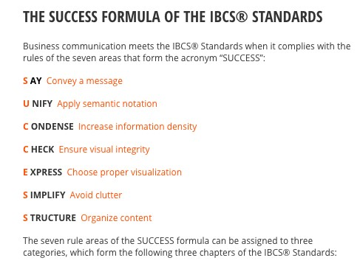

In some cases, individual organisations have published their own guidelines of best practice for when their employees are designing visualisations, including advise on visual

impairments like colour vision deficiency (colour-blindness) (Office for National Statistics, 2017). As discussed in the previous section, colour is a useful variable in visualisations, however it can cause problems for some users if they have visual impairments.

According to research (Birch, 1993), around eight percent of males have colour-blindness compared to only 0.4 percent of females. Those who suffer from colour-blindness cannot distinguish colours, either red, green or blue depending on the type, in the same way as those who do not. For example, a graph with red and green bars will look like bars of slightly different shades of green (Wexler, et al., 2017). It is therefore important to not use these and similar colours together. Luckily, software packages are now equipped with colour-blind friendly palettes. For example, Tableau, which this project will be using to develop its experiment’s visualisations, has a pre-set palette which uses shades of blue, orange and grey (Tableau Software, 2016). In addition, the experiment will collect information about colourblindness. It is important to create colour-blind friendly visualisations and collect this information to: firstly, not disadvantage any participants who are colour-blind, and secondly, to test if this pre-set palette works.

Visualisations are becoming more widely used in the media too with the use of infographics explaining complex issues like Brexit (BBC, 2019) and The Economist newspaper’s regular segment ‘Graphic Detail’ (2019).

Recently, there has been a study into journalistic use of visualisations in Scandinavia

(Engebretsen, et al., 2018). By speaking to journalists, it found out what has influenced their use of visualisations. A number of findings support the minimalistic school of academic theories including that bar and line graphs are the most effective, and that readers do not have the patience to learn unfamiliar visualisations. In support of the ‘pro-Chartjunk’ school, it found that pictograms and playfulness make visualisations more relatable, though conversely, it also found interactive visualisations to generate less feedback on social media. The study also agreed that the relationship with the reader is important and the need to “adapt your message accordingly” (p. 12). Most intriguing is the effect of the general move to small mobile screens by their readers. The move to mobile has driven a simple and linear design process. With the rise of portable devices in use at work (Scheck, 2016), this will have an impact on the design of visualisations and dashboards in the future. It will also have an impact on this research’s experiment and therefore the visualisations should be designed and hosted on a survey site with mobile device usage in mind.

Visualisations are also being used by unions (University and College Union, 2017) and consultancies (Ernst & Young Global Limited, 2018) to report on the gender pay gap data to their members and customers. This brings us onto the niche focus of this research project.

## Gender Pay Gap

The area of gender pay gap is of great interest to academics with many papers published. They tend to focus on the testing for the existence of a gender pay gap (Blau & Kahn, 2007), the response of organisations to, or effectiveness of, government policy and law (Bennedsen, et al., 2018), or on the sources of the gap (Boll & Lagemann, 2018). While these results and their findings are important, they are primarily designed for an academic audience and towards identifying factors for policy-makers to debate and form policy.

The three papers mentioned above are examples of where academic papers still have work to do regarding the use of good, appealing visualisations to report their results. These papers contain lots of tables and basic line charts and histograms of which many are orientated differently to that of the page. Others focus heavily on the mathematical models used to conduct the research (Lucifora & Meurs, 2006). Neither the visualisations, nor a focus on models, are easy to understand or engaging for non-academic readers illustrating the need for improving the communication of the data through visualisations.

Yet, some papers do make recommendations to help organisations understand their gender pay gaps and help combat them. A European Union (EU) report (Boll & Lagemann, 2018) states polices should aim to tackle within-sector differences in gendered pay; something this research project is doing by looking at the specifics of the UK educational sector.

Finally, Dragana Stojmenovska (2019) suggests that the gender of management affects pay and so providing good, unbiased visualisations to them should help mitigate or reverse any gender pay unbalances. Again, by considering the gender of visualisation users and understanding the intended user within the education sector, this research is helping to build upon this area of study.

## Expectations

Based on the literature review above, and other factors, there were several observations the researcher was expecting from the results.

### Demographics

1. Those participants from the UK and with English as their first language would outperform everyone else.
2. Based on spatial ability, men would outperform women, younger participants would outperform older participants, and STEM educated and/or occupied would outperform non-STEM participants.
3. Those with a higher education would outperform those with a lower education.
4. The design of the visualisations and web-survey would ensure participants’ results were not affected by colour-blindness.
5. Smaller devices and screens will adversely affect the results.

### Visualisations

1. The academic theories would be broadly correct with perhaps the exception of the radar chart (it would perform better than expected).
2. The most common visualisations would perform best (bar charts, line charts, pie charts).
3. The more complicated visualisations would be the least preferred (histograms, box plots and those with targets).

# Pilot

As aforementioned, it is important to conduct a pilot study in order to evaluate the proposed experiment’s procedures, data collection methods and uses of visualisations.

## Methodology

### Which Visualisations?

The first consideration was which visualisations to use in the experiment. Based on the conclusion from the literature review that they need to follow the minimalistic and datadriven school of thought, the logical starting place was the data.

An annual dataset from the UK Government’s Pay Gap Service consists percentage values for a range of categories for either male or female employees. For example, the percentage of a company’s female employees who are in the lower quartile, the equivalent percentage for its male employees, and repeated for each quartile. It has similar data for bonuses and hourly pay. It also contains the name of the employer, their address, number of employees, and if they submitted their data on time or not.

Using a data-driven approach, and with the use of glossaries (Berinato, 2016) (Wexler, et al., 2017) and a selection matrix (Appendix 1) (Few, 2012, p. 310) from academia, it was possible to shortlist a number of potential visualisations:

*The Good*

* Bar charts including diverging, stacked and bullet graphs. Studies have found bar charts to be the most effective and using Few’s matrix are good for time series, ranking, part-to-whole and comparison relationships. Additionally, the data uses the same measure (Berinato, 2016) and allows comparison to targets (Wexler, et al., 2017).
* Line graphs including slope charts, bump charts, and alluvial diagrams. These visualisations are the preferred methods of showing time series data either continuously in the case of line charts or, for the others, between two different time periods (Wexler, et al., 2017). Currently, there are only two years of data available, so all these options are viable.
* Box plots and histograms. These show the distribution of the data for single set of data (histogram) (Berinato, 2016) or for multiple comparisons (Few, 2012).

*The Bad*

By identifying the best visualisations to use according to academia, it was possible to identify those which are claimed to be worst; the same sources included ‘best to avoid’ sections. Including these in the experiment is a major requirement for testing if the academic theories are correct.

* Pie charts including donut. These show part-to-whole relationships (Wexler, et al., 2017) and when repeated can be used to show ranking and comparison relationships too. Donut charts are less effective than pie charts (Few, 2012). Therefore, these can

be directly compared to bar charts. They are used by the media (The Economist, 2015) and most people immediately know how they work (Few, 2013).

* Radar/spider chart. Each axis can represent either an independent measure or a single measure in parts and show multiple series of data. They can either be used in place of bar charts or line graphs with time data being best suited (Few, 2012).
* Units charts. Used to show tallies in a way that feels more concrete (Berinato, 2016) in either geometric shapes or irregular shapes like picture or icons (Few, 2012). Again, they are in place of bar charts.

*The Ugly*

These are visualisations which were considered but not chosen:

* Geospatial/Geographical charts. Maps used to represent values attributed to locations; often to compare countries or regions (Berinato, 2016). The address information in the dataset was not in an easily processable format or of sufficient quality.
* Treemap. A rectangle divided into segments like a pie chart and designed to overcome their limitations when with many slices (Berinato, 2016). The number of variables in the dataset will not produce too many slices and therefore a treemap is not required.
* Bubble/circle charts. Size of circle is used to show comparisons which are difficult for making precise comparisons (Wexler, et al., 2017). They were deemed to have similar issues to pie charts but worst performing so were not included.

### Original or Secondary Visualisations?

After identifying the types of visualisations, it was decided that, as the main purpose of the pilot was to test the effectiveness of the experiment format and collection methods, and that it wouldn’t affect this aim, it would be more efficient to use already published visualisations. The visualisations used were all sourced from the internet and from a variety of contexts including news publications, academic sources, and from analytics-related webpages. In some cases, where the answers to potential questions were included in the visualisation, like the title, these were removed. The pilot visualisations, questions and sources can be seen in Appendix 3.

### Questions

*Consent Form*

The pilot study included a consent and disclaimer page (Appendix 2) before the paper-based answer sheets (Appendix 4). As well as covering the formalities of the study, it was a good chance to evaluate the wording and comprehension of these paragraphs. To allow for confidential answers, the participants and their answer sheets were given a unique pilot identification number (UPID) in place of collection of personal information.

*Demographics*

By collecting demographic data through questions one to nine (Slides 2-6, Appendix 3), it will be possible to analyse any correlations between demographics, educational and ability levels and the devices used, and the results of the experiment. They will also allow comparison to the intended audience of the visualisations; school governors, trustees and HR professionals. Unless overwise stated, questions were based upon past work which was already proven to be successful and so that they were familiar to participants (Callegaro, et al., 2015).

Questions one and two allow the detection of any impact nationality and language may have on the results; particularly comprehension of the questions.

Questions three to seven allow for the analysis of spatial ability in gender, age and occupation as discussed in the spatial visualisation section of the literature review. In question four, ‘17 and younger’ is included, despite the consent statement, to filter out any under 18 participants. In question five, the options are based on the UK Government’s (2019b) nine qualification levels for England, Wales and Northern Ireland starting from Level 1. Question six, is included to be able to make a distinction between those with a high level of education in any subject and those in statistics. Question seven allows for a more direct comparison between occupation and the participants’ results compared to question six.

Questions eight and nine are included to take into consideration uncontrollable factors which may affect results. Question eight also allows for the testing of the colour-blind provisions made in the visualisations.

*Visualisations*

Questions were organised into their corresponding ‘good’/‘bad’ pairings so, for example, the pie chart was compared to a bar chart, two versions of time series visualisation were compared, and so on.

#### Questions 1 and 2 - Pie versus bar

To test the participant’s ability to understand pie and bar charts and their ability to communicate information correctly. The data is the same for both questions, so it is perfect for analysing which is better at communicating.

#### Questions 3 and 4 – Stacked bars

To test the participant’s ability to understand stacked bar charts, their ability to communicate information correctly, and the theory stacked bars work best when there are not too many segments (Wexler, et al., 2017).

#### Questions 5 and 6 – Time Series

To test the participant’s ability to understand bar charts and line graphs when they are visualising time series data. The data is the same for both questions, so it is perfect for analysing which is better at communicating.

#### Questions 7, 8 and 9 – Radar Charts

All questions are designed to test the participant’s ability to understand radar charts. By using the same data but changing the questions, it will be possible to determine which types of questions, comparisons and variables are best explained by these charts for use in the main experiment.

#### Questions 10 and 11 – Distribution Visualisations

Box plots (question 10) are ideal for showing distribution but may not be universally understood by participants (Wexler, et al., 2017). Histograms are sometimes mistaken for bar charts (Berinato, 2016) and too may not be universally understood by participants. Therefore, these questions are to test the participant’s ability to understand these distribution visualisations.

#### Questions 12 and 13 – Preferences

The graphs recommended by academics may not be those preferred or understood by the public. Therefore, these questions will determine which graph type each participant’s preferred visualisation is. It will allow for comparisons with the demographic answers to analyse any patterns and compare to the intended users.

*Likert Questions*

These questions (Appendix 5) were included in the pilot survey at the end of the answer sheets to collect data on the survey performance from the participants’ point of view. It was important to be able see if questions were understood and stress-free as to make the main survey as successful as possible. By asking if there were too many questions, if the survey was interesting and if participants lost interest near the end it would be possible to judge if the main survey could have more, less or a similar amount of questions, and if the questions should be designed or ordered in a certain way as to keep the participants engaged. Finally, it was important to ask if the survey would work in an online format to see if there was any evidence for not using these methods for the main online survey.

### Creating the Pilot

* The Consent and Disclaimer page, answer sheets and Likert questions were created using Microsoft Word.
* Visualisation questions were created using Microsoft PowerPoint.

### Running the Pilot

* Participants were asked if they would like to take part in the pilot study.
* The pilot was run in a quiet room in either a residual household or library and at a desk to allow for maximum concentration and comfort.
* A laptop was used to show them the questions PowerPoint presentation and an answer sheet provided for answers. Instructions on how to navigate the slides was given.
* Participants navigated the survey themselves with a mouse and could move back and forth through the slides and questions. Answers were written on the answer sheet.
* Participants completed their pilot on their own and separately from one another.
* Once started, the interviewer left the room but stayed within earshot. This was to not pressurise the participants by observing them, but still be able to answer queries or help with technical issues if required.
* Answers to queries were provided as long they did not help participants derive survey question answers. i.e. with the meaning of the question, not how the visualisation works.
* At the end, participants could be interviewed on what they thought, how it could be improved and if anything was missing; a suggestion from Adams et al. (2014).
* The pilots were between the 3rd abd 13th July 2019.

### Analysing the Results

* The results were entered into a Microsoft Excel spreadsheet which was saved securely in the researcher’s Google Drive account.
* The small number of participants and focus on processes over results allowed for simple data analysis procedures like tallying correct answers and calculating the mean and mode of the Likert answers.

## Findings and Considerations

As the focus of the pilot was to evaluate the process and effectiveness of data collection, the analysis will be related to how the experiment performed. However, the performance of the visualisations will be mentioned when related to the experiment’s performance or notable observations are made. The full results can be found at figure 2 for Demographics, appendix 6 for Visualisations and figure 3b for the Likert questions. Five participants were recruited mirroring the number of participants in the pilot study by Saraiya, el al. (2005) and with the intention of making it has representative as possible given the sample size.

### Consent and Demographics

In general, the consent page and the nine demographics questions performed as intended and with a range of answers (figure 2), particularly in nationality and gender, as to give some weight to the pilot results.

However, a few points were raised from the results for consideration in designing the main experiment.

* Use drop-down menus to ensure answers are standardised, principally in the country and occupation questions, where answers can be different but mean the same; China, Republic of China, PR China.
* Add more categories to the age question to split out 60 and above and standardise the intervals.
* Investigate the equivalent qualifications for Scotland and add them to the educational questions.
* Reword the statistical education question as participants struggled to understand what it was asking (figure 3).
* Add an option for retired participants (from feedback) and consolidate the occupation options.

|  |  |  |  |  |  |  |  |  |  |
| --- | --- | --- | --- | --- | --- | --- | --- | --- | --- |
|  |  |  |  | Demographics | | |  |  |  |
| Question | 1 | 2 | 3 | 4 | 5 | 6 | 7 | 8 | 9 |
| Unique Pilot ID | **Country** | **English First Language** | **Gender** | **Age Cat.** | **Highest Level of Ed.** | **Highest Level of Stat. Ed.** | **Occupation** | **Visual Def.** | **Device** |
| 01 | UK | Yes | Female | G 60+ | F B. Ed Degree | F | W Retired | B | B |
| 02 | UK | Yes | Male | F | B | B | C | D | A |
| 03 | UK | Yes | Female | C | G | F | P | D | B |
| 04 | Turkey | No | Female | C | G | C | V | D | B |
| 05 | China | No | Male | C | G | G | W  Marketing | D | A |

*Figure 2 - Pilot Demographics*



“Did not understand what

question was asking.”

–

UPID01



“Question could be more clear.”

–

UPID04

*Figure 3 - Statistics Education Question Feedback*

Page **25** of **164**

### Visualisations

*Questions 1 and 2 - Pie versus bar*

Four participants correctly answered that category 2 was the largest pie segment and all participants correctly answered that category 2 was the largest bar. These results reflect previous studies and the reasons for inclusion in the experiment. This was despite the fact, due to a pilot design oversight, the bar question was missing its key to inform the participants which colour corresponded to each category. Participants said they used the key from question one; inadvertently supporting the Gestalt theory of similarity. These two questions seem to have worked as predicted and therefore the format is suitable for implementation in the main experiment.

*Questions 3 and 4 – Stacked bars*

Four participants answered both questions correctly. One participant who answered incorrectly said afterwards that she became confused during the question. These questions did not quite work as planned - to show question three being harder to answer than four. However, there is evidence question three took a long time with calculations on the side of one answer sheet where the participant spent time to calculate values; supporting Few’s (2012) reservations about these visualisations.

*Questions 5 and 6 – Time Series*

Four participants incorrectly answered question five, while three were incorrect for question 6. These questions did not quite work as planned - to show question five being much harder to answer than six. Perhaps, the fact that revenues increased in 1994 and then fell in 1995 to a similar level to in 1993, participants viewed this as constant revenue from 1993 to 1995. It is also possible that the high number of incorrect answers was due to the wording of the question and not to the visualisation. One participant, UPID04, whose first language is not English, said the wording of “over time” could be clearer.

*Questions 7, 8 and 9 – Radar Charts*

**Question 7:** Three participants thought product 2 was best while the other two thought product 1.

**Question 8:** All participants thought product 2 performed best on usability.

**Question 9:** Three participants thought product 2 performed best on price while the other two thought product 1 was best. One participant, UPID03, stated they needed more information, asking if price should be measured against performance, or if the best price is the cheapest or most expensive.

The results from these questions lead to the conclusion that the use of radar charts is better reserved for questions with a clear context, an easily measurable variable, and when focussed on one measure not as a whole. For example, while usability is normally measured with the ‘best’ being highest, price could refer to actual price or value for money and therefore, the ‘best’, would be at opposite ends of the scale.

*Questions 10 and 11 – Distribution Visualisations*

Three participants correctly answered the box plot question. One participant, UPID03, who correctly answered the question, said she didn’t understand how the graph worked. She chose ‘other drinks’ as it was the smallest and the question asked for least. All participants correctly answered the histogram question despite the flaws with the visualisation. Asking a more specific question instead of a general one might have given different results.

*Questions 12 and 13 – Preferences* These two questions worked as intended.

*Considerations*

From the results, a few points were raised for consideration in designing the main experiment.

* Develop the questions in order to ask participants to both identify the correct segment and the correct percentage value; further testing communication.
* Develop the questions in order to know how confident the participants are in their answers. Alternately, if it is possible to calculate the time spent on each individual question, then it will be possible to determine which visualisation is easier to understand.
* Think more carefully about the wording of the question or question subject in order to make them clearer (time-series), not to lead participants to certain answers (box plot) and separate those participants who fully understand from those who only partly understand (histogram).
* Radar charts to be used with much more thought put into the labelling and context than provided in the pilot version. Focus on one measure and not as a whole.
* Add additional visualisations to preferences questions; the use of four choices was determined by the space on the presentation slide.

### Likert Questions

Based on these results (figure 3b), the format of the survey works well with the amount of questions not too high. In fact, with a low score, there is the potential for more; though the time taken was in the ideal range of 10-20 minutes (Revilla & Ochoa, 2017) at seventeen and a half minutes. As discussed above, for specific questions, wording was not as clear as it could be. Finally, the pilot was not wholly interesting to the participants. Considering the subject matter, it can be inferred that only a minority of participants would be greatly interested in data and its visualisation. However, it is interesting to note that many of the participants did not lose interest towards the end of the survey. This is important because if participants lose interest, they may start answering questions randomly or without the same level of thought as earlier in the survey.

*Considerations*

Before running the pilot, there was no intention to ask any Likert-type questions, but there may be a role in the main experiment for assessing how the survey went; particularly regarding any reduction of interest towards the end of the survey. Alternatively, being able to randomise all or sets of questions may reduce any negative effects on the positioning of questions.

|  |  |  |  |  |  |  |  |  |
| --- | --- | --- | --- | --- | --- | --- | --- | --- |
|  | Statement | 1=Strongly Disagree, 2=Disagree,  3=Neutral, 4=Agree, 5=Strongly Agree (please circle) | | | | | *Average (mode)*  *Score* | *Average (mean)*  *Score* |
| 1. | The questions were easy to understand | 1 | 2 | 3 | 4 | 5 | *4* | *3.8* |
| 2. | The questions were stressful to answer | 1 | 2 | 3 | 4 | 5 | *1* | *1.6* |
| 3. | There were too many questions | 1 | 2 | 3 | 4 | 5 | *1* | *1.8* |
| 4. | The survey was interesting | 1 | 2 | 3 | 4 | 5 | *3* | *3.2* |
| 5. | I lost interest towards the end of the survey | 1 | 2 | 3 | 4 | 5 | *1* | *1.6* |
| 6. | This type of survey will work well in an online survey format | 1 | 2 | 3 | 4 | 5 | *4* | *4.4* |
| Average time taken for the survey was 17.5 minutes (from 4 timed pilots). | | | | | | | *Red=poor result, orange=medium, green=good result* | |

*Figure 3b – Likert Questions Results*

## Discussion

Adam, et al. (2014, p. 128) have produced a checklist of questions for pilot studies which, by answering, will determine a pilot’s success and influence the research’s next steps. Most questions, such as those asking if questions and instructions were clear and what the completion time was, have been answered above. The rest will form the discussion below.

1. How is the pilot different from the main experiment?

The pilot is different in a few ways. Firstly, it was a paper and computer-based hybrid instead of a web-based survey. This is perhaps the largest limitation of the pilot. Ideally the pilot should have tested the ability of the intended web-survey provider, but time constraints and lack of access to Aston University’s Online Surveys account at the time warranted a slightly different approach.

Secondly, the visualisations were not developed from the gender pay gap data and instead were already published visualisations from a range of topics. Thirdly, there was an interviewer present. It is judged that these differences did not adversely affect the findings of the pilot and, in the case of interviewer presence, enhanced it through better data collection.

1. What were the costs?

The costs were minimal with only printing and travelling costs to consider. These will be removed in the main experiment by using a web-survey.

1. Is the data likely to be meaningful and sensible analysis possible?

The data collected from the pilot suggests that the results regarding the visualisations will be meaningful and provide the ability to make sensible analysis. In addition, the collation and analysis of the pilot data, even with only five participants, confirmed the aforementioned benefits of web-surveys and the electronic recording of data. The main experiment will require no time to be spent on data entry or basic analysis and reporting allowing more time for more in-depth investigation.

1. Was it needed?

Yes. The pilot identified several serious problems with the questions and raised numerous considerations to take forward to the main experiment.

# Main Experiment

As the main experiment is based upon the pilot study, in parts of this chapter only elements which are different or additional to those discussed in the pilot chapter will be included.

## Methodology

### Data Collection and Preparation

*Selecting and Downloading*

As defined in the introduction, the data for this experiment came from the UK Government’s Pay Gap Service at [https://gender-pay-gap.service.gov.uk/.](https://gender-pay-gap.service.gov.uk/) There are two ways for selecting and downloading the data; the whole country’s reported data for a given year (figure 4) or by selecting a sector and then each individual employer to compare before downloading this ‘compared’ dataset by year (figure 5).

*Figure*

*4*

*–*

*Downloading*

*full*

*annual dataset*

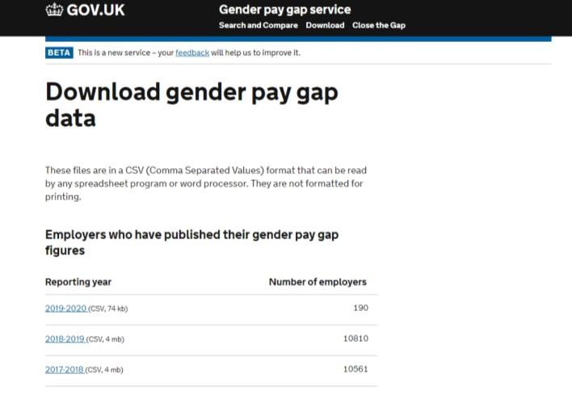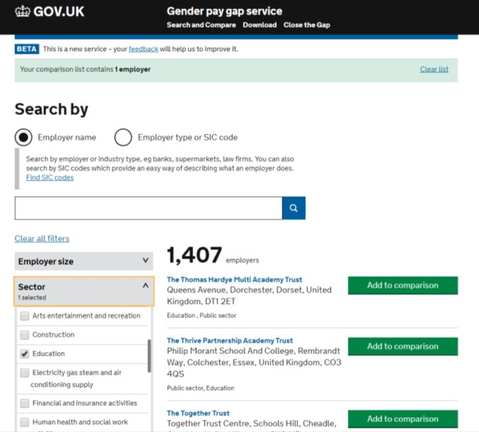

*Figure 5 - Downloading by Sector; Education*

For this research, both methods were used. This was because there was a difference in the data provided by the different download methods. The full annual dataset consisted of the fields described in the pilot study chapter. However, the ‘compared’ dataset did not include the employer’s address details. While these addresses were not of sufficient quality for geospatial maps, they would be useful for filtering the datasets on location when creating the visualisations. Therefore, the two datasets needed combining. The data for 2017-18 and 2018-19 were downloaded resulting in four files; two full annual datasets and two full education sector datasets. There were 893 education only records for both years.

*Combining Datasets*

The first task was to separate out the address details in the full annual dataset from one field to individual fields so that at least the town/city and postcode were separate to allow for filtering by location. To do this the data was imported into Microsoft Access. Using queries, the address data was isolated, exported, additional field headers added in a text editor, reimported into Access, and by using the commas in the data, the addresses were separated into separate fields. Again, using a query, the postcodes were identified and relocated into their own ‘Postcode’ column. For the towns/cities, a list of UK towns was downloaded (Stenning, 2015), and then matched using a query to identify and relocate to their own column. Any that did not match were identified and moved manually.

For example, below, Aston University’s address would change from the first column to those on the right.

|  |  |  |  |  |
| --- | --- | --- | --- | --- |
| Before |  |  | After |  |
| Address | Address 1 | Address 2 | Town | Postcode |
| Aston Street,  Birmingham, B4 7ET | Aston Street |  | Birmingham | B4 7ET |

These ‘fixed’ addresses were then appended back to the original annual dataset. This was done for both 2017-2018 and 2018-2019.

The next task was to combine the annual dataset with the ‘compared’ education sector dataset. Using a query, the two datasets were joined by Employer Name, meaning only exact matches would be selected and the addresses would be appended to the correct employer. This resulted in 779 records for 2017-2018 and 868 records for 2018-2019; a reduction in both cases most likely resulting from missing or incomplete address data.

The combined, education only datasets were then exported from Microsoft Access to Microsoft Excel with fields matching those described in the pilot chapter but with town replacing the address field. In some cases, data from these Excel Spreadsheets were isolated in their own Worksheets to prepare, organise and format for specific visualisations.

### Which Visualisations?

The pilot did not raise any major issues regarding the choice of visualisations used and therefore the choices for the main experiment were to come from those. However, the choice of software for creating them, and the researcher’s proficiency in these, also influenced the choice of visualisations.

### Software Packages

Two software packages were used when creating the visualisations, Microsoft Excel and Tableau, but why these software packages?

In addition to the researcher’s familiarity with these packages, Tableau and Excel were found to be the second and third most evaluated business intelligence tools respectively (BI-Survey, 2016) and therefore are justifiable as being used in the experiment. Some advantages of using Tableau are that it does not require any technical or programming skills to operate (Guru99,

2019), content can be created to “perform at any size, on any device” (Tableau Software,

2019), and it allows data visualisation “in a more powerful way compared to Excel” (365datascience, 2019).

Therefore, all visualisations, except the radar chart, were created in Tableau. The radar chart was created using Microsoft Excel due to Tableau not having a pre-set template. Excel was also used for data storage and rearrangements as Tableau is not an optimal data creation tool (365datascience, 2019).

### The Visualisations

### Creating the Visualisations

Unlike the pilot, these visualisations were newly created and therefore various academic theories, commercial guidelines and practical considerations had to be considered in their design. All visualisations can be viewed as part of the survey found at appendix 7.

*General Application of Theory and Guidelines*

There are several theories and guidelines which were applied to a number of visualisations, if not all of them, and so, before detailing specifics on individual or groups of visualisations, it makes sense to cover these.

#### Position and Proximity

Bertin’s (1983) idea of effective use of position has been interpreted as the position and order of the data shown.

In the circular charts – pie (figure 6) and radar – the data has been ordered clockwise from ‘Lowest Paid’ to ‘Highest Paid’ to mimic the hours on a clock. The idea being that as users are familiar with reading a clock, circular visualisations can too be organised this way and easily read (Few, 2012).

Similarly, for showing quartile data, the horizontal bar charts (figure 7), line chart and box plot, the data has been ordered ‘Lowest Paid’ to ‘Highest Paid’ from bottom to top. This was to match people’s assumption that values, in this case pay level, rise as they move up the vertical axis (Harris, 1999). Likewise, in the diverging and stacked bar charts, the employees were ordered from the lowest percentage of ‘Female Lowest Paid’ to the highest.

The Gestalt principle of proximity (Few, 2013) has been utilised in some visualisations through the use, or lack of use, of a data legend/key. For example, figures six and seven do not have a key. Alternatively, each segment or bar is labelled. This saves the user time when reading the graph when compared to having their eyes having to move back and forth from segment to key (Acampora, 2018). It also communicates the information with the least ink (Tufte, 2001). In those visualisations with a key (figure 8), not using them would have reduced the clarity and made them harder to use.

*Figure*

*6*

*-*

*Pie Chart*

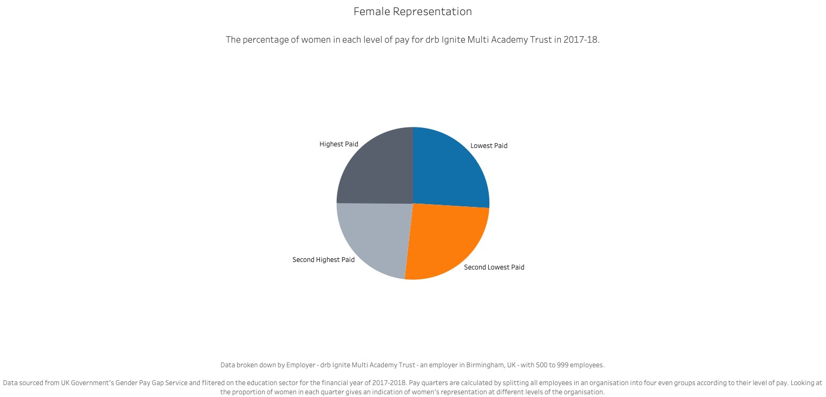

Page **33** of **164**

Page **34** of **164**

*Figure*

*7*

*-*

*Bar*

*Chart*

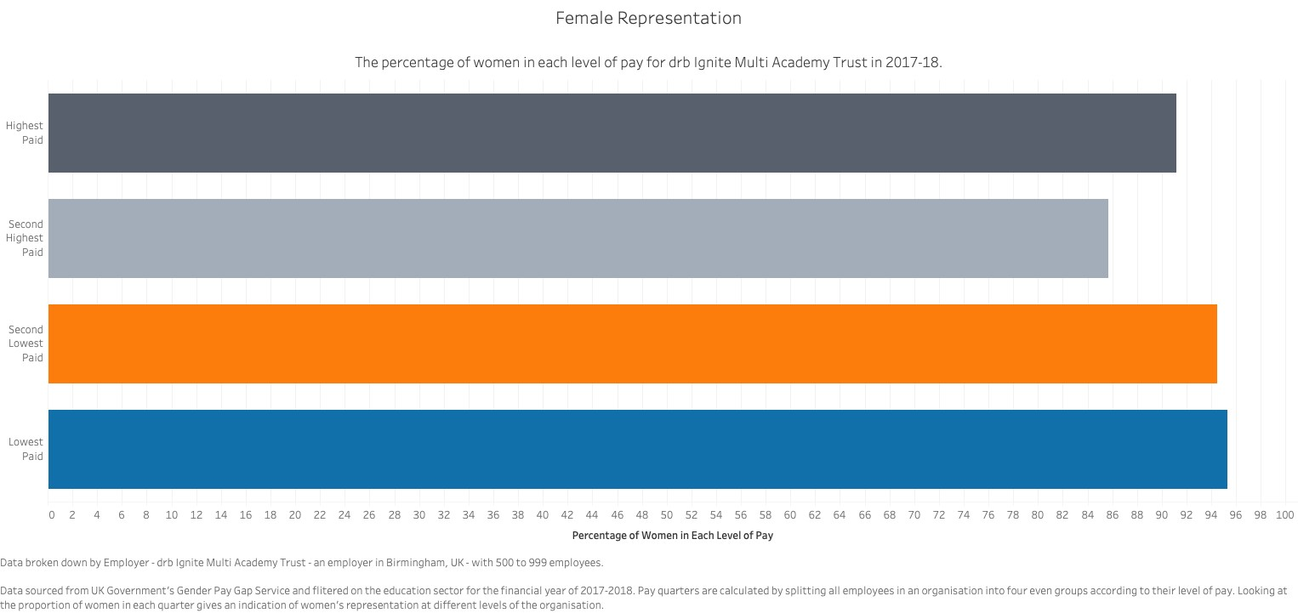

#### Clarity and Context

In addition to the use of keys or data labels there were other ways to ensure integrity through the use Tufte’s clarity (Tufte, 2001). Axis labels were given enough detail, without being too much, so that users could understand. For example, figure eight’s horizontal axis labels give both a long and short descriptions for both a detailed and more simplified description.

*Figure*

*8*

*-*

*Diverging Bar*

*Chart*

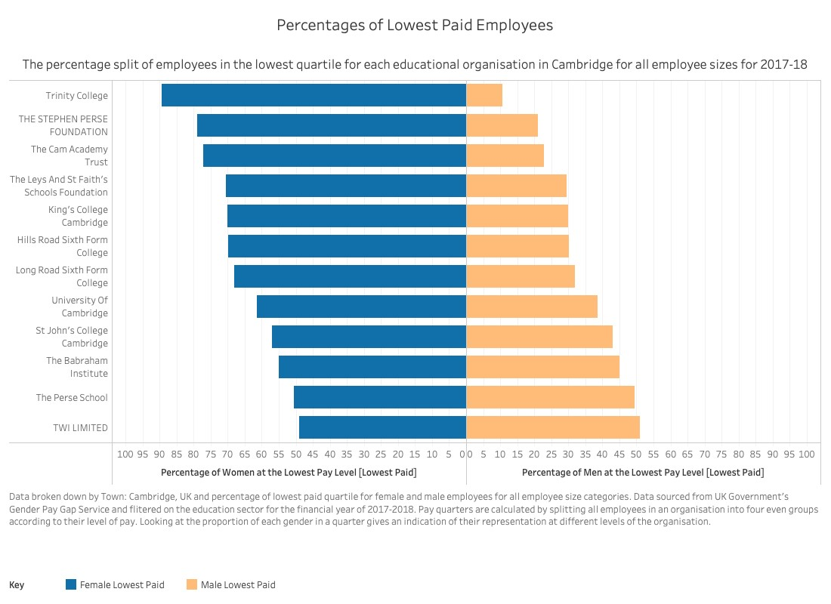

Figure eight also shows the high frequency of intervals in the horizontal axis. This was done on all visualisations in order that, without becoming clutter, there were as many axis intervals to be able easily read the values adding clarity and detail.

The final application of clarity comes from additional labels. Figure nine shows a textbox giving details explaining the purpose and value of the vertical axis being used a target line. These labels appeared on the other target visualisations too.

All visualisations included a title, subtitle and caption. This provided information about the data used; the source, year, any filters (sector, employer, town or number of employees), and how it was calculated either originally by the UK government or by the researcher. This allowed the user to understand what was being compared, how it was created, and which period, sector and size of employer was being represented. It may also help combat any preheld biases the user may have (Knaflic, 2015).

Page **35** of **164**

*Figure*

*9*

*-*

*Diverging Bar*

*Chart*

*with Target*

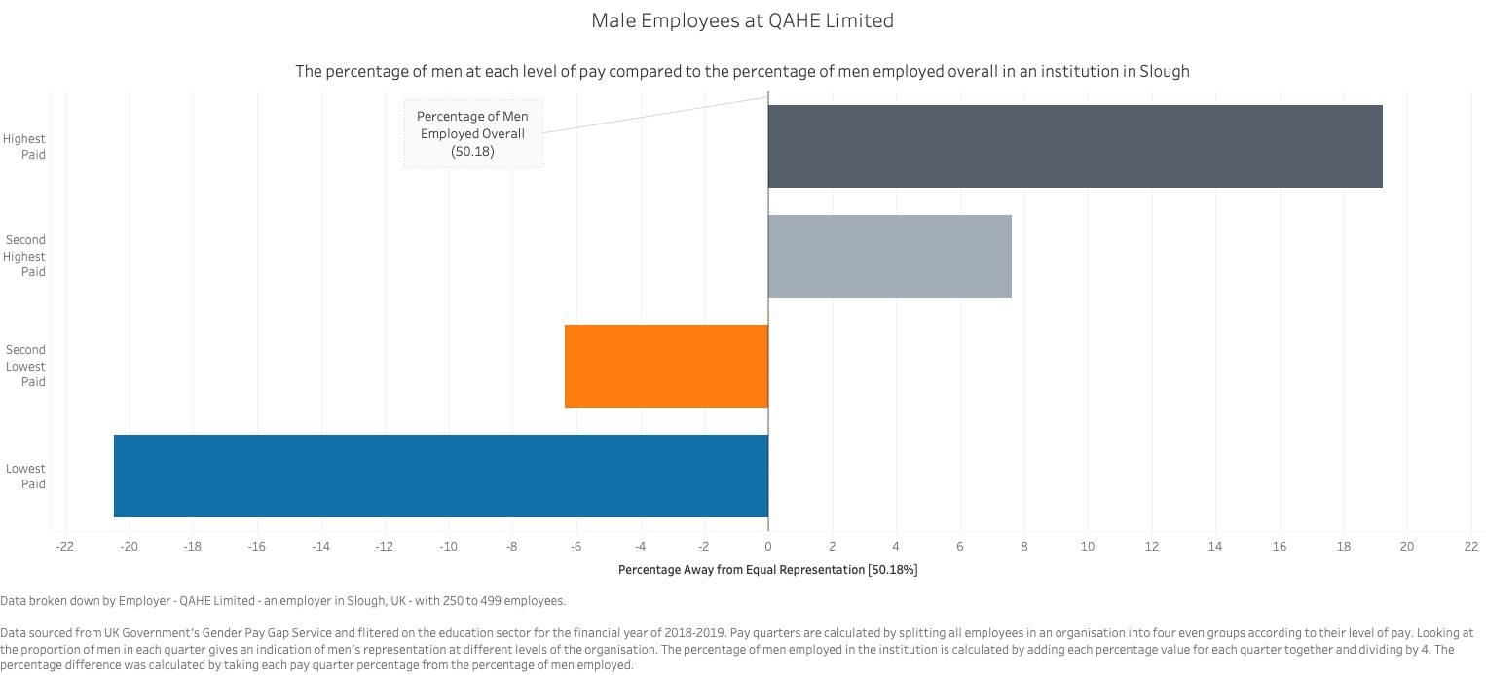

#### Similarity and Proportionality

It makes sense to combine the Gestalt principle of similarity (Few, 2013) – objects which are similar tend to be grouped together - with the six remaining visual variables of Bertin’s (1983): shape, orientation, colour, brightness, texture, and size. They have been used in two contrasting ways; to show or not to show differences.

Page **36** of **164**

First, all visualisation types have used the same shape type, brightness level and texture for each data variable shown on each individual visualisation. For example, the diverging target bar chart above (figure nine) uses rectangular bars for all data variables, has not dimed or brightened one bar compared to the others, nor changed the visual texture/pattern of any bars. This illustrates that for these visual variables the different data variables are equal. These principles are repeated in each visualisation in the experiment.

Second, there are differences in the shape, colour and in some cases orientation for each data variable shown on each individual visualisation.

In the diverging bar charts, orientation is used to differentiate the data variables. For example, in figure nine, the bars either measure from right to left or the left to right depending on their value compared to the target (below or above). In figure eight, they depend on the gender group. However, these are exceptions as most of the other visualisations orientate the data variables in the same way (figure 7).

Colour was a major decision to make when designing the visualisations. As discussed in the commercial usage section of the literature review, colour-blindness is a modern and necessary consideration. Tableau has its own colour-blindness palette which was chosen as a starting point. These can be seen in figure nine.

It also had to be decided how to use this colour palette. Colour can be used in three primary ways: sequential, diverging and categorical, and two additional ways: to highlight or alert the user (Wexler, et al., 2017). However, due to the nature of the experiment questions – particularly to test if users can identify certain data variables – using colour to order, highlight or alert could defeat the objective of these questions. So, these techniques, with the exception of the histogram question, were not used. This left the main use of colour to be categorical.

To adapt the principle of similarity and to help with clarity (Tufte, 2001) the same colour scheme was used for each data variable across visualisations. Consequently, the colours shown in figure nine for the pay level quartiles are the same for every visualisation involving these quartiles. Equally, those shown in figure eight to show male and female are the same in all visualisation with two genders. The shades of blue and orange in these are different to separate them from the quartile data. There are different colours used in the histogram visualisation too. Generally, the use of colour is reserved only for this categorical identification; resisting ‘Chartjunk’ or other unnecessary visual additions.

Finally, the size of the shapes representing the data variables were directly proportional to the actual numbers they depicted incorporating Tufte’s proportionality integrity principle (Tufte, 2001). This allowed users to physically measure the shapes to determine the answer to questions. It also allows the visualisations to tell the truth about the data and ensure Tufte’s graphical excellence. In relation was the decision to not use 3D visualisations as they skew the data, add unnecessary elements like sides (Knaflic, 2015), and would add an additional dimension; ignoring Tufte’s integrity principle for appropriate dimensions.

Page **37** of **164**

#### Data-Driven and Standardised

As discussed in the pilot chapter, the choice of visualisations was driven by the data being used. However, for this experiment there was also an element of visualisation driven decision making while designing.

For example, when designing the pie chart (figure 6), the data used was chosen because the values of at least two quartiles were very close. The same technique was used for the line chart data below (figure 10). This was done with the type of question in mind so to not make correct answers hugely obvious. Otherwise, the choice of visualisation – for example line or radar – would become redundant.

All data for all visualisations were shown in their percentage format and hence were standardised meaning when comparing one year to the next, as in figure ten, they were fair comparisons. By designing data-driven and standardised visualisations they were incorporating more of Tufte’s graphical integrity principles (Tufte, 2001).

*Figure*

*10*

*-*

*Time Series Line Chart*

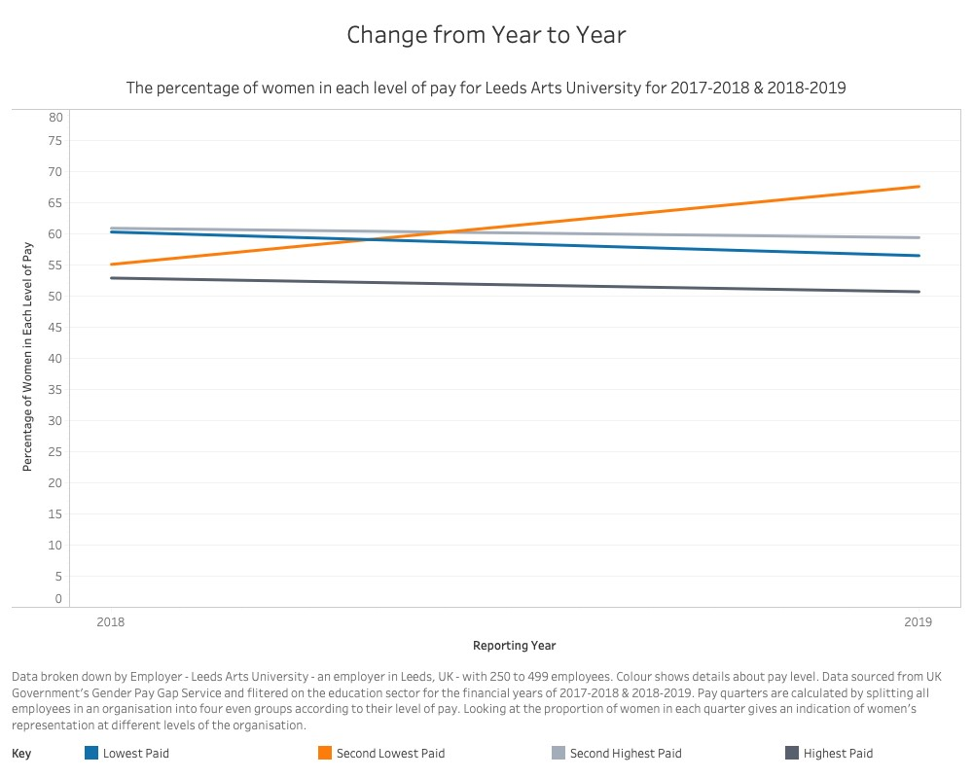

#### Adaptation and Innovation

As the choice of visualisation depended on the data and researcher’s proficiency with the software, there was a need to adapt the choices of visualisations from the pilot. The biggest instance of this relates to visualisations with a target.

Page **38** of **164**

In the pilot, the prime example of this type was the bullet graph. While possible to create in Tableau, and the two-dimensional format of the data (gender) applicable, they were judged not to work with the data in practise. The advantage of a bullet graph is that each bar can have its own target to be judged by (Few, 2013), but the quartile data for one employer will only have one target; equality. Therefore, it was judged that using a bullet graph would be a wasted use of the format, potentially confuse the user, and produce unnecessary extra ink (four separate targets). In its place it was decided to design a horizontal bar chart with a target line (figure 11). This would hopefully produce the same outcome as a bullet graph in a way that was both more familiar to users and with less design elements.

*Figure*

*11*

*-*

*Bar*

*Chart*

*with Target*

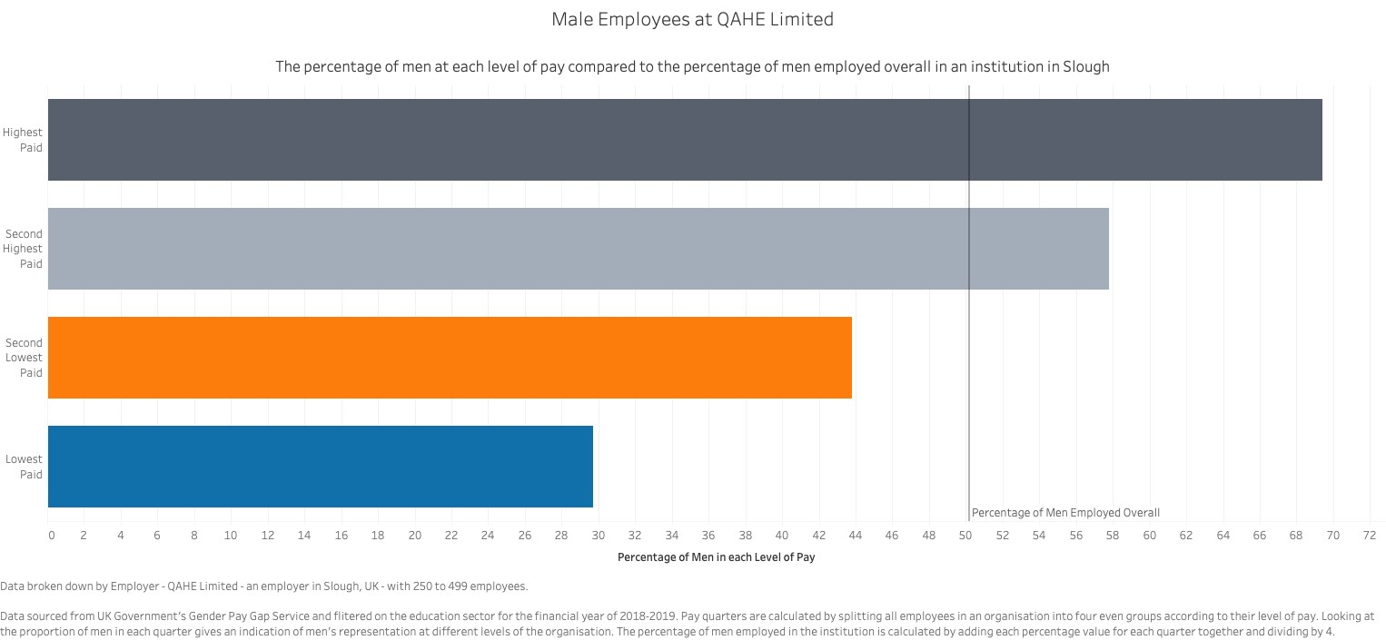

Page **39** of **164**

*Figure*

*12*

*-*

*Pie Chart with Target*

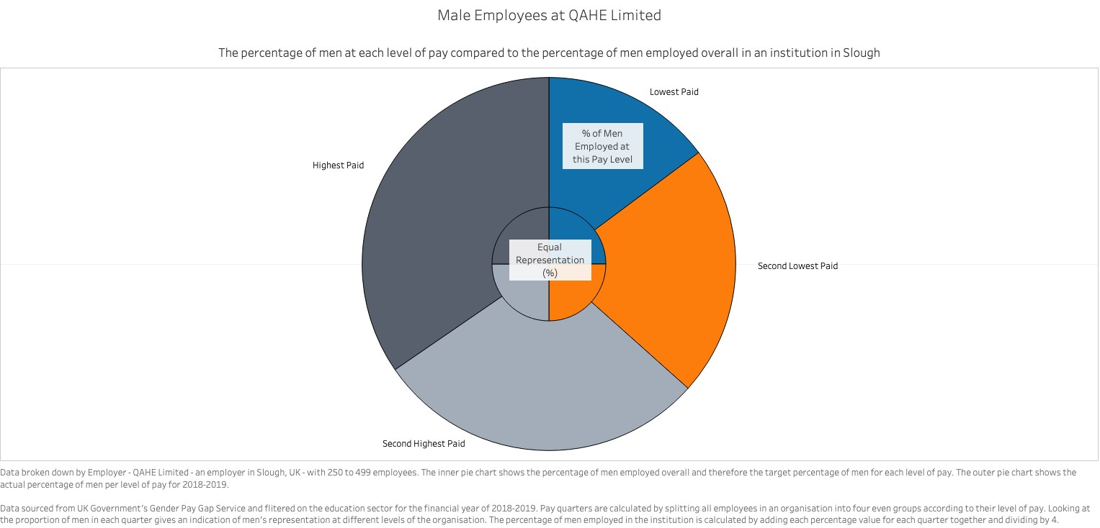

These target visualisations and the intended use and audience lead to the use of innovation also (Few, 2012) (Knaflic, 2015) through adding a target to a pie chart (figure 12). This allowed for the comparison of different visualisations for judging the performance of an employer on equality. The visualisation also used the Gestalt principle of enclosure and continuality (Few, 2013). The different datasets, target (inner) and quartile (outer), are enclosed by a black-lined circle to show they are both the same group and separate from each other.

Page **40** of **164**

However, by placing the target within the larger quartile circle there is a connection through one following the other.

Furthermore, while generally regarded as poor visualisations, it was important that when creating pie charts their best practices were followed. As they are divided into segments and used to show parts of a whole, the whole pie should add up to the whole dataset (Harris,

1999). Were possible (figure 6), data was also chosen to test Spence’s theory that recognisable segment sizes make pies work better (2005).

### Differences from the Pilot

Other than the difference in choice of a target visualisations explained in the previous section, there is one other difference. It was decided, though identified as appropriate in the pilot chapter, to not include a slope, bump or alluvial visualisation for two reasons: the number of visualisations in the survey would be too many, and the practical limitations of designing them in Tableau or Microsoft Excel.

### Method behind the Questions

Generally, the question forming process “starts with the conceptualisation and operationalisation of the theoretical constructs” that the survey wishes to measure (Callegaro, et al., 2015, p. 62). This means thinking about which theories the experiment wishes to test and how these tests transform into a web-survey question.

Questions can either be presented as stand-alone entities or as questions with several subquestions (Callegaro, et al., 2015). They will most likely, as a self-administered data collection method, be restricted to closed questions (Floyd J. Fowler, 2002). Fowler explains that open questions do not produce useful data, are difficult to code, and are only really useful as anecdotal material; all observations discovered in this project’s pilot study.

Largely, questions should use simple words and syntax, specific wording, all-inclusive and mutually exclusive response options, and only measure one dimension at a time. They should also avoid words with ambiguous meaning, leading questions and negatives (Callegaro, et al., 2015).

### Forming the Questions

*Demographics*

The pilot found that the majority of the demographic questions worked as expected with the exception of the statistical education question. Therefore, this section will focus on those questions where the pilot raised some considerations for improvement in the main experiment.

The age question was improved by adding some older age categories to help standardise the size of the categories results. The category 18-20 was unchanged due to the expectation many participants would be students and that all would fall into the same category if updated to 1826.

Page **41** of **164**

The occupation categories were updated in two ways. Firstly, occupations were consolidated by grouping similar occupations together. For example, ‘Business, Management and Financial’ became one option. Secondly, more occupational options, including ‘Retired’, were added to reduce the number of ‘Other’s to process.

Additionally, drop down menus were introduced to these and other questions to ensure answers were standardised, spelt correctly and as expected to aid analysis. For example, the country question used a list from Britannica Encyclopaedia (2019).

The largest change was the question regarding the statistical education question which caused lots of confusion. This was replaced with a Likert question asking about the participants confidence and regular usage of numbers, statistics and visualisations. The question was designed to gain the same information – the participants ability with statistics – but in a more user-friendly and understandable way.

The only consideration from the pilot not included was to add Scottish qualifications to the education question. It was judged that additional options would confuse participants and that any Scottish participants would be able to distinguish which option related to their own education.

*Visualisations*

As with the pilot, the idea of the main experiment was that questions were grouped into their corresponding ‘good’/‘bad’ collections in order to test the participant’s ability to understand the visualisations and the visualisations’ ability to communicate information correctly. These have not been changed too much from the pilot except the visualisations in each collection now showed the same data; with the exception of the ‘Distribution’ collection.

Page **42** of **164**

|  |  |  |  |  |  |
| --- | --- | --- | --- | --- | --- |
| **The**  **Collection** | **Description** | **Main Question(s)** | **Sub-**  **question 1** | **Sub-**  **question 2** | **Testing/Purpose?** |
| Pie versus Bar | Standard versions showing data for all four quartiles for the  same, single employer. | “Which segment/bar is the largest?” | Confidence (how sure?):  Very Unsure  Fairly Sure  Very Sure | How Easy?    Not  Easy/Hard  Fairly Easy  Very Easy | That bar charts are better than pie charts; give more accurate results, instil more confidence, and are easier to read. |
| Diverging bar versus stacked bar | Standard versions showing the lowest pay quartile data for both genders for a range of employers. | “What percentage of Long Road Sixth Form College’s lowest paid employees are male?” | Confidence | - | That diverging bars are easier to read, instil more confidence, and give more accurate results. |
| Time Series Comparison | A line chart, radar chart and vertical bar chart showing data for all four quartiles  for the same, single employer from 20172018 and 2018-2019. | “Of those that decreased, which level of pay saw the smallest decrease in the percentage of women from 2018 to 2019?” | Confidence | How Easy | That a line chart is best for a time series. The bar chart and radar chart will be more  difficult, instil less confidence and give less accurate results. |
| Distribution | A box plot showing data for all four quartiles for a range of employers and a histogram showing the highest pay  quartile data for all employers in 20182019. | **Box plot:**   1. “Which pay level has the smallest range of values?” 2. “Imagine you work for Spencer Academies Trust and you are monitoring your institution's performance. In how many levels of pay is the percentage of men is the Trust above average?” **Histogram:** 3. “Which of these statements accurately describes what is shown below?" 4. “Imagine you work for the institution which lies within the highlighted segment. How would you rate its performance?” | Confidence  (for all but histogram question 2) | - | To what degree both are understood in two ways. The first in a general way with an overview question and second, in a more specific way by asking for a precise answer for one employer. |

Page **43** of **164**

*Likert Questions*

|  |  |  |  |  |  |
| --- | --- | --- | --- | --- | --- |
| Targets | More innovative versions of a pie chart, bar and diverging bar chart showing data for all four quartiles for the  same, single employer. | “At which pay level is the percentage of men closest to equal representation based on the number of men employed at the institution overall?” | Confidence | How Easy | Which type of visualisation is best for targets. Similarly, to pie versus bar, it’s testing if the bar charts are better than pie charts; give more  accurate results, instil more confidence, and are easier to read. In addition, it is testing which bar may be best. |
| Preferences | Five questions asking for one visualisation they prefer the best or least based upon the collections above | 1) “Of the graphs/charts used in this survey, which do you prefer?”  (Pie, bar, line, histogram, box plot and radar) 2) “Which of these bar graph types do you prefer?”  (Diverging, bar, bar with target and stacked)   1. “When trying to compare information to a target which graph did you prefer?”   (Pie, bar and diverging)   1. “When comparing information between time periods (year to year, month to month etc) which graph/chart do you prefer?” (Bar, line and radar) 2. “Of the graphs/charts used in this survey, which do you LEAST prefer?”   (Pie, bar, line, histogram, box plot and radar) | - | - | Which visualisations are the most and least preferred. To compare to previous research and to inform decision on dashboard choices. |

As stated in the pilot section, originally there was no intention to add any Likert feedback questions in the main experiment. However, it was judged that doing so would allow some analyse of how the survey performed and if there were any elements of its design which affected the performance of the participants or visualisations. Therefore, the feedback questions from the pilot were added to the web-survey; with one minor difference. To simplify completion and analysis compared to the pilot versions, the questions were all worded negatively - “questions were

Page **44** of **164**

hard” and “survey was boring” – so that a ‘Strongly Disagree’ was always positive feedback and a ‘Strongly Agree’ was always negative regardless of which question it was the answer to. Unlike all the other questions in the survey, these feedback questions were optional so that participants could finish the survey earlier if they so wished.

### Question and Answer Types

It was important to choose appropriate question types and answer options to ensure the participants could understand and answer the questions to the best of their ability and in a way that resulted in the intended type and quality of data required for the experiment.

Questions can be categorised by their complexity; single item, multiple item, and other question type like graphic (Callegaro, et al., 2015)

*Single Item Questions*

These are the simplest type where it addresses a single dimension of a single concept and results in one item as an answer. They can be used for both open and closed-ended questions.

These are the most common question type in the experiment being used in the demographics and visualisations sections with most of the questions being closed with a range of answers to choose only one option from. How these answers are presented is slightly different however for a few reasons.

Radio buttons are the default option for web-surveys. They have the advantages of being used in other web-based scenarios, and are therefore familiar to users, and they can be presented both vertically and horizontality (Callegaro, et al., 2015). These were used on all questions with less than four options, for example the language demographic question and the confidence sub-questions, as they would fit horizontally on one line. Those with more than three options, were designed in two different ways. For those with wordier answers or where it was judged being able to see the options for comparison was best, for example the education or visual deficiencies questions, the radio buttons were still used and presented vertically. For others a drop-down menu was used.

Drop-downs were used for these questions because they are also a familiar format, they are best for longer lists, for example the country question, and good for when the radio layout will not fit on one screen, like the quartile questions; or in this case across the screen in one line. The country question also started prepopulated with ‘United Kingdom’ with the assumption most participants would be from the UK. This would save time for most participants reducing one negative of drop-down menus (Callegaro, et al., 2015).

For the open-ended questions, a text box was used where a response could be typed. For the diverging bar versus stacked bar questions, the answer box included validation enabling only numbers to be entered. For the feedback questions, anything could be typed in.

*Multiple Item Questions*

These consists of single item questions grouped together to save space, time or because they have the same context (Callegaro, et al., 2015). Examples of these are the Likert questions in both the demographics and the feedback sections of the experiment.

### Choosing a Survey Provider

Given the type of questions mentioned above and the necessity of having graphics as a main feature of most questions, the options for a survey provider was narrowed to two; Survey Monkey and Online Surveys (formally Bristol Online Surveys). While Survey Monkey included all the required question types and features, they were available for a subscription fee. Therefore, it was decided, after being given an account on Aston University’s account and a test of its features, to use Online Surveys.

### Designing the Survey

*General Survey Design*

For this section, the design options and choices were made after consulting Mick Couper’s book *Designing Effective Web Surveys* (2008).

For longer surveys – of which it is judged this survey is – there are two design options according to Couper: scrolling in one survey or page design with each question presented on separate forms.

Scrolling surveys are most like the paper-based self-administered surveys web-surveys are usually used to replace, respondents can look back and forth through the questions free to answer in any order, and with any skips and routing not automated. Participants can change answers at will, determine the survey length and downloading the survey is slightly quicker.

Page surveys may involve a single question per screen and often designed to occupy the whole screen; reducing scrolling. They allow for the customisation of the question text including validation messages, automated skips and routing and question order including randomisation.

Couper states that there are relatively few studies comparing the two approaches but that it depends on the goals and content of the survey. With this in mind, it was decided to use a page survey design.

In addition to the elements of page surveys above, there were a few major reasons for this decision. Firstly, the use of graphics in all the visualisation questions meant that page design would be better for survey performance in terms of downloading speeds. Secondly, the survey needed to be completed in a certain order and without being able to see future questions or revisit past ones. Being able, for example, to see the standard bar chart question before answering the standard pie chart one would unfairly influence the results; as would being able to change it in hindsight. In addition, there were a couple of screening questions near the beginning which needed to be completed before proceeding; the consent and age questions. Thirdly, it was judged a page design would give better quality of life for the participants: reduced scrolling, possible better performance on mobile devices as each question can better fill a screen, and validation after each page instead of at the end of the survey for all questions.

Furthermore, while some are outdated or contradict some choices above, it was worth considering several design principles of Dillman (1999):

1. Utilise a user-friendly design considering the ability of all possible users and keeping as simple as possible.
2. Include a motivational welcome screen with clear instructions and begin with a fully visible question.
3. Avoid using a save and restart option
4. Use a graphic or symbol to represent process through the survey.

*Survey Structure*

As stated in the previous paragraph, there was a certain order participants needed to complete the survey questions. Firstly, there was the consent and disclaimer (privacy) notice which informed participants of the important information before started.

Secondly came the demographic questions. These were placed here to both mimic common practise of other surveys and to gain this information through, potentially, less exciting questions while participants were most keen to complete the survey after starting. As with the consent question, there was a screening question. Anyone who answered ’17 and younger’ in the question were directed to the same screening screen as the consent question (figure 12a).

*– Survey Screening*



*Figure 12a*

Thirdly, came the visualisation questions which were ordered in a specific, opposite way to the pilot. While the pilot grouped questions together, this survey was designed to separate the collections described in ‘Forming the Questions’.

This was done for a couple of reasons. Firstly, to add a bit of variety to the survey. There are a number of certain visualisations in the survey, particularly bar charts, and so splitting them up would hopefully remove any feelings of tediousness. Mainly, however, it was to combat any effect on visual literacy the survey may have on participants. Considering Boy, et al.’s research that users can be taught to be proficient in using visualisations (2014), it was important to order the questions in a way to reduce this effect.

Initially, the visualisations from each of the collections were separated with other visualisation types used as buffers. For example, the stacked bar chart has four other visualisations between it and the diverging bar chart, separating the collection, and a box plot between it and another bar chart two questions later, separating the visualisation type. This removed the influence of visual literacy on each collection question. So, in the stacked bar versus diverging bar example, even if they remembered they had already answered this question, a participant would do well to remember the data and answer previously given after answering four other questions.

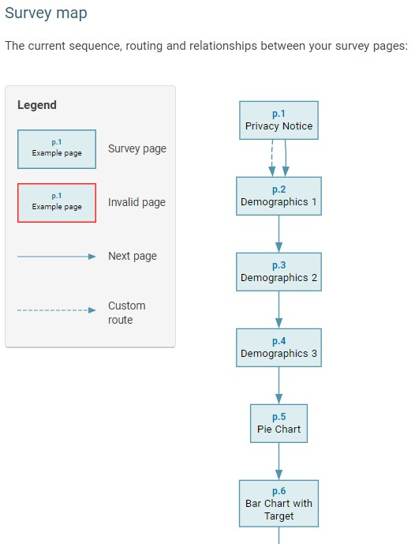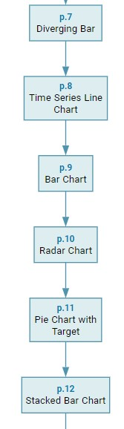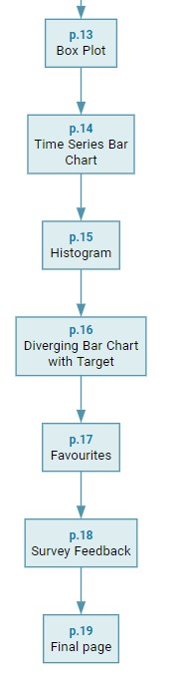

*Figure 12b - Survey Map from Online Surveys*

Subsequently, visual literacy was taken into consideration over the whole survey, i.e. becoming more proficient at each visualisation type as they progress and providing better answers to later questions for repeated types. For example, having already answered a standard pie chart question compared to a standard bar chart, participants may perform better when comparing a pie with target to a bar with target than without the ‘practice’ of the first pair.

Therefore, for the collections of pie versus bar, diverging bar versus stacked bar and targets the questions were ordered:

* Standard pie before standard bar
* Bar with target before pie with target
* Diverging bar before stacked bar
* Diverging bar with target after bar with target and pie with target.

Designing them in this way, should reduce the effect of visual literacy and ensure the results of the later questions are comparable to those earlier.

The preferences questions were kept to the end like the pilot as to not provide a preview of upcoming questions and because it makes more sense to ask these questions after a participant has experienced the visualisations.

Finally, came the feedback Likert and free textbox questions. As the least important questions, they were best for placement at the end so that any loss of enthusiasm or lack of concentration and resulting poor answers would affect these and, hopefully, not the more important visualisation questions.

*Survey Settings*

It was decided to show a survey progress bar, give a completion receipt and allow a response printout. This was to allow participants to see their progress, keep their responses for their records, and most importantly to be able to quote their response identification number if they wanted to have their data deleted as per the consent notice.

The survey appearance was kept basic so there were no distractions from the questions. Only an Aston University logo was added for professionalism.

### Testing the Survey

It was important to test the survey before it was launched. This was done by the researcher and supervisor.

The researcher went through the preview on both the desktop computer it was designed on and a tablet computer; testing the performance, aesthetics and usability of the survey. Tests were done with both the fixed width default and fluid width option which is designed for mobile device use. However, the survey seemed to perform better on both the desktop and tablet with the fixed width default, so this was kept.

The survey was then duplicated and set up as a password protected survey and sent to the supervisor. This resulted in a few observations mostly regarding the wording and formatting of the questions. These were addressed and the survey was ready to launch.

### Launching the Survey

The potential mode of contacting potential participants depends on circumstances and traditionally email has been the preferred option for distributing web-surveys with their advantages over mail and telephone (Callegaro, et al., 2015). However, with the introduction of the EU’s General Data Protection Regulation (GDPR) and Aston University’s ethics guidelines the use of email addresses obtained for reasons other than to participate in this or other surveys is no longer acceptable. The owners of the addresses are very unlikely to have given their express permission to be contacted to complete the survey (Information Commissioner's Office, 2019); especially those obtained through relationships developed with the researcher at former workplaces or volunteering with the Scout Association. Aston University also disallow the formal contact of students or staff without ethical approval.

Therefore, another distribution method was needed which had the same benefits of email; free, can easily include a web link, and can reach a large number of people. It was decided to use social media.

Online communities have attracted attention from many scientists over the years with websurveys used frequently (Callegaro, et al., 2015). It is a convenient way to reach a population and can receive responses quickly (Adams, et al., 2014).

However, Adams, et al. (2014) also highlights the flaws with using social media; they can be unrepresentative and only gain responses from friends and family. Consequently, it was important to develop a promotion strategy which aimed to widen the range of people the social media posts were seen by and therefore the number of potential participants.

Firstly, numerous social media platforms were used to promote the survey and provide larger reach; Facebook, Twitter, Instagram, LinkedIn and WhatsApp. These were chosen for the sole purpose they are the platforms used by the researcher. Yet, these five platforms are in the top seven most popular in the UK (social-media.co.uk, 2019).



*Figure*

*13*

*-*

*Instagram post with "Link is*

*in my bio"*

Secondly, several techniques were used to increase interaction with the posts gathered from marketing websites.

* Make posts visual (Rose, 2017), know your audience (Tran, 2019), and have a personality (Tay, 2018). This was done by using a photo of a cat, dog, rabbit and a still from How I Met Your Mother – a television programme. It was judged that these would make the posts more visible, noticeable and fun; attracting attention to a post which may otherwise be ignored. The use of photos allowed the use of hashtags like #catsofinstagram to widen reach (figure 13).
* Clear message and call to action (Tay, 2018). The messages asked people to complete the survey and where they could find the link if not in the post (Instagram posts and Facebook stories do not allow links) (figure 13).
* Add relevant hashtags (Rose, 2017) and stay topical (Tran, 2019). Survey specific hashtags were included on all posts, where character limits allowed, like #DataAnalytics, #dataviz, #DataScience #Tableau. Using relevant hashtags makes it more likely the posts will reach people interested in the survey topic; “motivated or interested people are most likely to respond (Floyd J. Fowler, 2002).

It was also possible to add topical hashtags depending on the day it was posted. Some were day of the week specific, #SaturdayMotivation, while others were topic related which were trending on the day. For example, #EqualPay was trending on Twitter during a debate around pay in Women’s football in the United States of America after their Women’s World Cup win (figure 14). Doing this meant the posts gained a wider reach.

* Use analytic tools to monitor engagement (Rose, 2017). It was possible through likes, retweets, shares and comments to see which posts were the most successful and concentrate on these platforms and try to add extra or different hashtags (figure 15).

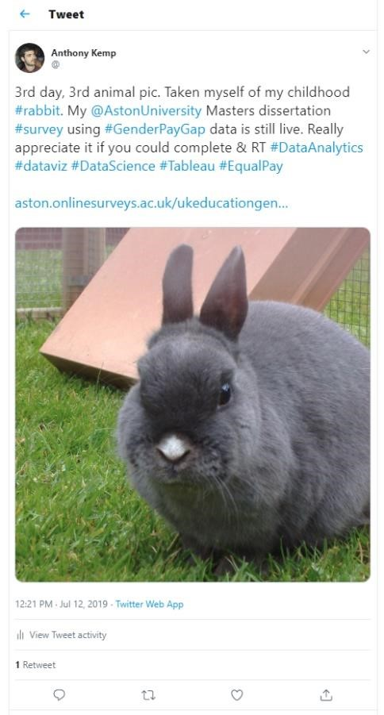

*Figure*

*14*

*-*

*Twitter Post with #EqualPay*

*Figure*

*15*

*-*

*LinkedIn post showing analytics (views)*

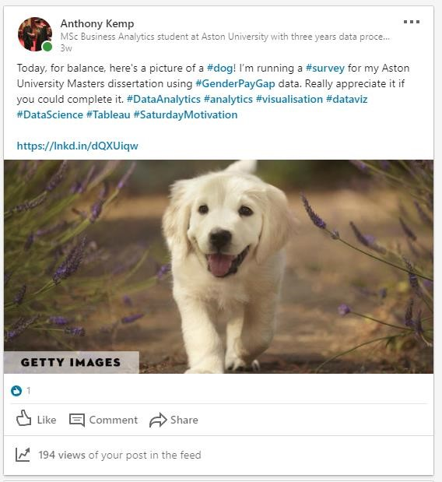

For platforms with profiles which were private like Facebook and WhatsApp, different methods were used. The survey was posted in a Scout related Messenger group whose members had already given verbal permission to be contacted about it. Furthermore, the survey was posted in two Facebook dissertation ‘exchange’ groups where surveys could be posted and completed with the understanding the favour would be returned (figure 16). This method would extend the reach on Facebook beyond friends and family but would likely skew participants towards certain occupations and ages; students and 18-25.

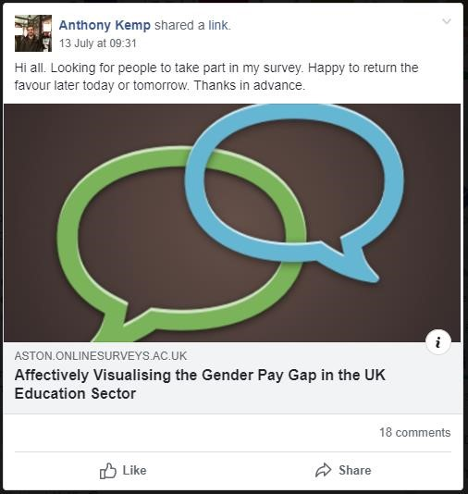

*Figure*

*16*

*-*

*Facebook post in 'exchange' group*

On WhatsApp, the link was sent to groups of friends. While this did skew respondents to friends and family, it would likely be the most effective method as “whenever a relationship between potential respondents and a researcher already exists, the email (or WhatsApp in its place) may be…more effective ” (Callegaro, et al., 2015).

Finally, effort was made to be active in responding to messages. For example, figure 16 shows eighteen comments on a post. These included thank you messages to those who completed the survey, helping to keep the post near the top of feeds and more visible to others.

In conclusion, the use of web-surveys has lent itself to distribution by email in the past, but for privacy and ethical concerns this method was discounted, and the use of social media chosen. While social media use has a few problems around gaining a representative sample, a number of social media marketing techniques were developed to reduce this concern.

### Running the Survey

* Participants were invited to partake in the survey through the above methods.
* The survey was completed at a time, location and on a device convenient for each individual participant.
* Instructions on how to use the survey were included within the survey. Participants navigated it themselves with a mouse or touchscreen but could only progress in one direction. Answers were submitted within the survey form.
* Participants could complete the survey on their own or with help from others.
* Answers to queries were provided as long they did not help participants derive survey question answers but in a much more remote way compared to the pilot.
* At the end, participants could communicate their views through social media if they wished but there was no formal process for doing so with everyone.
* The survey was launched on Wednesday 10th July for two weeks and collected 57 responses; an amount judged to be enough for significant results.

### Analysing the Results

* Online Surveys automatically collated the results and created basic summary visualisations for viewing in the web browser.
* It was also possible to browse individual responses and to create advanced crosstabulation results.
* Alternatively, the results – summary, individual or cross-tabulated – could be downloaded in Microsoft Excel format or as portable document format (PDF) for analysing outside of the web browser. They were stored on the researcher’s secure Google Drive account.

## Findings

### Demographics

*Which Country are you from? and Is English your first Language?*

The majority of participants (46) were UK-based (figure 17). Excluding the UK, other participants came from the Europe (5), South-East Asia (5), and the United States (1).

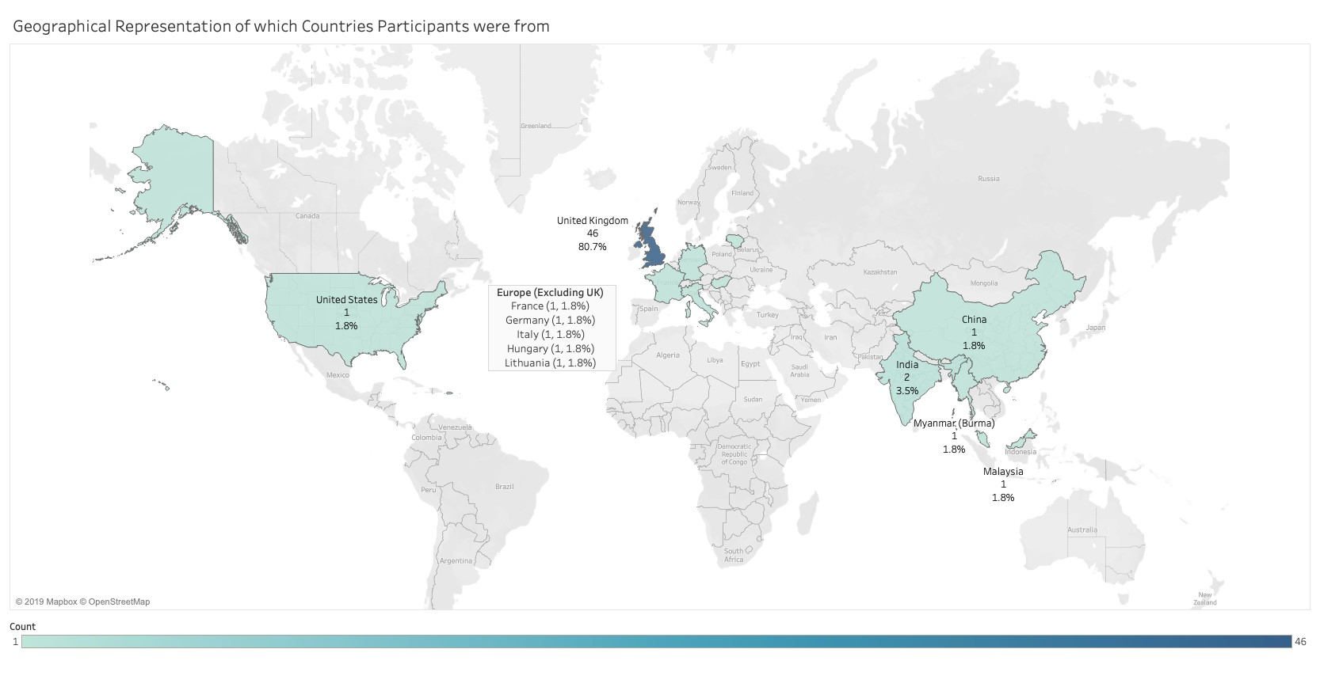

*Figure*

*17*

*-*

*Participant Map*

The majority of participants at 73.7% stated English is their first language. With 26.3% answering no these are good results for analysing any effects of language on the performance of the visualisations (figure 18).

*Figure 18 - English First Language*



By cross-tabulating these results with the country participants are from, it is possible to see from which countries these English-first speaking

participants reside

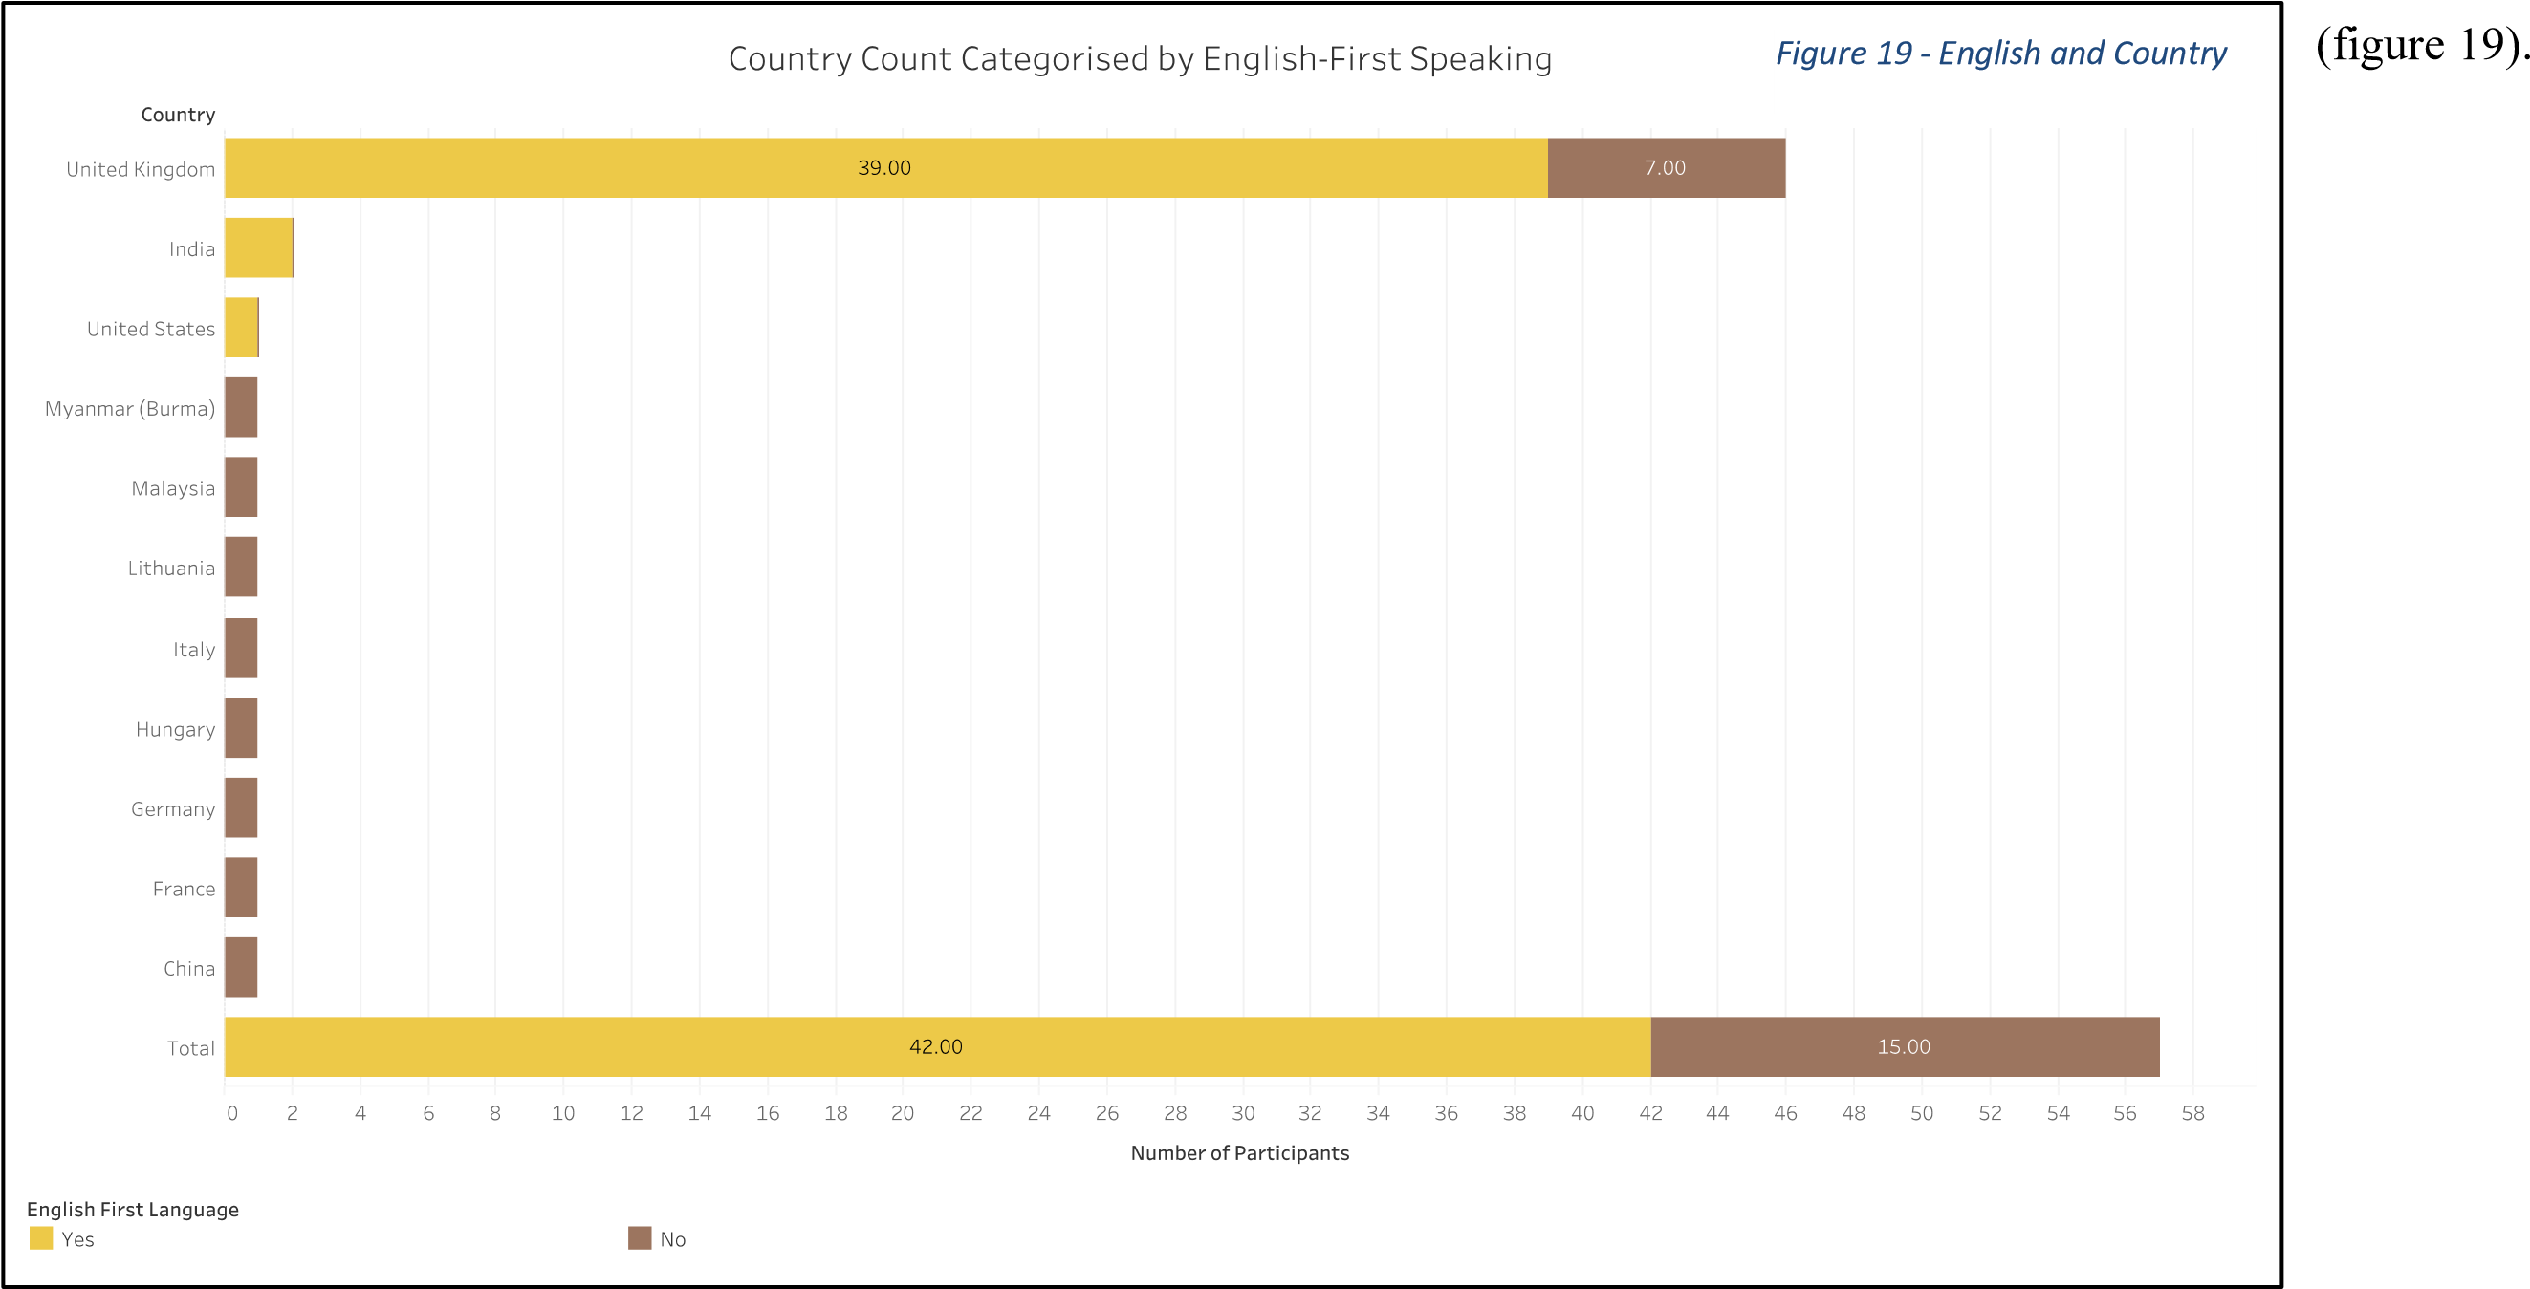

*Please select the gender identity you most identify with?*

There was a good spilt of genders in order to evaluate possible differences in spatial ability between male and female users (figure 20).

*Figure*

*20*

*-*

*Gender*

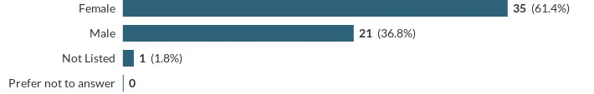

*Which category below includes your age?*

A range of ages from 21 to 69 completed the survey, but the results are dominated by the 21-29 category. This may make it harder to evaluate possible differences in spatial ability between different ages (figure 21).

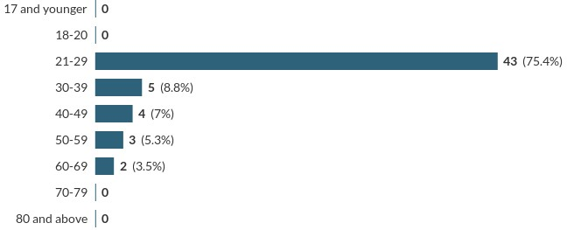

*Figure 21 - Age Ranges*

*What is the highest level of education you have completed?*

Again, a range of participants with different levels of education completed the survey, but with a skew towards those with higher levels (figure 22).

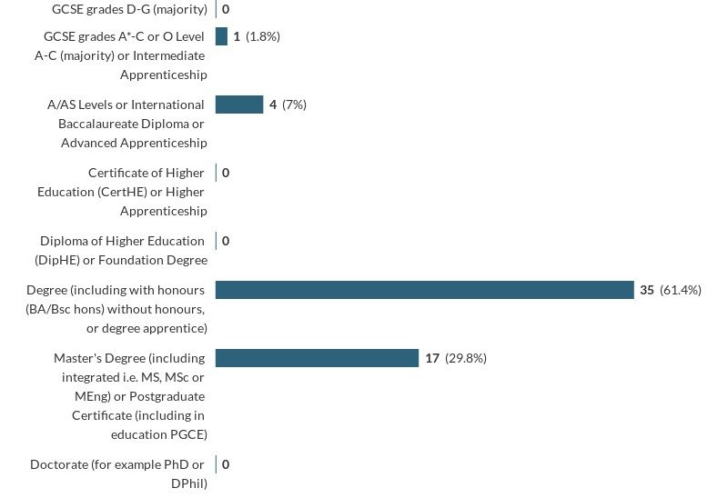

*Figure 22 - Education Levels*

*Please select to which level you agree with the following statements:*

By detaching the ‘neutral’ answers and combining the two levels of ‘agree’ and ‘disagree’ it is easier to see the level of confidence participants have in their own ability with numbers, statistics and visualisations (figure 23). Percentages may not equal 100% due to rounding. Full results can be seen in Appendix 8.

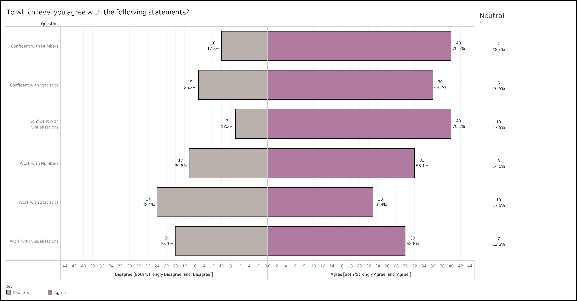

*Figure 23 - Levels of Confidence and Work Use*

Most participants are equally confident of their ability with number and using visualisations, but slightly less so with statistics. Most stated they work with numbers regularly and slightly less with visualisations, but less than half said they work with statistics regularly. Equally, statistics is the least worked with category and the category participants felt least confident. Visualisations was the second least worked with category but had the least number of not confident responses suggesting that participants feel confident in using them regardless of regularly using them at work. Finally, confidence with visualisations and regularly working with statistics had the highest number of neutral responses suggesting some uncertainty or lack of strong opinion on these topics.

*Which category best fits your current occupation/job?*

The participants were from a good range of occupations, but the results needed a little reorganising. The three answers to ‘Other’ were in fact ones which could have been included in specified categories, so the results were modified to reflect this. Firstly, one participant entered “student” which was moved to the ‘Retired, Student or Unemployed’ category. and removing it from the ‘Other’ category. Another entered,

“Clinical Research” which was moved to ‘Healthcare: practitioners, technicians & support workers’. Finally, one entered “Freelance Photographer/Videographer” which was moved to “Arts, Design, Entertainment, Sports and Media”.

Therefore, the top category was ‘Retired, Student, Unemployed’ with 19.3%, followed by ‘Business, Management and Financial’ (17.5%) and with ‘Education, Training and Library’ in third with 14% (figure 24). The categories in second and third are good for representing the target user; teachers and HR professionals.

|  |  |  |  |  |  |
| --- | --- | --- | --- | --- | --- |
|  |  |  |  | | |
|  | |  |  |
|  |
|  |
|  | |
|  |  |
|  |
|  | |

*Figure 24 - Treemap of Occupation*

*Do you suffer from any of the visual deficiencies/impairments below?*

Most participants do not suffer from any visual impairments (66.7%)(figure 25), but the survey did include some who did (33.3%). Fortuitously, the survey included two individuals with colour-blindness allowing for some evaluation of the performance of the colour-blind friendly palette.

*Figure*

*25*

*-*

*Visual Deficiencies*

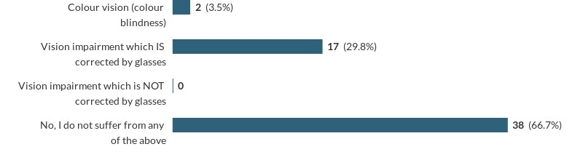

By cross-tabulating these results with the gender (figure 26), it is possible to see there is a good split of genders across the categories.

Interestingly, given that colour-blindness is more common in men, there is an even split of genders across this very small sample. Again, while not significant, it will allow for evaluation of the visualisations’ colour-blindness credentials for both genders.

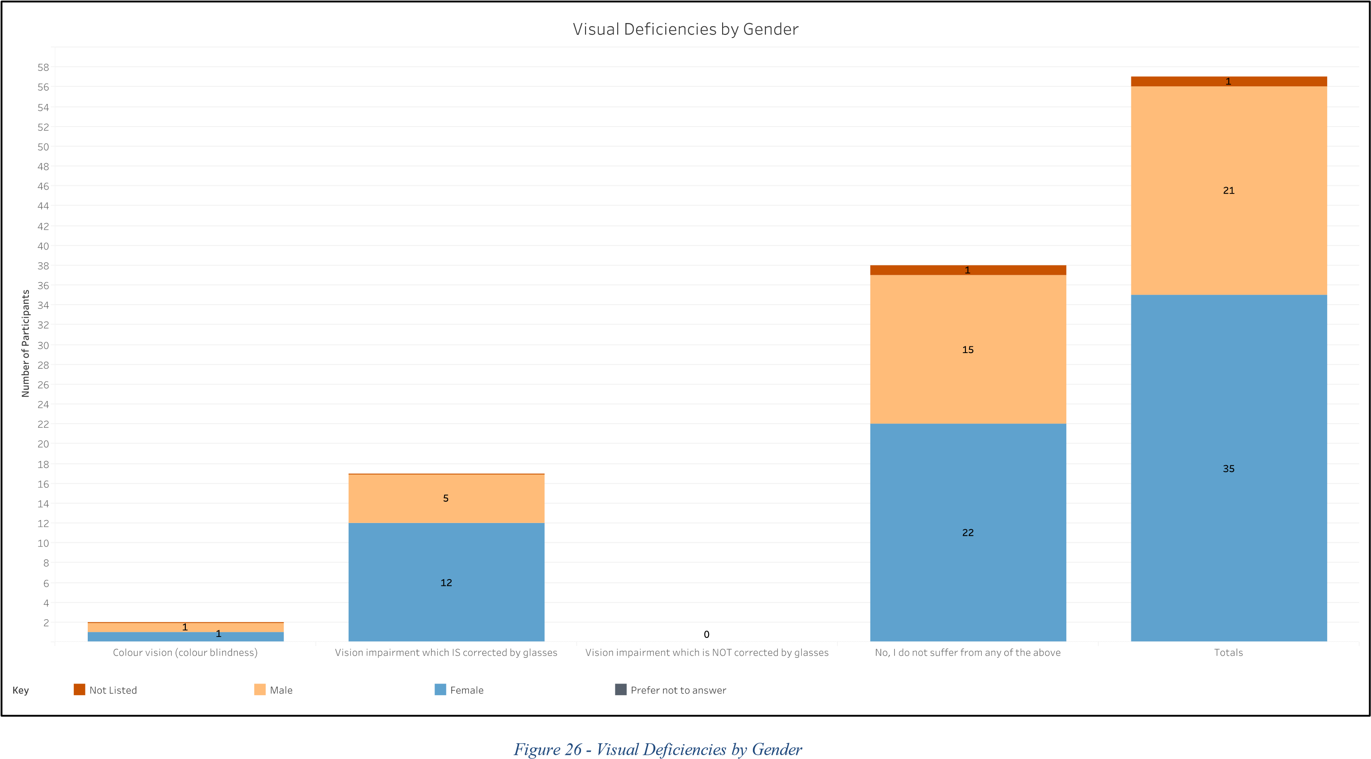

*Device*

Figure 27 reveals that most participants used a small hand-held device to complete the survey.

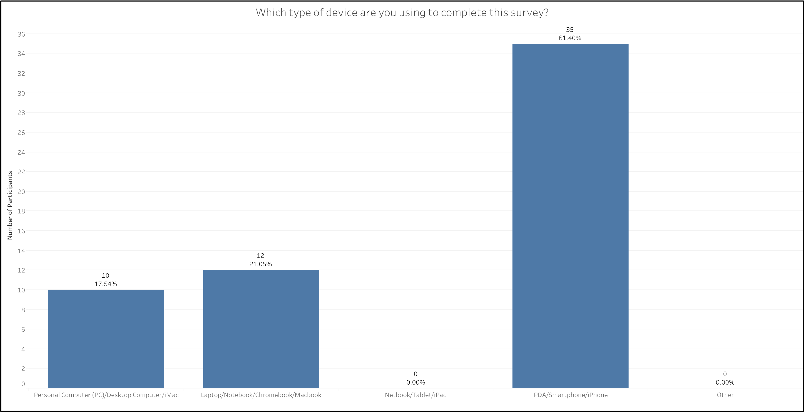

*Figure 27 - Devices Used*

### Visualisation Collections

This section will look at the performance of participants for the six collections of visualisations: pie chart versus bar chart, diverging bar chart versus stacked bar chart, time series, distribution, targets, and preferences.

*Pie Versus Bar*

For both questions, only two answers were chosen - ‘Lowest Paid’ and ‘Second Lowest Paid” (figure 28).

For the pie segments, most participants (73.7%) incorrectly identified ‘Second Lowest Paid’ as the largest segment. Of those 42 participants,

83% were ‘Very Unsure’ or ‘Fairly Sure’ of their answer while 90% found it ‘Not Easy/Hard’ or ‘Fairly Easy’ to decide on their answer. Of the 15 participants who correctly identified the largest segment, only 13% were ‘Very Sure’ of their answer and no-one found determining the correct answer ‘Very Easy’.

For the bar chart, the results were much better. All but one person (98%) correctly identified the largest segment. Of those 42 participants, 75% were ‘Very Sure’, 23% ‘Fairly Sure’ and only 2% ‘Very Unsure’ of their answer. Similarly, more participants found answering easier: 64% ‘Very Easy’, 32% ‘Fairly Easy’, and 4% ‘Not Easy/Hard’.

*Figure*

*28*

*-*

*Pie Versus Bar*

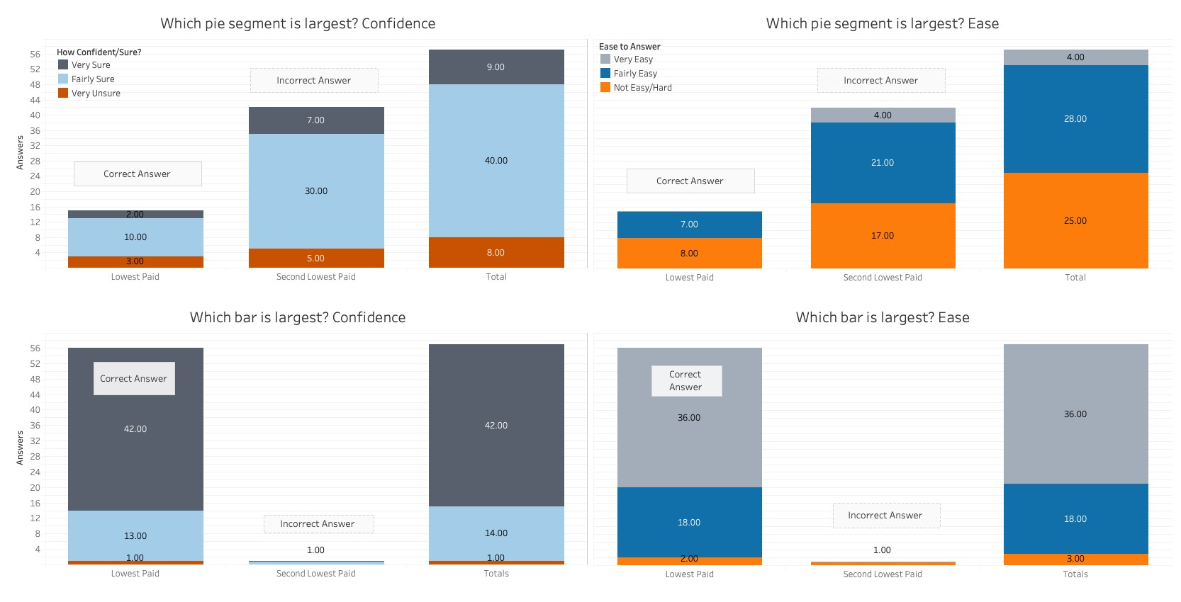

*Diverging Versus Stacked*

The correct answer was 31.9% which no-one answered. But, when rounded to 32%, 30 participants (53%) correctly answered using the diverging bar chart and 21 participants (37%) answered correctly using the stacked bar chart. The stacked bar saw more participants give the correct answer for the wrong gender and also more participants giving answers either-side of 32% (figure 29).

|  |  |  |  |  |  |  |  |  |  |  |  |  |  |  |  |  |  |  |  |  |  |  |  |  |  |  |  |  |  |  |  |  |  |
| --- | --- | --- | --- | --- | --- | --- | --- | --- | --- | --- | --- | --- | --- | --- | --- | --- | --- | --- | --- | --- | --- | --- | --- | --- | --- | --- | --- | --- | --- | --- | --- | --- | --- |
|  | | | | | | | | | | | | | | | | | | | | | | | | | | | | | | | | | |
|  |  |  |  |  |  |  |  |  |  |  |  |  |  |  |  |  |  |  |  |  |  |  |  |  |  |  |  |  |  |  |  |  |  |
|  |  |  |  |  |  |  |  |  |  |  |  |  |  |  |  |  |  |  |  |  |  |  |  |  |  |  |  |  |  |  |  |  |
|  |  |  |  |  |  |  |  |  |  |  |  |  |  |  |  |  |  |  |  |  |  |  |  |  |  |  |  |  |  |  |  |  |
|  |  |  |  |  |  |  |  |  |  |  |  |  |  |  |  |  |  |  |  |  |  |  |  |  |  |  |  |  |  |  |  |  |
|  |  |  |  |  |  |  |  |  |  |  |  |  |  |  |  |  |  |  |  |  |  |  |  |  |  |  |  |  |  |  |  |  |
|  |  |  |  |  |  |  |  |  |  |  |  |  |  |  |  |  |  |  |  |  |  |  |  |  |  |  |  |  |  |  |  |  |
|  |  |  |  |  |  |  |  |  |  |  |  |  |  |  |  |  |  |  |  |  |  |  |  |  |  |  |  |  |  |  |  |  |
|  |  |  |  |  |  |  |  |  |  |  |  |  |  |  |  |  |  |  |  |  |  |  |  |  |  |  |  |  |  |  |  |  |
|  |  |  |  |  |  |  |  |  |  |  |  |  |  |  |  |  |  |  |  |  |  |  |  |  |  |  |  |  |  |  |  |  |
|  |  |  |  |  |  |  |  |  |  |  |  |  |  |  |  |  |  |  |  |  |  |  |  |  |  |  |  |  |  |  |  |  |
|  |  |  |  |  |  |  |  |  |  |  |  |  |  |  |  |  |  |  |  |  |  |  |  |  |  |  |  |  |  |  |  |  |
|  |  |  |  |  |  |  |  |  |  |  |  |  |  |  |  |  |  |  |  |  |  |  |  |  |  |  |  |  |  |  |  |  |
|  |  |  |  |  |  |  |  |  |  |  |  |  |  |  |  |  |  |  |  |  |  |  |  |  |  |  |  |  |  |  |  |  |
|  |  |  |  |  |  |  |  |  |  |  |  |  |  |  |  |  |  |  |  |  |  |  |  |  |  |  |  |  |  |  |  |  |
|  |  |  |  |  |  |  |  |  |  |  |  |  |  |  |  |  |  |  |  |  |  |  |  |  |  |  |  |  |  |  |  |  |
|  |  |  |  |  |  |  |  |  |  |  |  |  |  |  |  |  |  |  |  |  |  |  |  |  |  |  |  |  |  |  |  |  |
|  |  |  |  |  |  |  |  |  |  |  |  |  |  |  |  |  |  |  |  |  |  |  |  |  |  |  |  |  |  |  |  |  |
|  |  |  |  |  |  |  |  |  |  |  |  |  |  |  |  |  |  |  |  |  |  |  |  |  |  |  |  |  |  |  |  |  |
|  |  |  |  |  |  |  |  |  |  |  |  |  |  |  |  |  |  |  |  |  |  |  |  |  |  |  |  |  |  |  |  |  |
|  |  |  |  |  |  |  |  |  |  |  |  |  |  |  |  |  |  |  |  |  |  |  |  |  |  |  |  |  |  |  |  |  |
|  |  |  |  |  |  |  |  |  |  |  |  |  |  |  |  |  |  |  |  |  |  |  |  |  |  |  |  |  |  |  |  |  |
|  | | | | | | | | | | | | | | | | | | | | | | | | | | | | | | | | |

*Figure 29 - Diverging Versus Stacked Correct*

|  |  |
| --- | --- |
| *Figure 30 - Diverging Versus Stacked Confidence* |  |
|  |

Figure 30 shows

that the majority of participants were only fairly confident of their answers for both the diverging and stacked bar graphs.

Of those who got their answer correct, one participant for both bar graphs were unsure in their answer.

Of those who answered incorrectly, a high number of participants were ‘Very Sure’ of their answer; especially with the stacked bar graph with 72.2% of incorrect answers ‘Very Sure’.

*Time Series*

The correct answer was ‘Second Highest Paid’ of which the majority answered using all three time series visualisations; line chart, radar chart and bar chart. As figure 31 shows more participants answered correctly using the line chart (74%), followed by the radar chart (67%), and the bar chart performing worst (51%). Of the participants who answered correctly, the results show that the line chart performed best on confidence

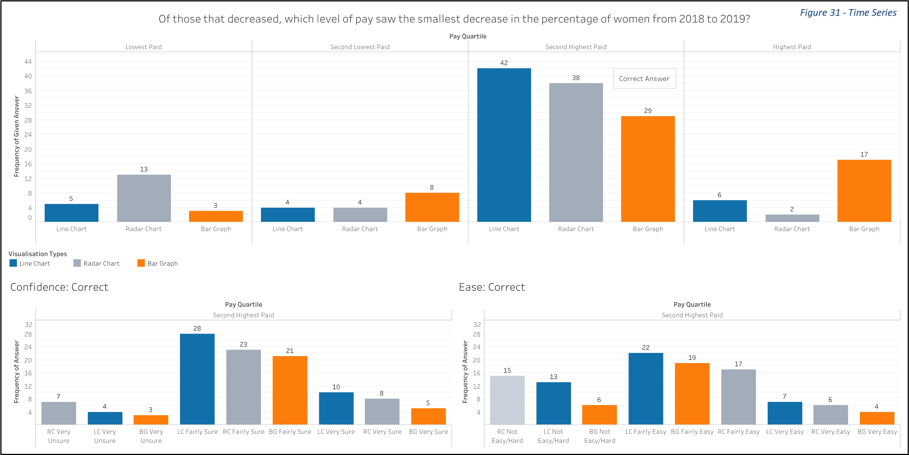

and ease too. Interestingly, the worst performing visualisation on correct answers (bar chart) was not the worst on confidence or ease. The radar chart had the most ‘Very Unsure’ and ‘Not Easy/Hard’ responses.

*Distributions*

#### Box Plots

The correct answer to the first question about the smallest range shown by the different box plots was ‘Second Lowest Paid’ which 44 participants (77.2%) correctly identified (figure 32). However, only 8 of those 44 were ‘Very Sure’ of their answer with a greater number (12)

‘Very Unsure’. Almost all participants who were ‘Fairly Sure’ of their answer did answer correctly, nevertheless. Almost an equal number of participants were ‘Very Unsure’ and wrong (11) than ‘Very Unsure’ and right (12).

The second question was about identifying in how many quartiles Spencer Academies Trust was above the sample average. The correct answer was three with only 17 (30%) participants answering correctly (figure 33) and 30 participants (53%) choosing two quartiles. Again, only a small number of correct participants (4) were ‘Very Sure’ and almost equal with those ‘Very Sure’ and wrong (3). However, this time many more participants who were ‘Very Unsure’ were wrong. The number of participants who were ‘Very Unsure’ regardless of their answer was the same for both questions.

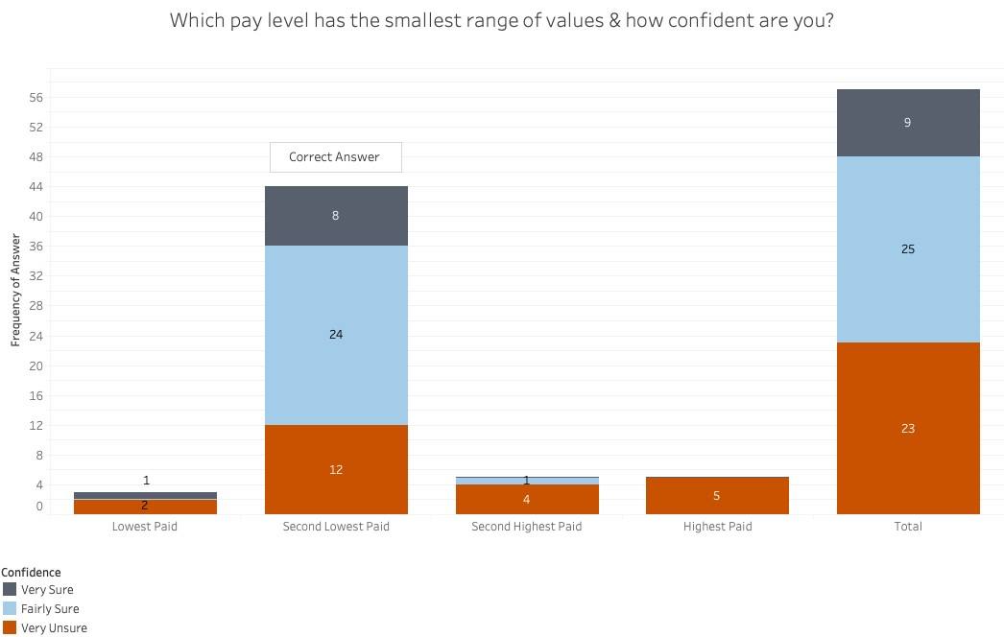

*Figure 32 - Box Plot Range*

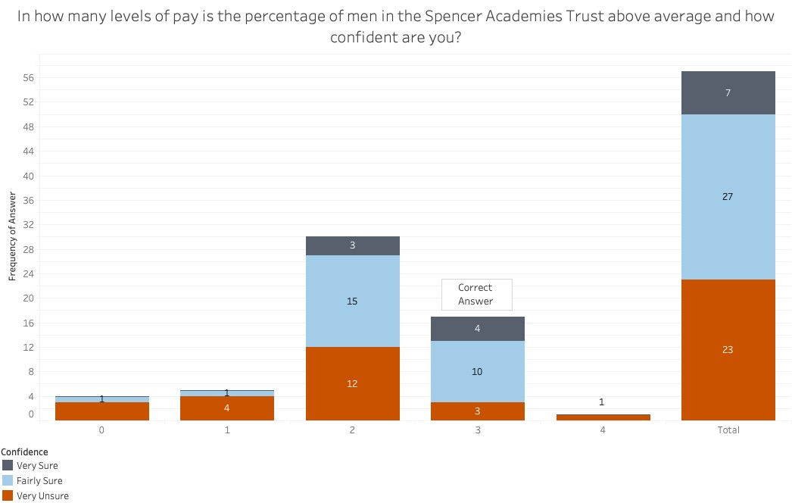

*Figure 33 - Box Plot Average*

#### Histogram

The first question asked the participants to identify which statement correctly described the histogram. The histogram illustrated that women are over represented in the highest quartile for 2018-2019. Only 12 participants (21%) answered correctly with one, six and five ‘Very Sure’, ‘Fairly Sure’ and ‘Very Unsure’ respectively (figure 34). The majority of people (54%) stated that ‘It’s impossible to know/I don’t know’ with 19 ‘Very Unsure’. Eight participants were ‘Fairly Sure’ and four ‘Very Sure’. There isn’t too much difference between the number of participants who chose the correct answer, and the combined number who chose under or equally represented.

The second question asked participants to judge from ‘Very Poor’ to ‘Very Good’ the performance of an institution within a highlighted band. The expected performance judgement of an institution within this band would be ‘Good’ or ‘Average’. As figure 35 shows, the majority (57.9%) of participants chose ‘Good’ with ‘Average’ in second place (22.8%).

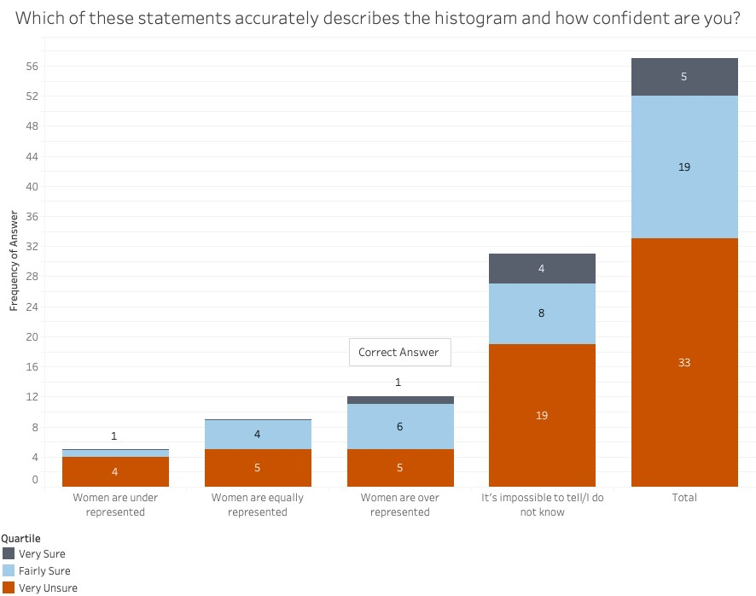

*Figure 34 - Histogram Gen. Statement*

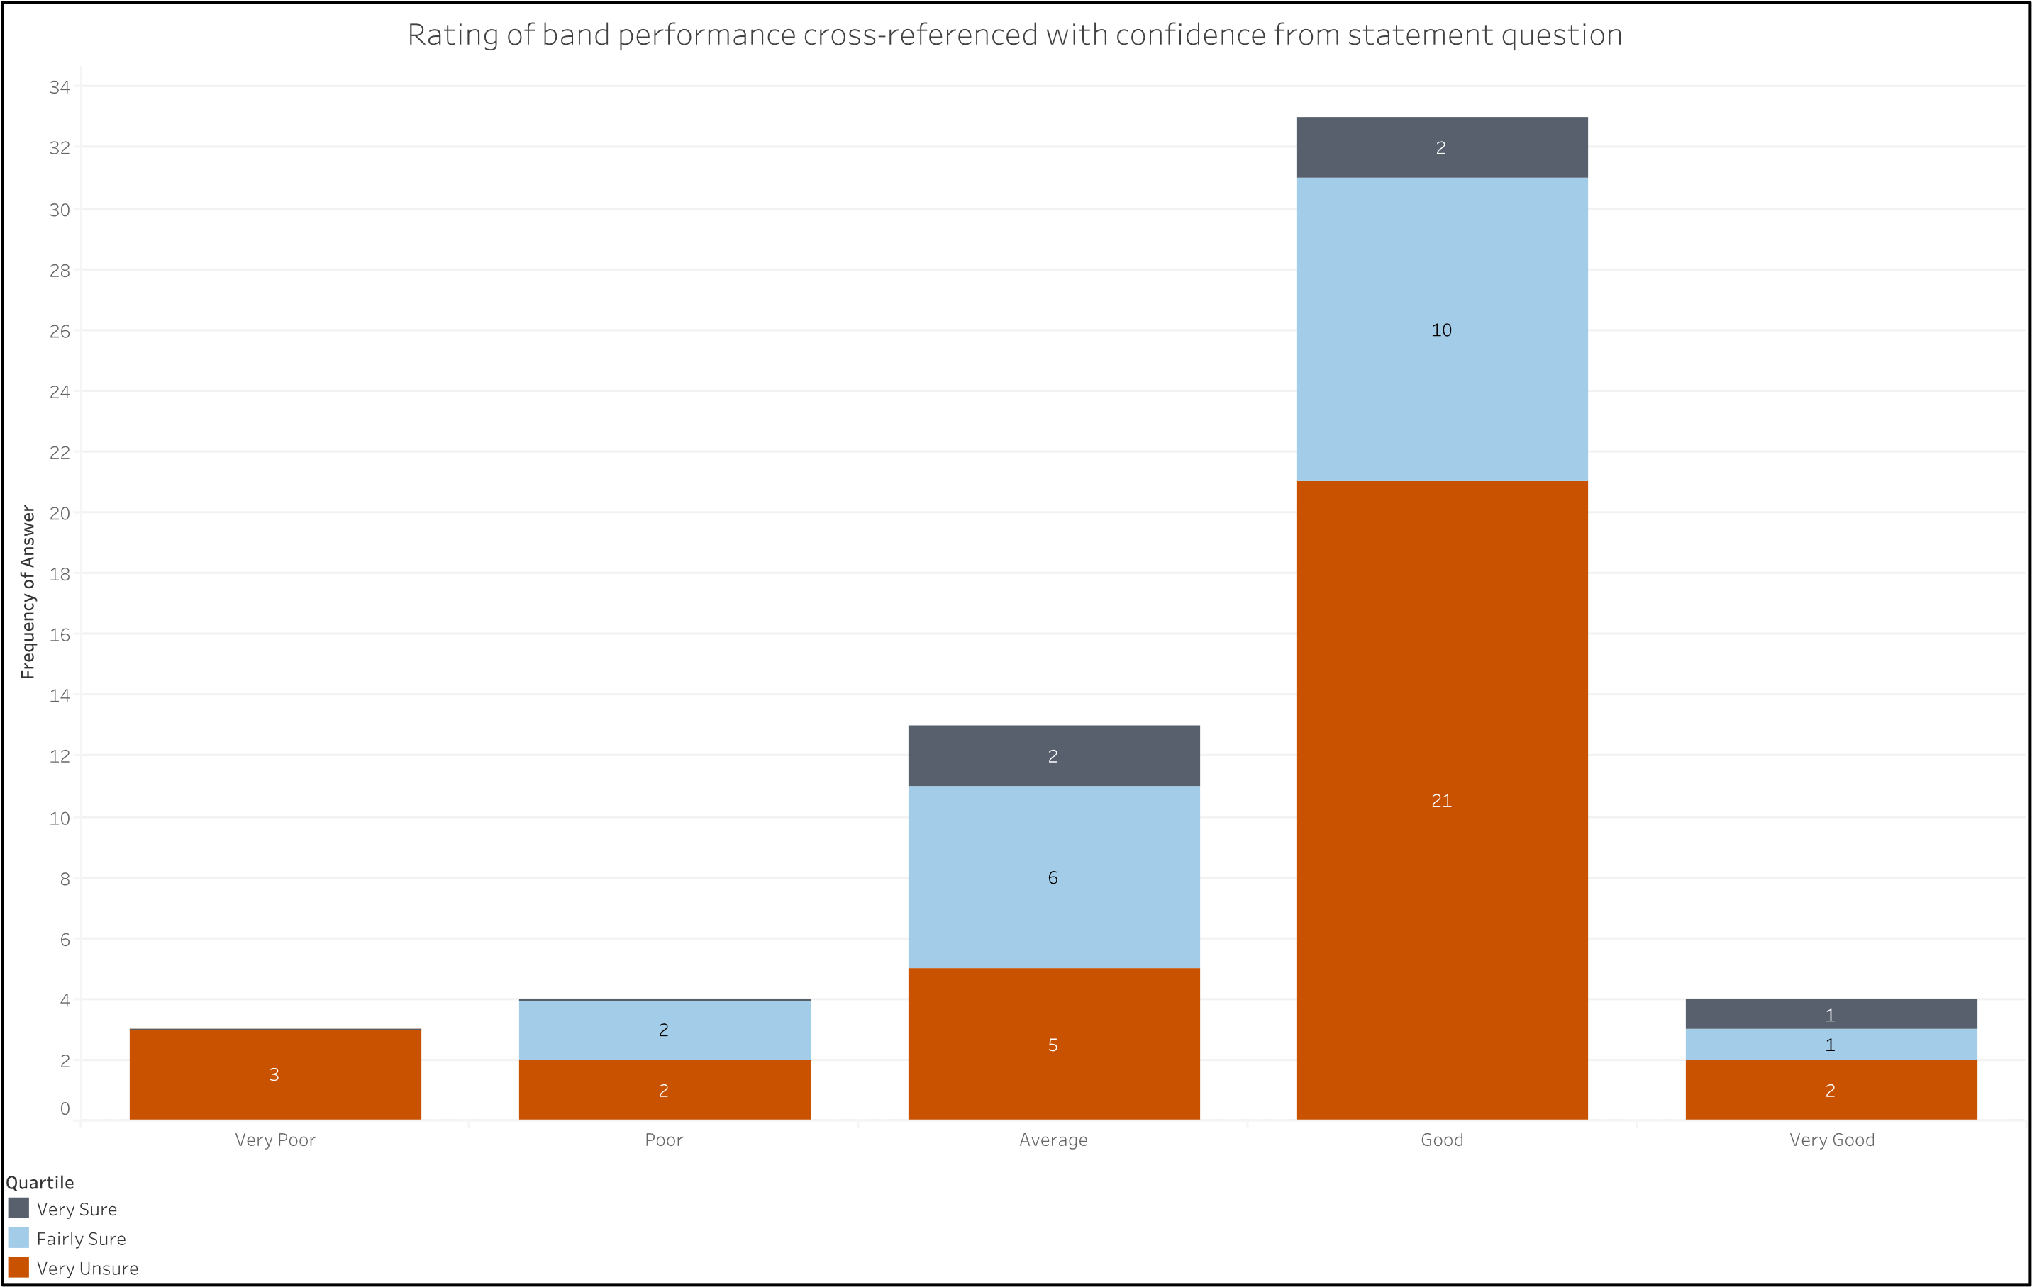

*Figure 35 - Histogram Rating*

*Targets*

These visualisations were designed to test their ability to communicate information with regards to a target. All questions asked the participants to judge at which quartile the institution was closest to equal representation (the target). The answer was ‘Second Lowest Paid’. For all three visualisations, the majority of participants correctly identified the correct answer; 72% (41 participants) with the bar chart, 54% (31) with the pie chart, and 82% (48) with the diverging the graph (figure 36). The majority of participants who chose ‘Second Highest Paid’ – the next closest to the target – did so with the pie chart (56%). Of those who answered correctly, the diverging bar chart gave participants the most confidence and was the easiest to use. The pie chart gave the least confidence and was the hardest to use.

For all answers, figure 37 shows that the bar chart gave the most confidence (‘Very Sure’), closely followed by the diverging bar chart, and the pie chart scoring significantly less. The pie chart also has a higher percentage of its positive confidence outside the correct answer with four (80%) and 16 (47%) for ‘Very Sure’ and ‘Fairly Sure’ correspondingly. The diverging bar chart performs best on this same measure with only two participants who were ‘Fairly Sure’ answering incorrectly (8%) and none who were ‘Very Sure’ wrong.

When looking at all answers for ease of determining the answer, figure 38 displays that the easiest visualisation to use was again the diverging bar chart with 32% stating ‘Very Easy’ compared to 16% for the bar chart and 11% for the pie chart. The hardest to use was the pie chart with 53% stating ‘Not Easy/Hard’ compared to 40% for the bar chart and 28% for the diverging bar chart.

*Figure*

*36*

*-*

*Targets*

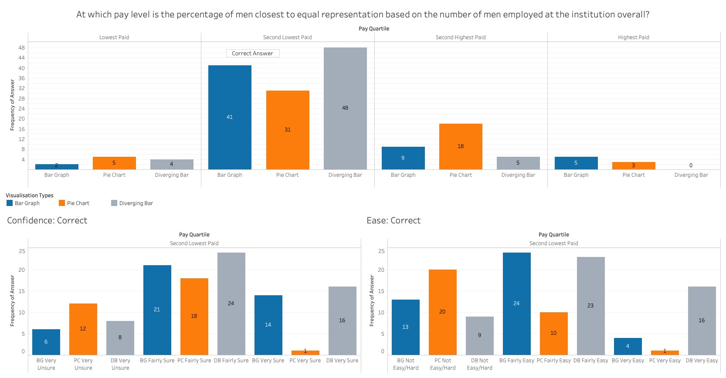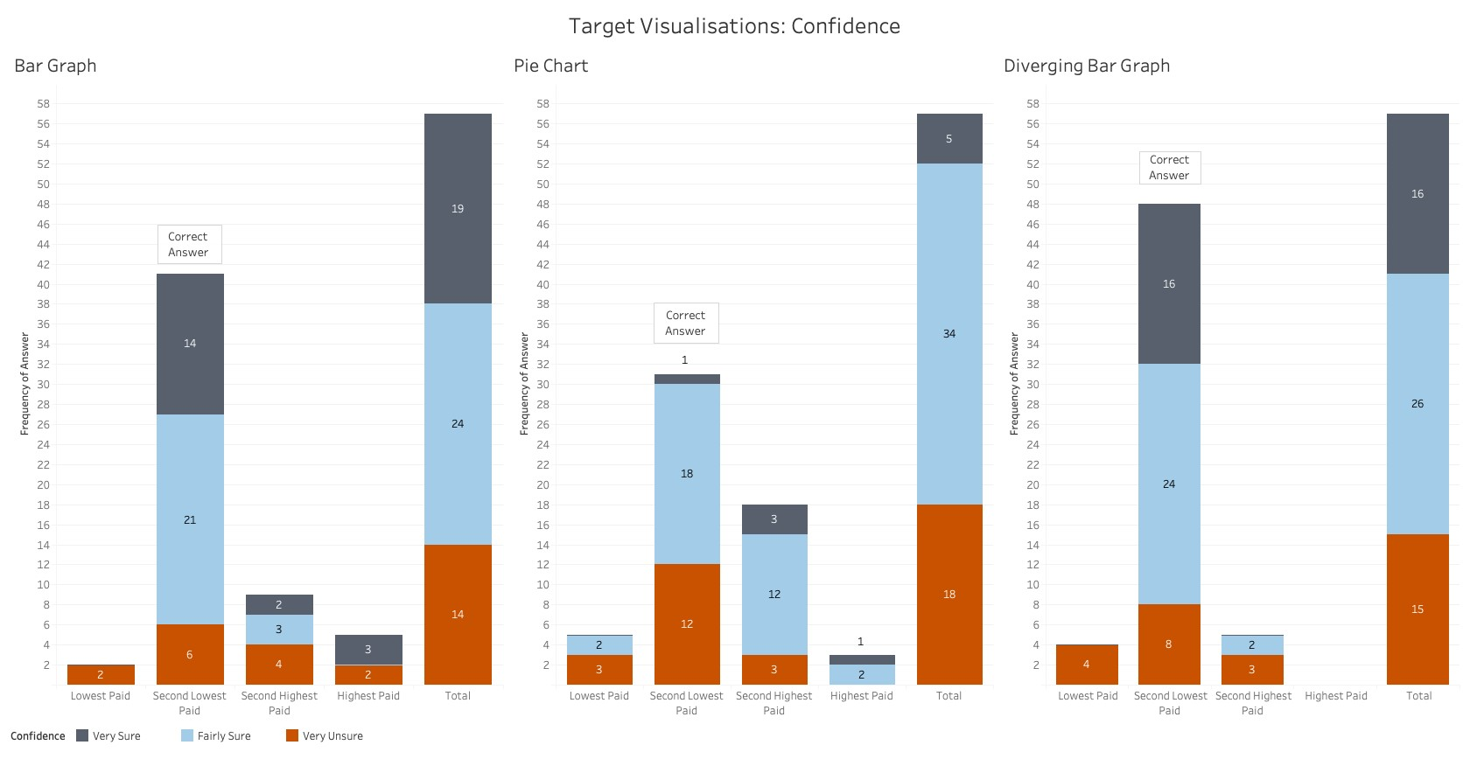

*Figure 37 - Targets Confidence*

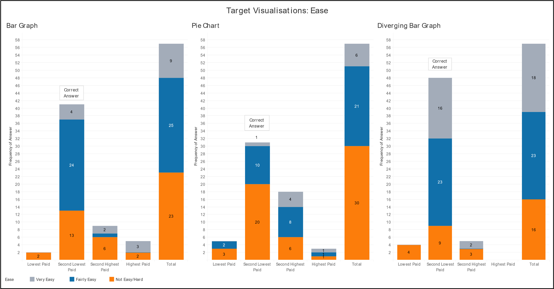

*Figure 38 - Targets Ease*

*Preferences*

The final few questions asked the participants about their preferences around the visualisations used in the survey. These have been tallied and split into numbers of participants who correctly and incorrectly answered the question when choosing their most/least preferred.

#### Most and Least Preferred

The favourite visualisation was bar chart followed by the line chart. The least favourite was the radar chart followed by the box plot. Figure 39 shows these plus the percentage of participants who correctly answered the standard – i.e. non-target version or first question for box plot and histogram – question. The pie chart had the highest number of participants answer incorrectly when choosing it as their favourite, whereas the radar chart had the highest number answer correctly while stating it was the least favourite; followed by the box plot.

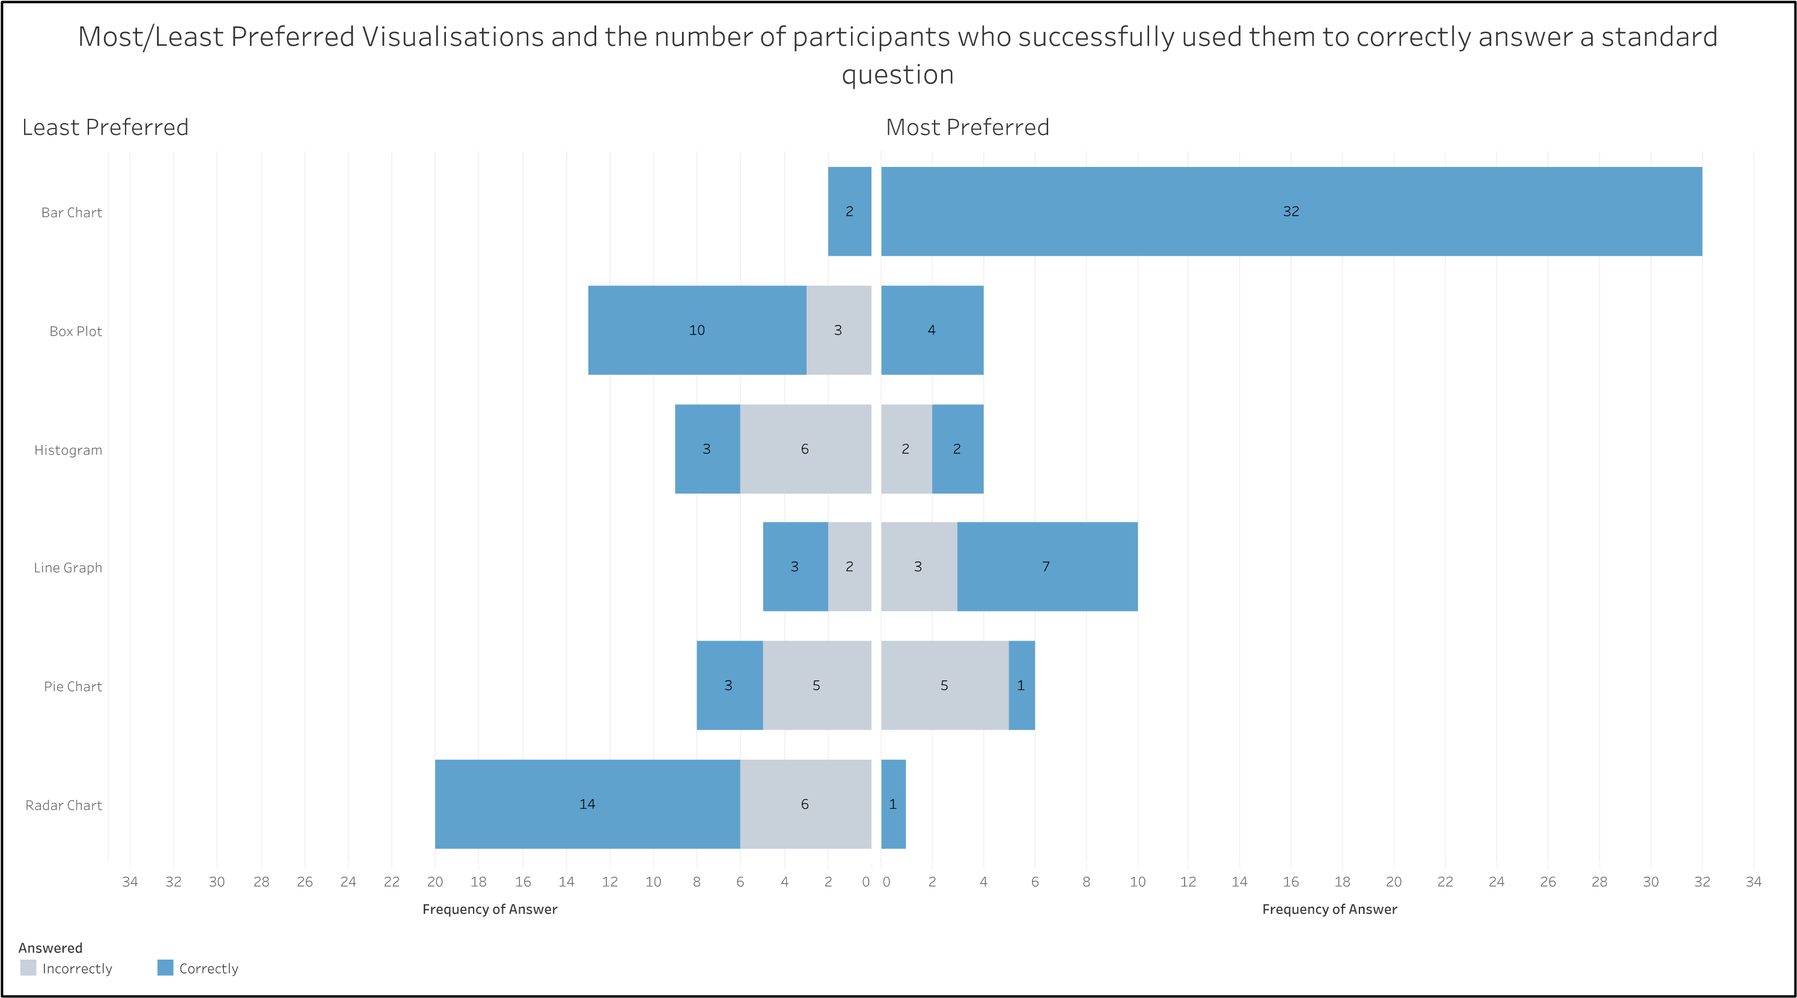

*Figure 39 - Most/Least Preferred Visualisations*

#### Bar Charts

The favourite bar chart was the one with a target, but it was not the most successful visualisation for those who preferred it (figure 40). The standard bar chart had 100% of those who chose it as their favourite answer correctly but was the least preferred overall. The diverging bar was more popular than the stacked bar and had a better success rate.

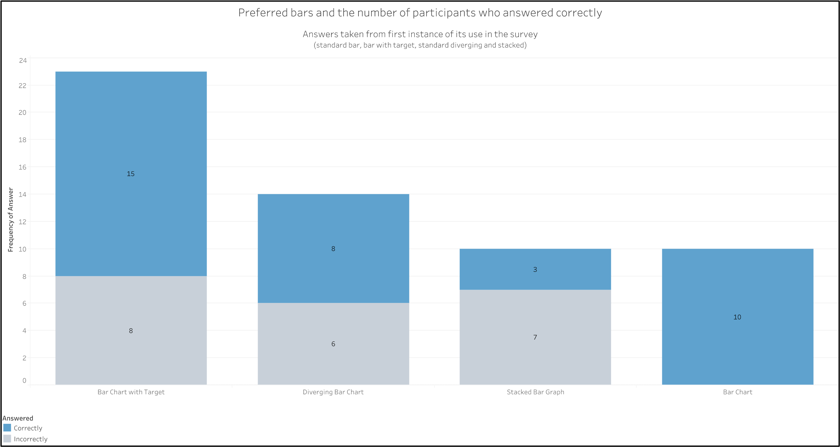

*Figure 40 - Preferred Bar Charts*

#### Targets

The favourite visualisation with a target was the bar chart, but still saw 22% of these participants answer incorrectly (figure 41). The least preferred, the pie chart, was also the least successful. While not being the favourite, the diverging bar chart was the most successful – of those

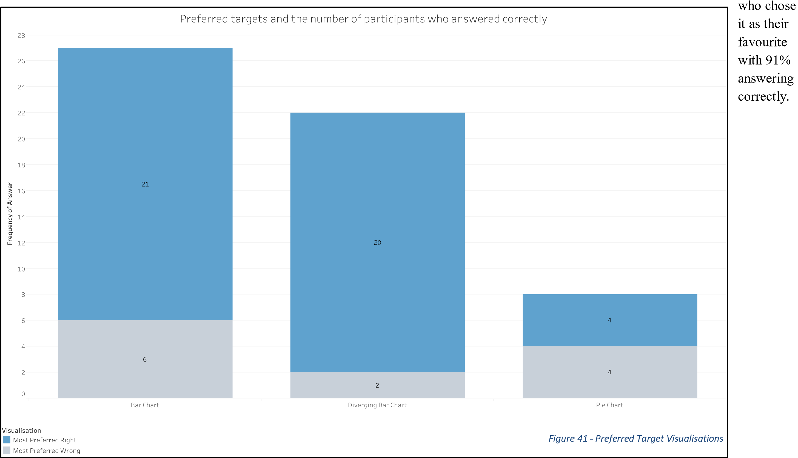

#### Time Series

The favourite visualisation for time series data was the line graph, though 43% answered incorrectly (figure 42). However, the visualisation with

the largest

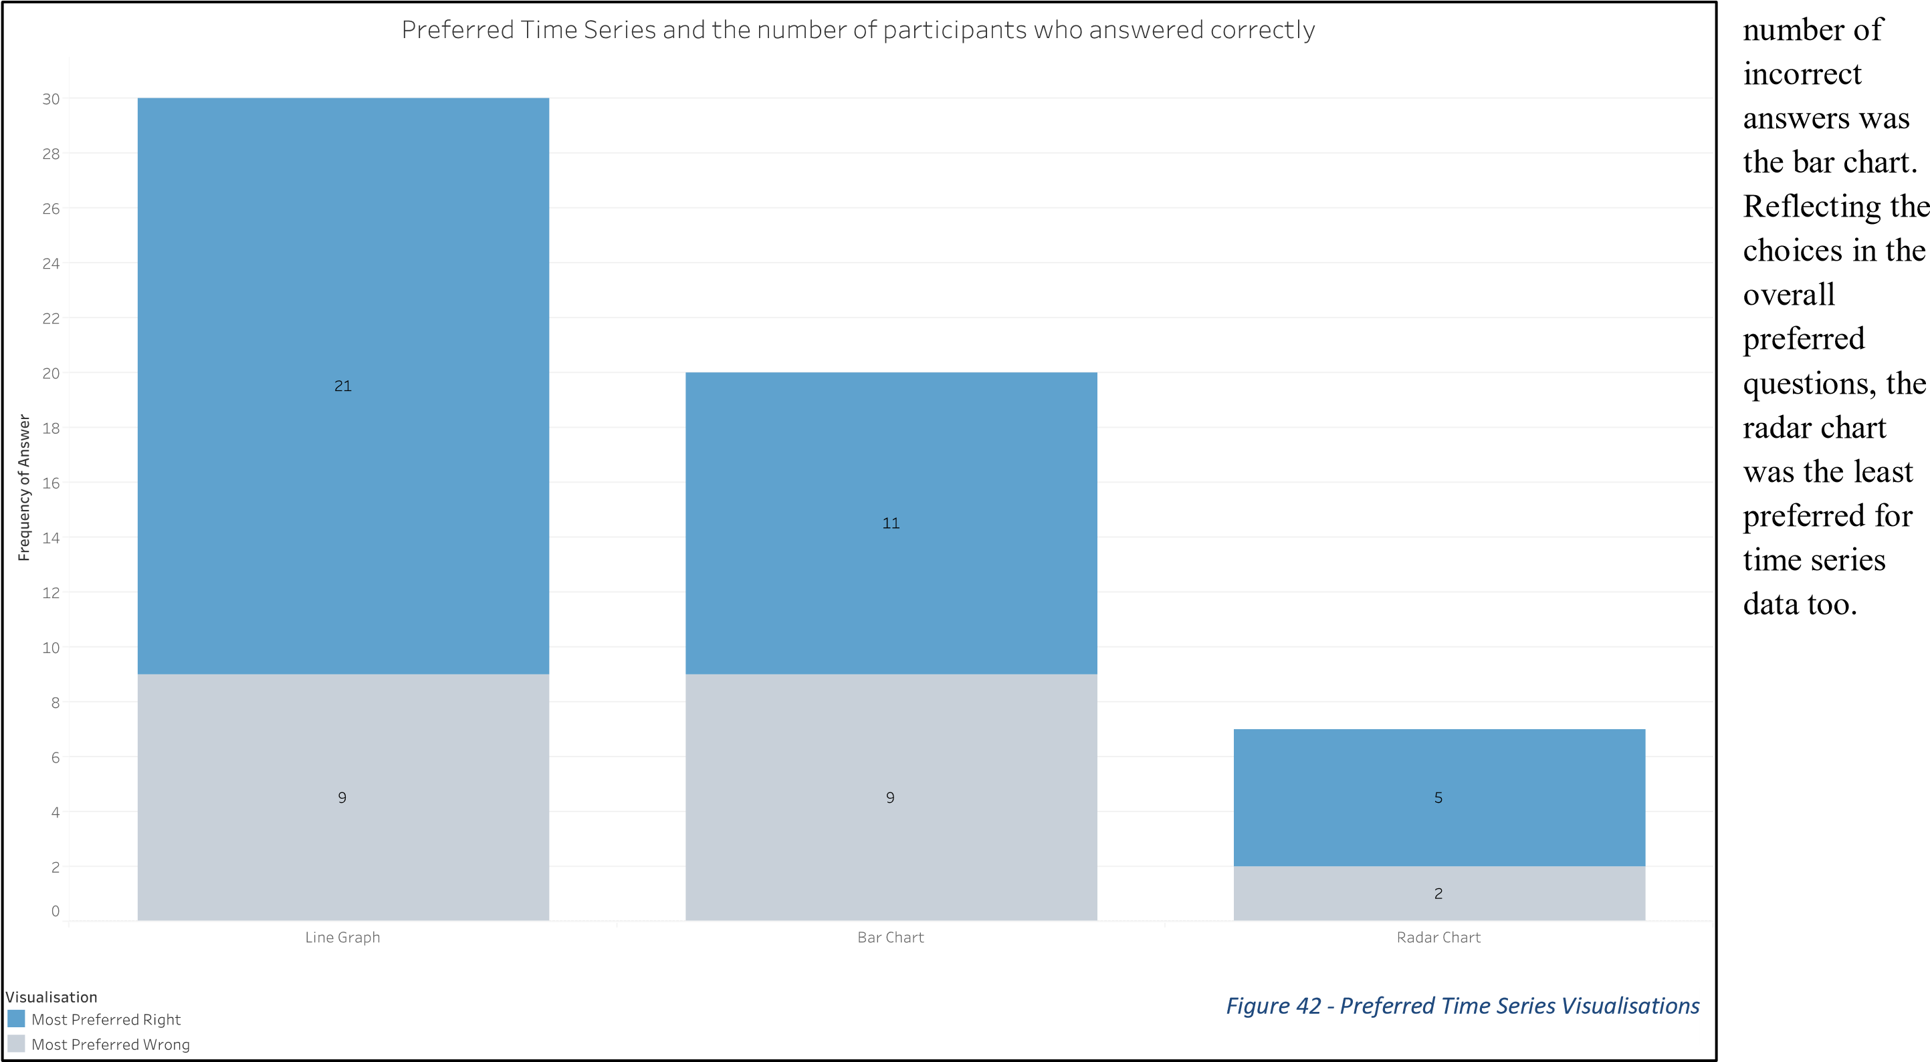

### Additional Research of Interest

*Spatial Ability*

These results are a series of cross-tabulations of results from demographics and the visualisation results to show the results when taking into consideration the research into the differences in spatial ability depending on gender, age, occupation and education. The second histogram question on ranging the performance has been omitted due to there being two acceptable answers. All results are represented as percentages to standardise the results.

#### Gender

Male participants outperformed female participants on all visualisations except the histogram general statement (first) question (figure 43). The results are close for the standard bar chart, line chart, diverging bar chart and stacked bar chart with the standard and diverging bar charts performing the best for both genders. The biggest gender differences were seen in the bar chart with target, the second box plot question (range), and the pie chart with target.

#### Age

For age, the results are split over three different graphs: ‘Versus’ (standard pie chart, bar, diverging and stacked graphs) (figure 44), ‘Time Series’ (time series collection plus box plot) (figure 45), and ‘Target’ (target collection plus histogram) (figure 46).

##### ‘Versus’

No major trends in ability to answer correctly and age were found, with the exception of diverging bar chart, where the percentage of correct answers increases with age.

‘Time Series’

Slightly more of a trend between age and correctness with correct answer decreasing with age in the radar chart and second box plot question.

##### ‘Target’

Similar to ‘Time Series’ graph with some decrease in correctness in some visualisations as age decreases.

In conclusion, these results do not illustrate a strong trend, one way or another, between correct answers and the age of the participant.

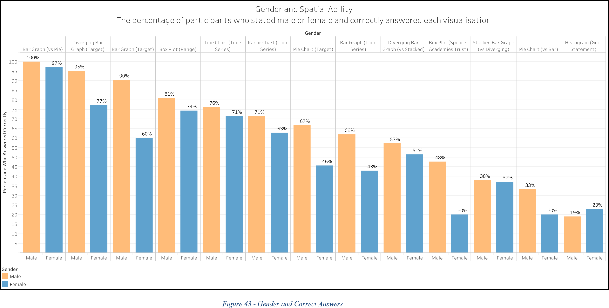

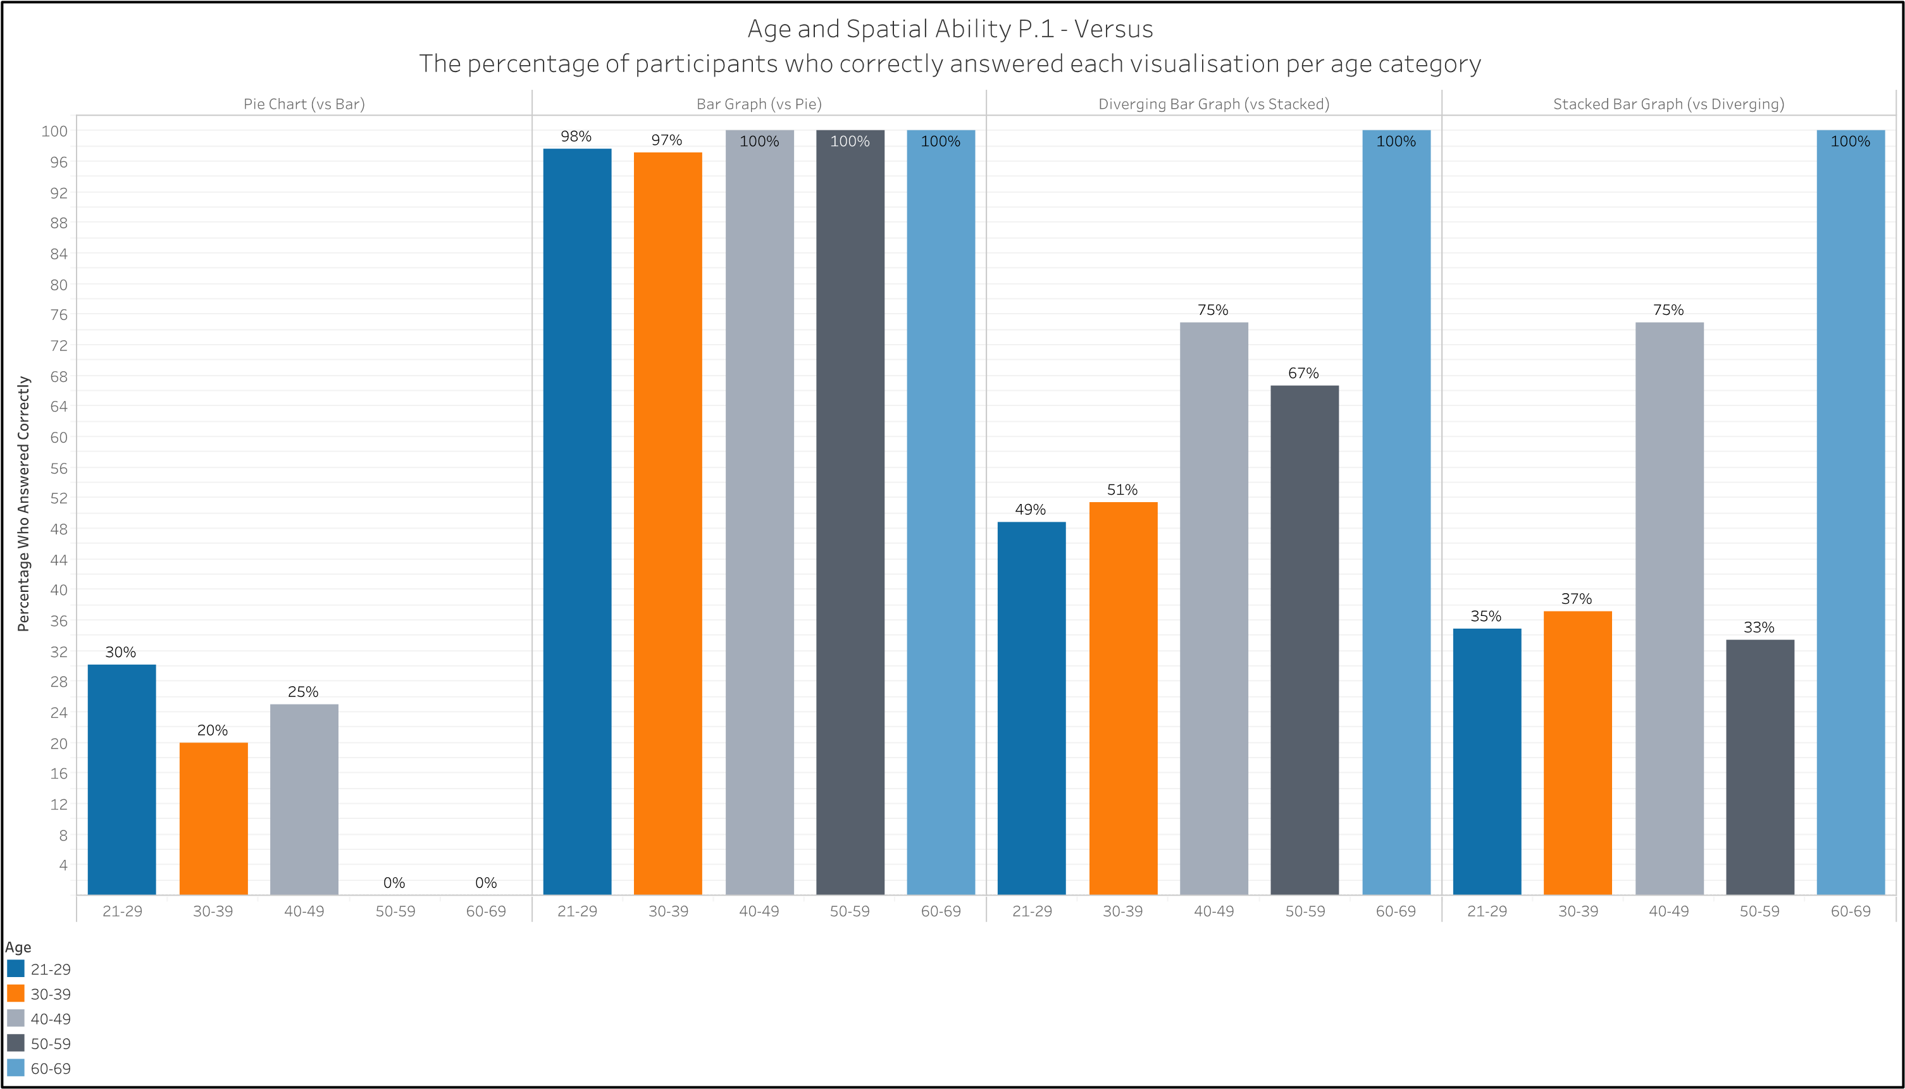

*Figure 44 - Age and Versus Visualisations*

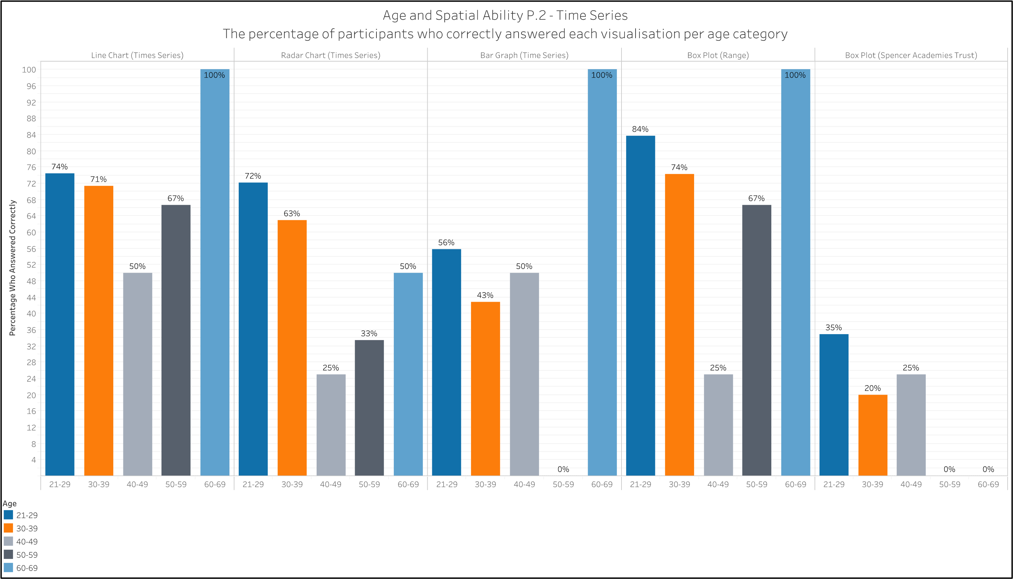

*Figure 45 - Age and Time Series/Box Plots*

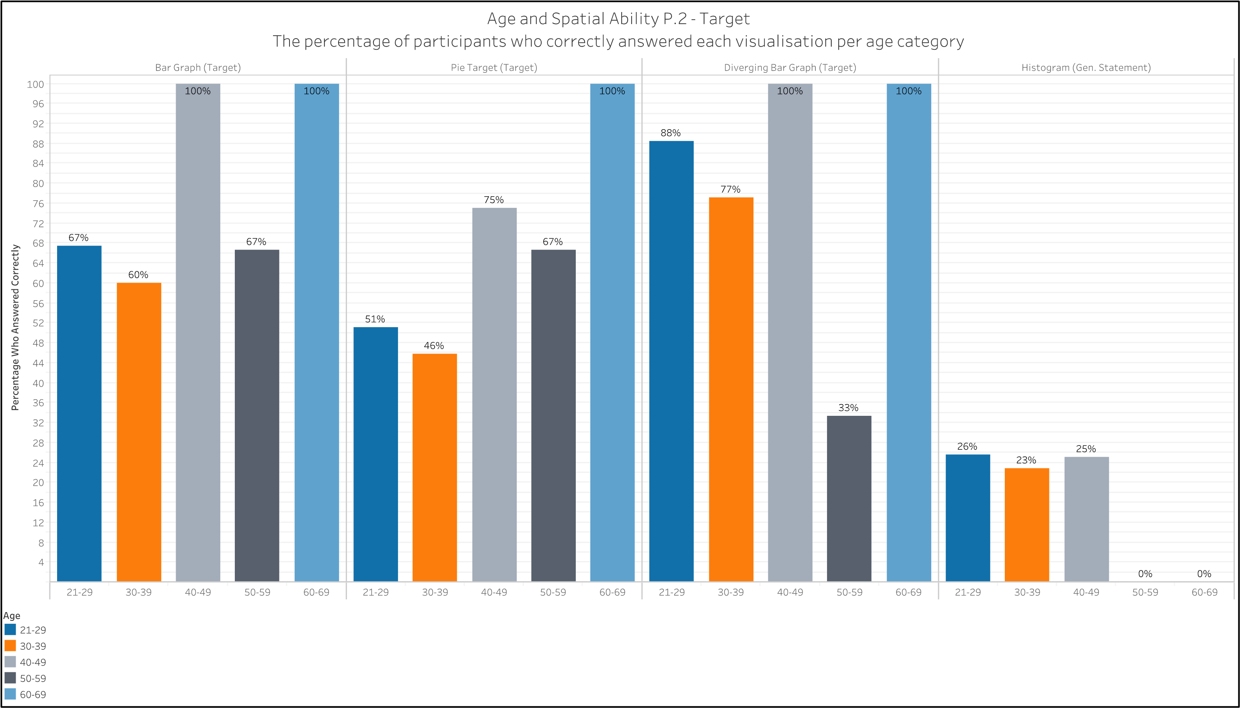

*Figure 46 - Age and Target/Histogram*

*Occupation*

To reflect the research discussed in the literature review, these results are presented in two categories – STEM and non-STEM – and with the percentage of correct answers for each visualisation (figure 47). In ten of thirteen visualisations, the STEM occupations performed equally or better than those in non-STEM occupations. The three which the Non-STEM performed better were the diverging target bar chart, stacked bar chart and the pie chart.

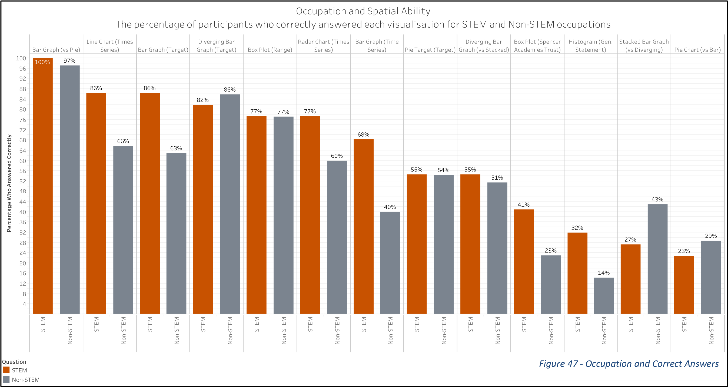

*Education*

These results show the percentage of participants who answered correctly at each level of education (figure 48). The visualisations are ordered left to right, highest to lowest, in order of the average correct percentage across the levels of education. The lowest level of education consistency performed well, though there was only one participant in this category. Overall there was no strong, consistent trend, positive or negative, between education level and correctness. There are some possible trends within certain visualisations, however, like each target visualisations (both positive and negative), and the histogram.

*Question 7*

This question was to gauge the participant’s confidence in and how often they work with numbers, statistics and visualisations and how it reflects their performance. By presenting the results in two parts – confidence (figure 49) and ‘work with’ (figure 50) – it is possible to see the two different elements and match them with education and occupation; education with confidence – the idea being that a higher level of education boosts confidence especially if it involves statistics - and ‘work with’ with occupation.

For both parts, the best performing visualisation was the standard bar chart with 97% correct answers on average, followed by the diverging bar with target with 78%, and with the box plot (range) in third with 72%. The line chart came a close fourth. The worst performing was the histogram (17%).

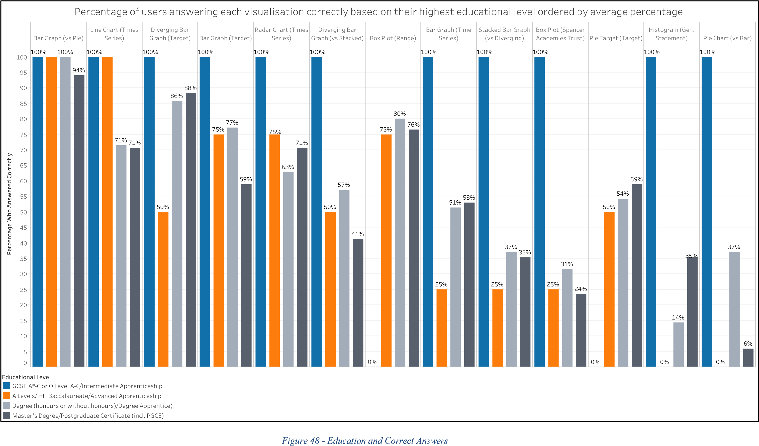

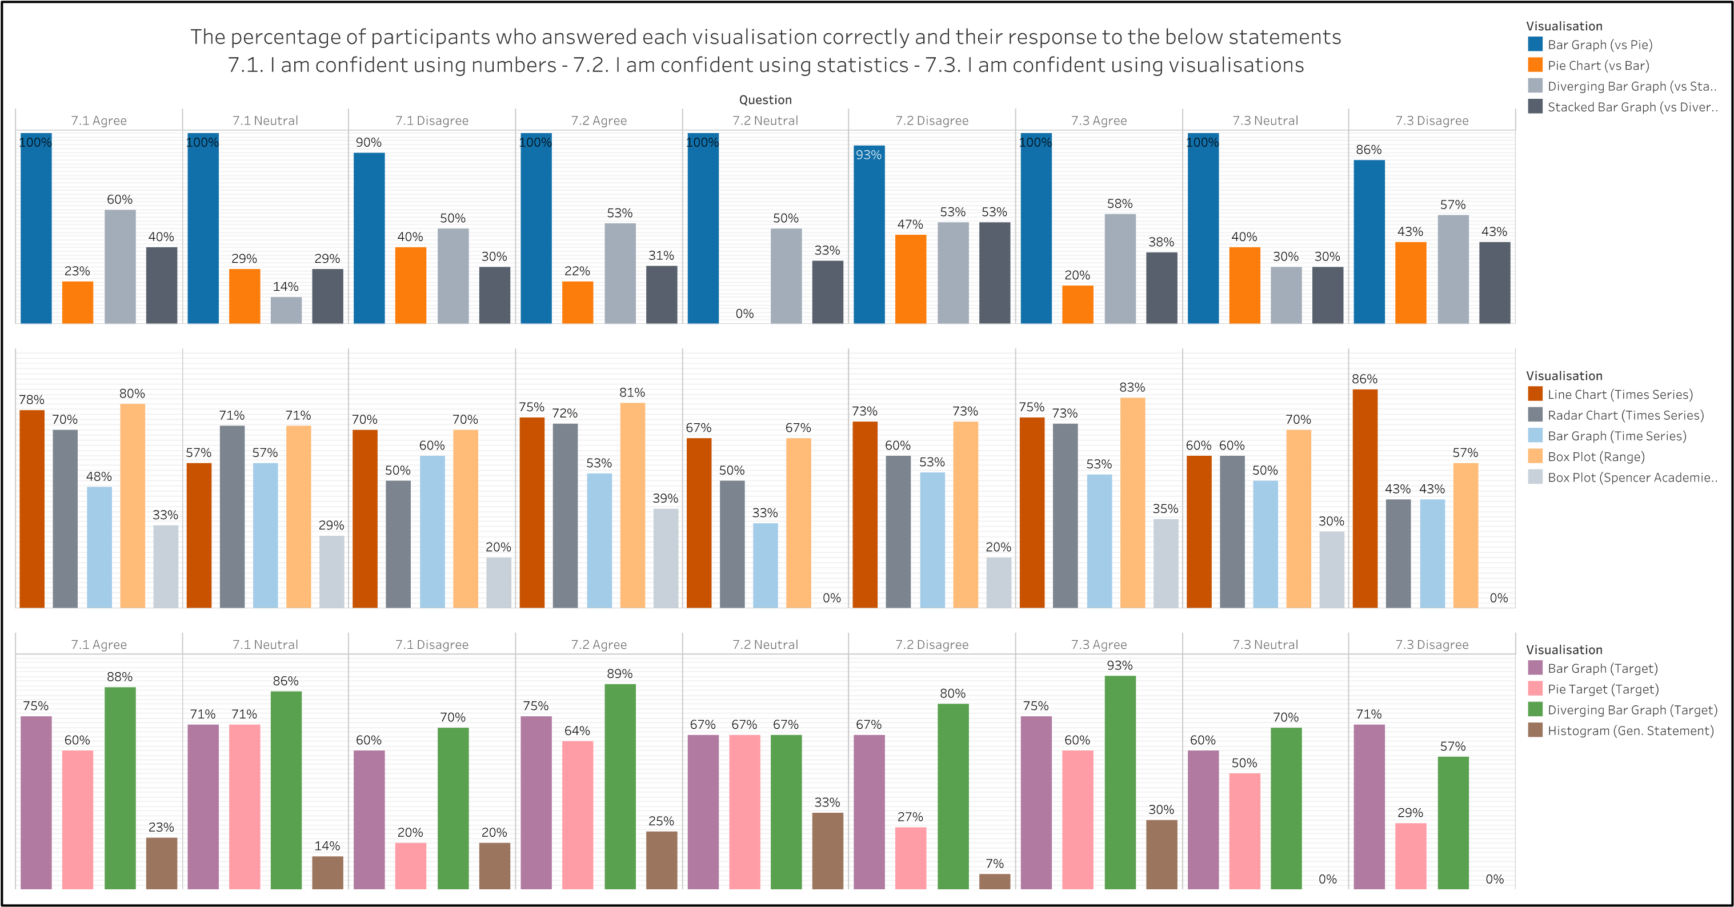

*Figure 49 - Confidence Q7 and Correct Answers*

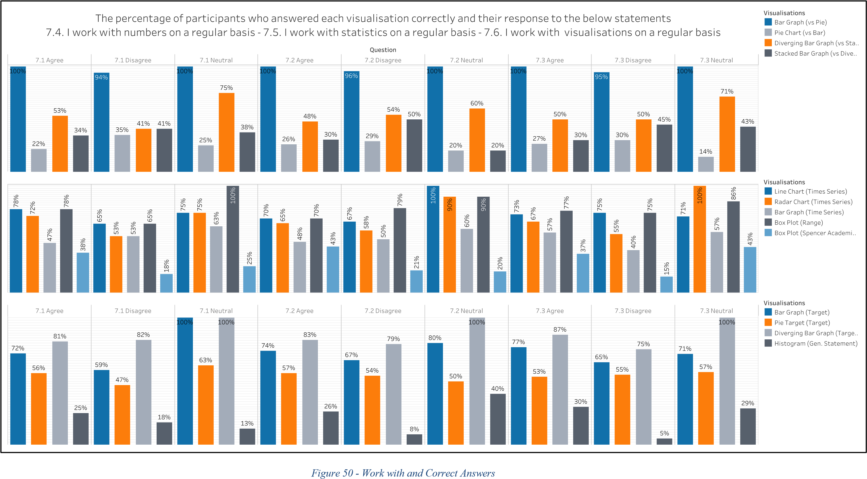

*Devices, Deficiencies and Dominion*

These results will look at the effects of uncontrollable factors like devices used, the visual deficiencies of participants, and the country they came from and the language they use.

#### Devices

Mobile devices category performed best (including equally) for seven visualisations, laptop devices for six, and the personal computer category for two (figure 51). The personal computer category did see the least variability in their correct answers, however.

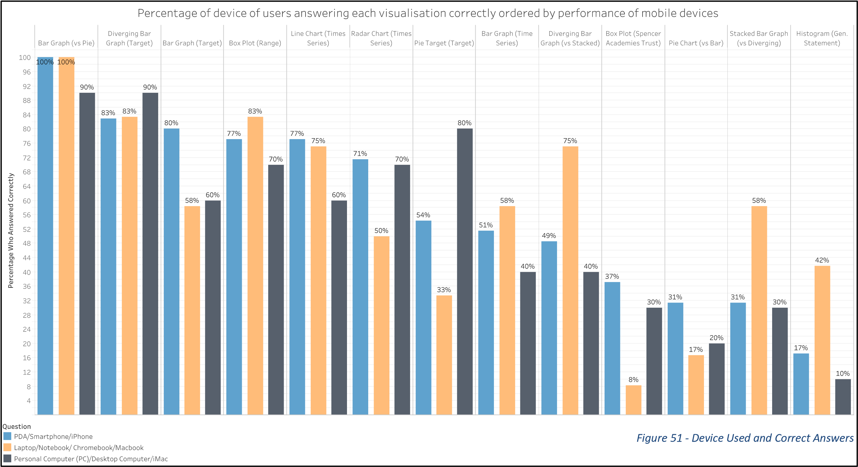

#### Visual Deficiencies

In seven of the thirteen visualisations (figure 52), the percentage of correct answers for those without any deficiencies is higher than those with.

Only the standard bar chart resulted in 100% correctness for those with colour-blindness.

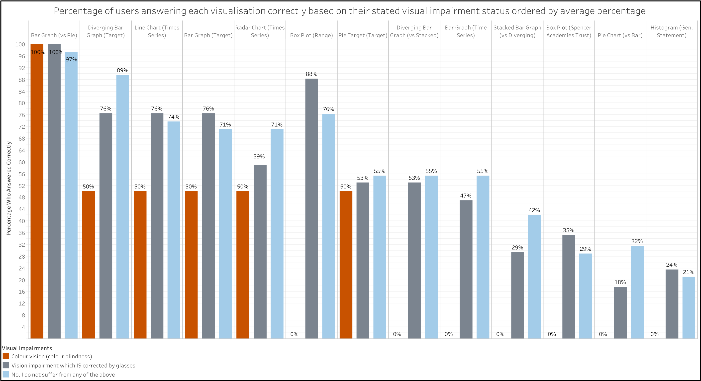

*Figure 52 - Visual Deficiencies and Correct Answers*

#### Country and Language

There seems to be a negative effect on correct answers when English was not the participant’s first language with their correct answers below average for all but the histogram and standard pie chart (figure 53). Similarly, there is a negative effect on non-UK participants but not as bad.

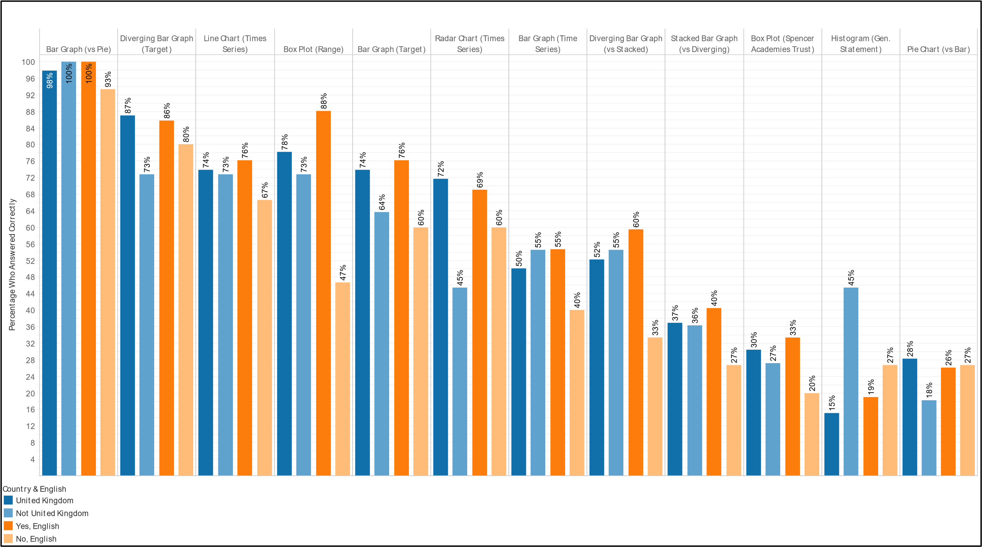Percent age of users answering each visualisat ion correct ly based on t heir count ry and language ordered by average percent age

*Figure 53 - Country and Language and Correct Answers*

### Survey Feedback and Performance

The final part of the survey was a few optional feedback questions. 56 out of 57 participants chose to leave their feedback.

*Likert*

Overall, the majority of participants disagreed with the negative Likert statements about the survey (figure 54). However, a number people of participants did agree with them with the highest two being that there were too many questions (32%) and that they lost interest near the end (33%). A large number of people were neutral about how hard the question were (33%) and how boring the survey was (30%).

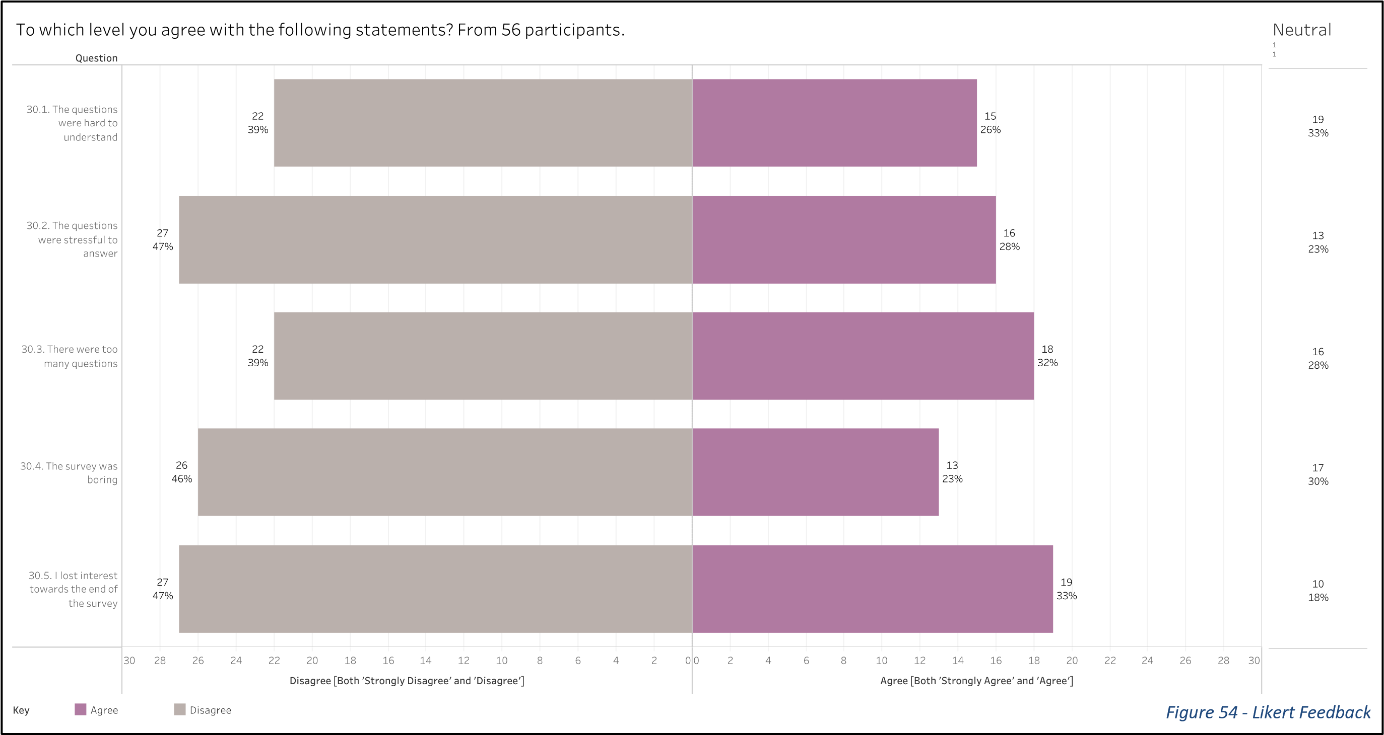

*Free-text questions*

|  |  |
| --- | --- |
| **Category** | **Count** |
| **Difficult Wording/Confusing Questions** | 10 |
| **Problems on mobile** | 3 |
| **Clearer Graphics** | 3 |
| **Great survey/good luck** | 3 |
| **Find statistics difficult** | 2 |
| **Visualisation Feedback** | 2 |

Two questions were asked; for improvements and further comments. These entries were in six broad categories with the results below (figure 55). Ten participants reported issues with question wording, confusion over a question’s meaning, or in one case, a spelling mistake. It’s unclear whether the confusing questions were due to the words used or content of the question. One participant thought that "A non maths or stats person would struggle to understand the questions" (Unique Response Number (URN), 492892-

*Figure 55 - Free Text Feedback* 492883-48728423).

One of those in the graphic category, had problems with the scale used in the visualisations stating: “A lot of the charts asked for almost exact comparisons, but the indicated values rose in multiples of 5. When the percentage difference may be only 1%, it is almost impossible to be accurate in a verdict without truly accurate numbering.” (URN, 492892-49288348693536).

One participant stated they found it interesting “…to see how different graphs can make the figures look better or worse than they actually are!” (URN, 492892-492883-48673117).

Finally, two participants gave additional feedback on the visualisations. One found that “…some of those graphs were awful to read! Especially the radar chart and the box plot.” (URN, 492892-492883-48743942) and another suggested that the time series bar chart visualisation “…could have been read better if they were next to each other. Blue 2018, pale blue 2019; orange 2018, pale orange 2019; grey 2018, pale grey 2019 etc” (URN, 492892492883-48948535).

*Time Taken*

Finally, it is worth looking at the time taken to partake in the survey. Most participants completed it within 30 minutes and the average time was 19:24 minutes. The results (figure 56) are presented by age to again take into consideration the research into the differences in spatial ability depending on age. There is no strong trend of any correlation between the time taken to complete the survey and age.

Page

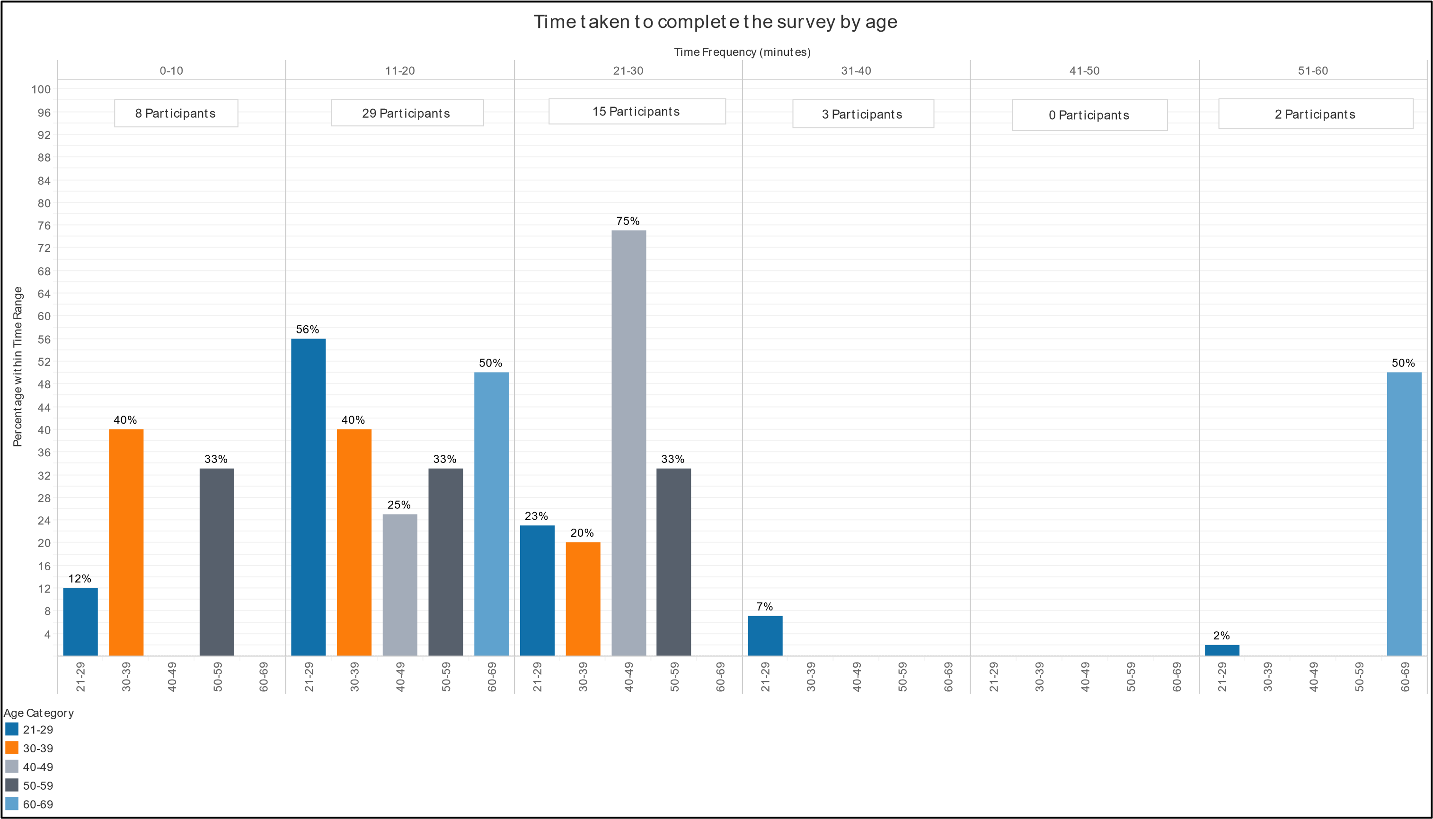

*Figure 56 - Time Taken by Age*

Page **98** of **164**

## Discussion

This section will proceed to interpret the results presented in the previous chapter regarding the research objectives, the theories and guidelines outlined in the literature review, and to the relative strengths, weaknesses and limitations of the research project. It will proceed in a similar order to which the results were presented: demographics, visualisations, and survey performance.

### Demographics

Most of these questions performed as intended with the only exception being the visual deficiency question. One participant highlighted, informally, that they had more than one of the stated deficiencies and therefore could only choose one; a slight limitation of the survey. Generally, the questions received the desired results. However, there were a few imbalances in respondents which has most likely had an effect on the ability to make conclusions in some areas. These will be discussed in the applicable sections.

The demographic results can be categorised into two areas: those which support the researcher’s expectations and those which do not.

*Supporting*

#### Country and Language

The survey saw a number of participants from outside of the UK and who do not have English as their first language. As the intended users of these visualisations are UK-based stakeholders, these results are representative. The expectation was that the non-UK, Englishfirst speaking participants may struggle to understand the questions either due to the wording used or because of a difference in education in visualisations. Overall across the visualisations, those from outside the UK performed worse with those who do not have English as their first language the next worst performing. The comments in the free-text questions at the end of the survey lend some support to the reason for the poorer performance with participants from France, Italy and India stating they struggled with understanding some

### questions.

#### Gender

A good split of genders partook in the survey with most identifying as either male or female. This meant there was a sufficient number of each to be able to make conclusions regarding any possible difference in spatial ability. Previous research has found that men outperform women in this area (Esipenko, et al., 2018) and this research supports these findings. In all visualisations except the histogram general statement question, a higher percentage of male participants correctly answered the questions compared to the percentage of female participants.

The biggest differences were seen in the bar chart with target, the average box plot question and the pie chart with target. These questions required the participant to compare a number of elements on the visualisation – either a bar/segment and a target line/segment or several points – and therefore having to make numerous judgements based on size and distance. As research suggests men outperform women on these judgements it’s not surprising these types

Page

of visualisations, with lots of different elements to judge, saw the biggest difference in performance.

With this in mind, the visualisations with the closest performance between males and females were also those with minimal elements to compare: standard bar chart, line chart, diverging bar chart and the stacked bar chart. Supporting the conclusion that less elements to compare is better, is the fact the diverging bar with target was the second best performing for both genders. By making the target line the axis, and in doing so removing an additional point of reference, the visualisation is easier to understand and gain the correct answer for both genders; especially compared to the other target visualisations.

Understanding which visualisations work best for each gender is vitally important. The education sector, at least in schools, is heavily a female occupation (74%) (Department for Education, 2018) and therefore those using the proposed visualisations will mostly be female. Therefore, the best visualisations based on gender and correct answers for female users are the standard bar chart, the diverging bar chart and box plot – but only when it’s used to communicate a dataset’s range. The worst ones to use are the box plot (average question), pie chart with target, and the histogram. However, the top three preferred visualisations for female participants only included one of the best performing – the box plot – with line graph and pie chart being preferred over a bar chart (figure 57). This supports evidence of users preferring inferior visualisations (Bishop, et al., 2013).

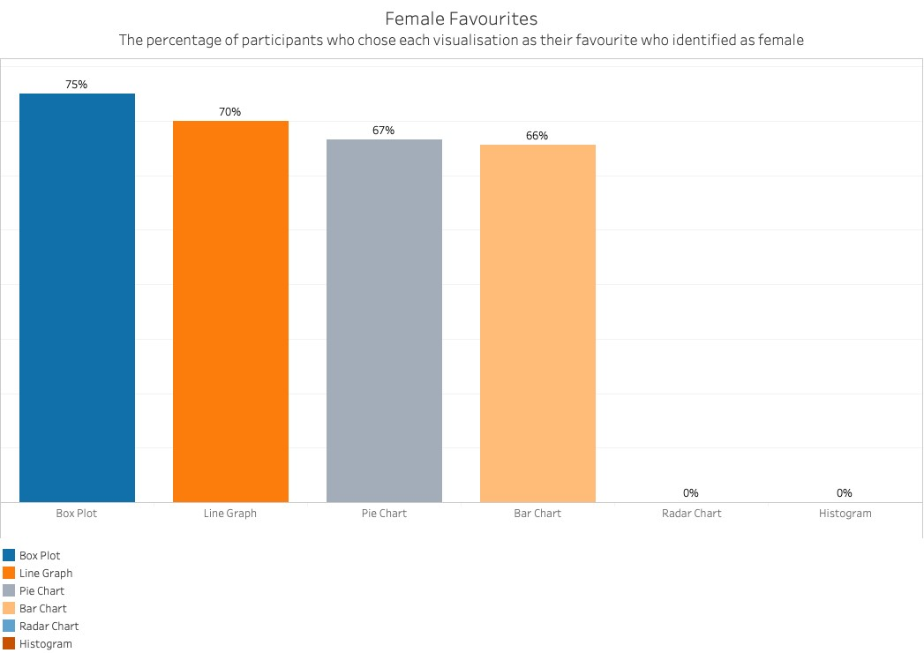

*Figure 57 - Female Most Preferred and Correct*

#### Occupation

There were a good range of occupations represented by the participants. Esipenko, et al.

(2018) also found that STEM degree students outperformed those of humanities students. Therefore, the results of the occupation question were categorised into STEM (22) and nonSTEM (35) occupations. Figure 58 shows how these were split.

|  |  |  |  |
| --- | --- | --- | --- |
| STEM | Count | Non-STEM | Count |
| Business, Management and Financial | 10 | Student, Retired and Unemployed | 11 |
| Healthcare | 6 | Education, Training and Library | 8 |
| Computer and Mathematics | 4 | Sales | 5 |
| Architecture and Engineering | 2 | Art, Design, Entertainment, Sports and Media | 3 |
|  |  | Retail | 2 |
| Transportation and Logistics | 2 |
| Hotel and Food | 1 |
| Legal | 1 |
| Life, Physical and Social Sciences | 1 |
| Office and Administration | 1 |

*Figure 58 - Occupation Split*

The STEM occupations performed equally as good or better on ten out of thirteen visualisations supporting research that those of a STEM background are better with data visualisations with the top visualisations being the standard bar chart, line chart, and bar chart with target.

The top visualisations for non-STEM participants were the standard bar chart, diverging bar chart with target, and the box plot (range). Interestingly, the non-STEM participants outperformed the STEM participants using the diverging bar chart with target, the stacked bar chart and the pie chart with the last two being the worst performing visualisations overall. Perhaps the reason for this is the greater use of these two visualisations in the areas where non-STEM employees are likely to come across visualisations in their life; the media (The

Economist, 2015), video games (Paradox Interactive, 2016) or mobile phone applications (Money Dashboard Ltd, 2019). Conversely, the growing use of academic theory and commercial guidelines in the ‘corporate world’ has most likely influenced the results of the survey by making participants from STEM occupations more familiar with the better alternatives; helping to explain their better performances.

However, these results may be more to do with the participant’s confidence and familiarity of working with the visualisations due to their work rather than because of their education as suggested by Esipenko, et al.’s research.

The results also offer the ability to analyse which visualisations are best for the users this research is focussed upon; the educational sector. By looking into the performance of just the ‘Business, Management and Finance’ – assuming this category reflects HR professionals - and ‘Education, Training and Library’ occupations it is possible to conclude which visualisations are best for the intended users of gender pay gap visualisations.

The top visualisations for HR professionals are the standard bar chart, line chart, radar chart and diverging bar chart with target. The top visualisations for education are the same but with the box plot (range) replacing the diverging bar with target. These results (figure 59) are mostly in line with the STEM and Non-STEM results but suggest some tailoring to the user is required for educational institutional dashboards.

*Figure*

*59*

*-*

*Specific Occupations and Correct Answers*

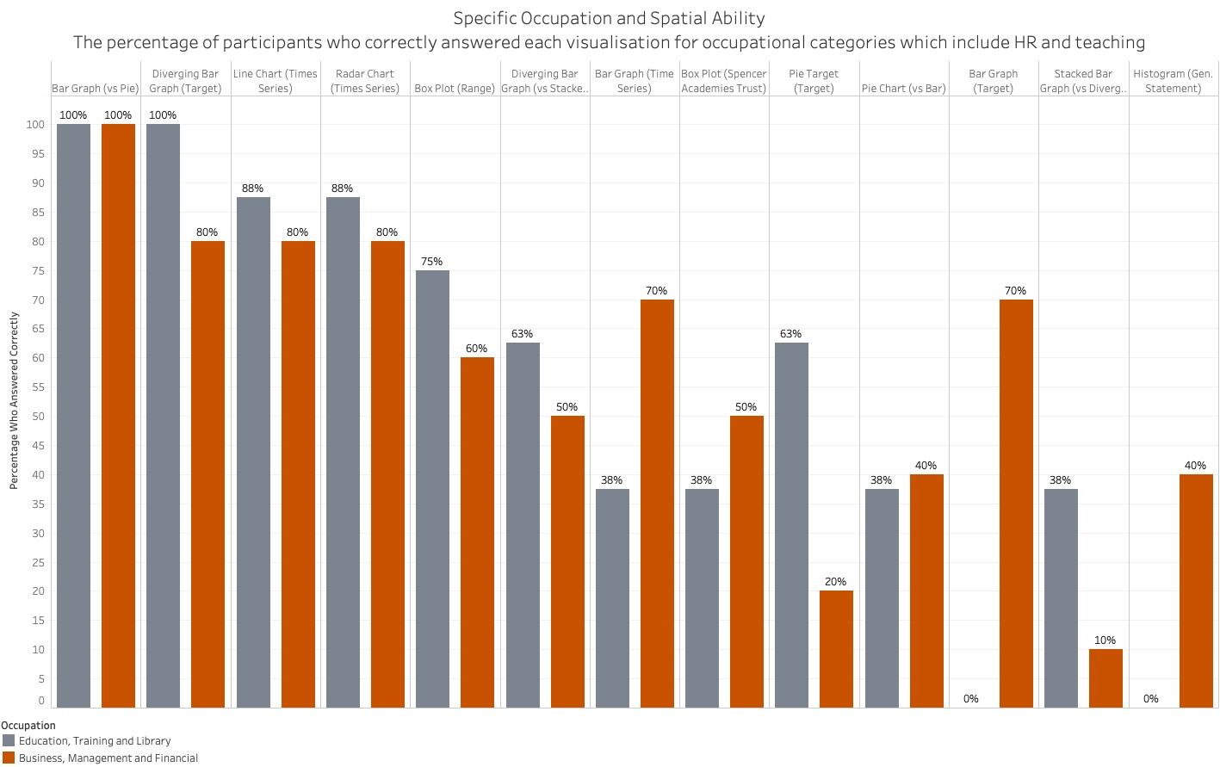

#### Visual Deficiencies

There were a good number of participants with visual deficiencies and those without. While, not a significant number, there were two with colour-blindness. This allowed some analysis of any possible affects colour-blindness had on performance. When looking at the genders of colour-blindness, it was interesting to see a female sufferer; given that colour-blindness is more common in men (Birch, 1993).

While designing the visualisations and survey every practical consideration was implemented to make sure that these deficiencies did not affect the performance of the visualisations and participants. For example, using the colour-blind palette and clear labelling. In only 54% of visualisations did participants without a deficiency outperform those with one. Given this and that those with a deficiency (33%) were half the number of those with one (66%), the results suggest that the visualisations and survey worked as intended in reducing the effect of the deficiencies on performance. However, the small number of participants with colourblindness makes it very difficult to make any definitive conclusions regarding their performance.

*Opposing*

#### Age

There were a range of ages represented by the participants, yet with a large skew towards those aged 21-29 (43 out of 57). Previous research has found that as age increases spatial performance decreases (Salthouse, et al., 1990), but perhaps not enough to affect spatial visualisation (Techentin, et al., 2014). Therefore, the expectation was that older participants would perform slightly worse. While there was this trend in the radar chart, and very slight similar findings in the target and histogram visualisations, overall there was no strong correlation between an increase in age and a decreasing performance in correctly answering the questions for most visualisations. This would suggest support for the research by Techentin, et al. (2014).

A second consideration was the affect age may have on the time taken to complete the survey with older participants potentially taking longer (Techentin, et al., 2014). Again, there is very little evidence that the time taken to complete the survey increased with age with only those aged 40-49 and 60-69 taking longer than the 30 minutes; most participants completed it within this time period. The three participants aged 50-59 were equally spread across the three categories from 0-30 minutes.

However, with 75% of participants in one, younger category it is judged that making any definitive conclusions is difficult. The reason for this age skew is likely down to the method of distributing the survey. Having not asked in the survey – an oversight – it’s impossible to know for sure how many participants came from which channel of distribution. Nevertheless, from interactions – likes, comments and shares – it’s possible to conclude that Facebook, Instagram and Twitter made a bigger impression on participants. According to The London School of Economics and Political Science (LSE) (2017), these social media platforms are primarily used by those aged 18-34 (Facebook) and 18-29 (Twitter and Instagram) providing a possible explanation for the survey’s age imbalance. WhatsApp was also used to increase participation by sending the link to friends; utilising findings that those with an existing relationship are more likely to respond (Callegaro, et al., 2015). Again, these friends mostly fall into the 21-29 category. Interestingly, LSE (2017) states that 61% of users on LinkedIn are aged 30 to 64. Perhaps a better promotional campaign there would have helped balance the ages.

#### Education

There was a range of educational levels represented by the participants but with a skew towards degree and master’s degree levels. The expectation was that those in higher levels education would outperform those in lower levels. Firstly, the lowest level of education consistently performed highly; though there was only one participant in this category. Of those in the higher levels, those with degrees performed best in seven visualisations (just over half) with those with master’s performing best in five. Therefore, there was no strong trend uncovered by the results and it is judged that occupation and experience is more likely to affect the ability of a participant to successfully use a visualisation. However, the substantially low numbers of participants with lower levels of education make it difficult to make definitive conclusions to support or dismiss any hypothesises.

Nevertheless, the higher levels of education results do reflect the intended users with 98.7% of teachers having a degree or higher (Department for Education, 2018) and so it’s possible to determine the best performing visualisations based upon degree and higher. The top three visualisations, averaging out the two percentages of correct answers, are standard bar chart, diverging bar chart with target, and box plot (range); mirroring the top visualisations overall.

#### Device

A range of devices were used by the participants, but a large majority used a mobile device

(excluding tablets). Similar to participant’s age, this is likely to be impacted by the distribution channels used to promote the survey. WhatsApp for example, is primarily used on mobile devices. However, the UK is “now a smartphone society” (Ofcom, 2015) and therefore it is not surprising such a large number of participants used a mobile device. It also reflects the trends seen in the way people consume information in the media (Engebretsen, et al., 2018).

What is surprising however, is that despite a few bits of feedback saying it was difficult to answer on a mobile, and the researcher’s expectation that it would be, the results show no trend to support this. In fact, those using a mobile device outperformed or equalled those who didn’t in seven visualisations. As with the visual deficiencies, great effort was made in the design process to ensure all participants could perform to their best regardless of the device used. Still, it was expected that a larger screen size would be an advantage. Perhaps the availability of a touch screen on mobile devices and the resulting ability to be able to magnify the screen, gave these participants an additional feature which mitigated the screen-size disadvantage or even gave them an increased advantage over those without touch screens.

Visualisations *As Easy as Pie?*

The first collection – Pie versus Bar – was designed to test the performance of a pie chart and bar chart in communicating information. The expectation, derived from the literature, being that the bar chart would outperform the pie chart. From the results, it is clear to see that this expectation was met not only by the standard bar chart outperforming the standard pie chart 98% participants correct to 26%, but also by the target bar and diverging bar charts outperforming the target pie chart 72% and 84% participants correct to 54% respectively.

The bar charts saw increased confidence in a participant’s answers too with 73% (42) ‘Very Sure’ for the standard bar chart compared to only 16% (9) for its corresponding pie. Additionally, all ‘Very Sure’ participants correctly answered the bar chart while only two of the nine for the pie chart were correct. Similarly, target bar and diverging target bar had higher levels of confidence with 33% (19) and 28% (16) respectively to the target pie chart’s 9% (5). Again, the number of participants with the highest confidence and correct was higher in the bar charts – 14 bar and 16 diverging – than the pie chart’s one. These results mirror those where participant can be confident of their ability to understand familiar visualisations even when they perform poorly (Wakeling, et al., 2015).

A parallel narrative can be told of the ease of use. The pie charts performed worst compared to both bar chart types. The standard pie only saw four participants (7%) state it was ‘Very Easy’ to use and all answered incorrectly while 25 said it was ‘Not Easy/Hard.’ The opposite is true of the standard bar with 36 participants (63%) stating ‘Very Easy’ who all answered correctly. Only three participants said it was hard to use. Again, the bar charts performed better than the pie when incorporating a target with 16% (9) of bar and 32% (18) of diverging to the pie chart’s 11% (6). More participants found the pie chart ‘Not Easy/Hard’ too with 30 to 23 (bar) and 16 (diverging).

These results support the findings of previous studies and academic writing. In particular, that pie charts do not efficiently communicate information (Cleveland & McGill, 1984) because

“the human eye isn’t good at ascribing quantitative value to two-dimensional space” (Knaflic,

2015, p. 63) and more than a few segments makes values hard to distinguish (Berinato, 2016). Brinton (1914) was right to question their value. When compared to the bar chart, the results also support the fact that bars are easier to decide size differences with length a more effective visual feature (Wexler, et al., 2017).

One theory which these results seem to discredit is that of Spence (2005). He believed that with few categories and with familiar proportions, 25% or 75%, pie charts are good. The standard pie chart was designed with these in mind with proportions as close to 25% as the data allowed. The results were still poor. Perhaps selecting data that were all close to 25% removed the perceived advantage stated by Spence. Conversely, the participants did manage to either answer correctly or the next largest for the standard pie. This was not true for the target pie chart where answers included all segments even though not all segments looked visually the same size; at least one (‘Lowest Paid’) was notably smaller. However, it is judged that the bar chart would have still outperformed the pie chart with different data.

Interestingly, the target pie chart performed much better than its standard version in correct answers. This may be down to the addition of a reference inner pie to which participants were asked to judge the outer pie by. Reference lines are useful for displaying the norm (Few, 2012) or in this case reference segments to display the ideal norm (target) using innovation. However, it is difficult to say for sure if this innovation solely led to increased performance with pie charts. The standard pie chart was both the first visualisation and first pie chart in the survey. Therefore, the improved performance could be due to increased visual literacy (Boy, et al., 2014) and familiarity (Wakeling, et al., 2015) with pie charts and visualisations in general as participants progressed.

Finally, the bar chart was overwhelmingly preferred to the pie chart with 32 participants choosing it as their most preferred to six for the pie chart. Moreover, 100% of those 32 correctly answered the standard bar chart question compared to only one of the standard pie chart’s six. This adds to the findings of Bishop, et al. (2013) in that it is possible for some users to prefer inferior visualisations. However, more participants did least prefer the pie chart (8) than those who most preferred it.

*Prime Time*

The ‘Time Series’ collection was designed to test the ability of a line chart, radar chart and bar chart to effectively communicate information from two different years. The expectation was that the line chart would be best, and bar chart the worst. From the results it is clear that this expectation was met with 42 participants (74%) correctly answering the question with a line chart compared to 38 (67%) for the radar chart and 29 (51%) for the bar chart. These findings correlate to the related literature: “Line graphs are especially useful for showing the shape of change through time…”and “…to emphasise the information’s shape… rather than individual values as in bar graphs” (Few, 2013, p. 129). They also make it easier to identify trends (Wexler, et al., 2017).

Surprising, according to the literature, was the performance of the radar chart. Normally, the data would be presented in a bar chart, could be ranked and would therefore be easier to read; if a little boring (Few, 2012). However, it was thought by the researcher that this would be untrue for time series data. A bar chart of time series data cannot be ordered in any order other than that of year and therefore the bar chart was designed with 2017-18 data first and then 2018-19 data afterwards along the horizontal axis. Therefore, it would be harder to successfully compare the different quartiles. Few (2012) also suggested time data would work best on radar charts. These are the reasons why the researcher’s expectations differed from those of the literature and potentially why the results reflect this.

However, as observed by one participant, URN 492892-492883-48948535, the time series bar chart could have been improved by organising the data by quartiles instead of years; lowest quartile 2017-18 and 2018-2019, second lowest quartile 2017-18 and 2018-19 etc. This would have reduced the amount of movement required to compare the quartiles over the two years and perhaps increase the percentage of correct participants. It would have also better implemented Gestalt’s principle of proximity (Few, 2013) and Bertin’s of position (1983).

Nevertheless, it is judged that the line graph would have still performed best. Additionally, the visualisations were helped by the fact that only two years were available for comparison. The design of the line chart lends itself to a greater number of years for comparison compared to the radar – which becomes more difficult to read a more datasets are added (Few, 2012) – and the bar chart which would increase in size as more datasets are added. This would either make the visualisation larger or the bars smaller to fit its destinated space. Both would make it harder to interpret and go against Tufte’s excellence principles of least ink and smallest space (Tufte, 2001).

The line chart also made the participants more confident in their correct answers with 10

(18%) answering correctly and being ‘Very Sure’. The radar chart and bar chart were second and third with 8 (14%) and 5 (9%) respectively. The line chart was again top when looking at ease of use. It saw 7 (12%) participants correctly answer and state it was ‘Very Easy’ compared to 6 (11%) for the radar chart and 4 (7%). Admittedly, these percentages are not very high for any of the visualisations, but this might be due to two reasons. As discussed, there was only two years of data to show. This meant that judgements on any trend was only using two data points, each year, and is therefore potential harder to spot. Secondly, the data shown was purposely chosen due to the closeness between the quartiles, so the answer was not obvious. This has undoubtably affected the confidence and ease of use the participants felt. Having said that, the line chart still performed the best for generating correct answers and those with ‘Fairly’ or ‘Very Sure’ confidence as expected by the literature.

Finally, the most preferred time series visualisation was the line chart with 30 (53%) participants choosing it over the bar chart (35%) and the radar chart (12%). While the results again add to the findings of Bishop, et al. (2013) regarding some users preferring inferior visualisations – 45% who chose the bar chart were incorrect compared to 30% of the line graph – it is interesting to observe that the opposite can also be true. Here, the results reveal that the least preferred visualisation, the radar chart, was in fact the second most successful. Perhaps Brinton (1914) was again correct in distrusting the radar chart.

*Bar Exam*

Finding that a bar chart is better than a pie chart and is the worst for time series data is useful, but further insight can be found by analysing which bar chart is best. This was the reason behind the ‘Diverging Bar versus Stacked Bar’ collection and can also be seen from the ‘Target’ collection.

Firstly, the diverging bar outperformed the stacked bar with 30 participants (53%) answering with the rounded correct answer of 32% for male employees compared to 21 (37%) with the stacked. The stacked bar also saw more participants (5) give the corresponding answer (68%) for the wrong gender, illustrating the confusion these graphs can cause by requiring users to make calculations (Few, 2012). The target diverging bar also outperformed the target bar chart, though to a lesser extent – 48 (84%) to 41 (72%). As discussed under the gender results in the demographics section above, this is most likely due to having less elements to compare. The target bar involves calculating the different from the horizontal axis value and that of the target line. The target diverging bar however, only requires the participant to read the horizontal axis value for each quartile and judge which is the smallest and therefore closest to the target.

There seems to be very little literature on the comparison of stacked and diverging bars, but there are authors who find them useful – Knaflic (2015) - and those who believe they are useful on some occasions: when only using two segments, when comparing the sum of multiple parts among multiple bars, and when comparing Likert scale percentages (Few, 2016). The stacked bar in the survey adhered to the first two occasions and still performed poorly and therefore these findings would suggest that stacked bars still have significant flaws in their design even when designed to maximise their effectiveness.

As mentioned in ‘As Easy as Pie?’, the percentages of correct answers and ‘Very Sure’ confidence were 73% for the standard bar, 25% for the target bar and 28% for the target diverging bar. In addition, the standard diverging bar saw 13% correct and ‘Very Sure’ and 14% for the stacked bar. Overall, this means the best for confident, correct answers was the standard bar chart by quite some way; agreeing with Cleveland and McGill’s (1984) views that bar charts are better than stacked bars.

However, the standard bar chart question only asked for the participant to judge which bar was the largest and therefore required less judgement based on the axis and numbers. Therefore, it is fair to say that the best bar chart for making judgements where the reading of the axis is required, is the diverging bar. It outperformed the standard bar when including a target and was close against the stacked bar; when looking at ‘Fairly’ and ‘Very Sure’ it performs best. The stacked bar also saw 72% of participants being ‘Very Sure’ of their incorrect answers; much smaller than the diverging bars 26%. This illustrates that users can be confident in visualisations they use incorrectly (Wakeling, et al., 2015).

While the survey did not ask how easy participants found answering the ‘Diverging versus Stacked’ collection, it can be inferred that the diverging bar chart was easier to use as it resulted in the highest number of correct answers. This is backed by the ease of use results from the target bar charts. Only 16% (9) answered correctly and found the target bar ‘Very Easy’ while more than double did with the diverging version (32% (18)). More participants found the bar chart ‘Not Easy/Hard’ too with 23 to 16 for diverging. Again, illustrating the benefits of the diverging bar chart by making it easier to see if bars are negative or positive (Wexler, et al., 2017) i.e. below or above the target.

Still, the diverging bar was not the participants most preferred bar chart coming second with 14 to the bar chart with target (23). This is despite the fact that more people who chose the bar chart with target incorrectly answered this question (35%) to those who chose the diverging bar chart (35% (standard diverging bar question)). Remarkably, the most successful bar chart – the standard one – was the least preferred. Again, these results complement the research by Bishop, et al. showing participants preferring inferior visualisations (2013).

*Distribution Plan*

The ‘Distribution’ collection was a little different to the other collections in that it was not designed to directly compare the box plot against the histogram. Its purpose was mainly to evaluate the effective of these visualisations when used to display data best suited to them. The expectation was that these visualisations would perform poorly due to their association with statistical analysis (Berinato, 2016) and relatively low use, “except by statisticians and well-trained data analysts” (Few, 2012, p. 92), meaning a lack of familiarity which can affect performance (Wakeling, et al., 2015).

From the results, it is clear to see that the expectation was correct for the histogram but not entirely for the box plot. Starting with the box plot, 44 participants (77%) correctly answered the range question. Of these participants 73% were either ‘Fairly’ or ‘Very Sure’ of their answer; 18% ‘Very’. This seems to support the suggestion made in the literature review that Rensink’s work (Rensink & Baldridge, 2010), on the human visual system and its ability to identify average values and variability in multiple-variable visualisations, can be applied to box plots. However, it is impossible to say for sure, as almost an equal number of participants were ‘Very Unsure’ and incorrect (11) than ‘Very Unsure’ and correct (12), suggesting the number of correct answers from those ‘Very Unsure’ could be suspect and possibly due to guesswork.

Where the box plot really struggled was in the second question regarding the number of times

Spencer Academies Trust was above average. While it showed 82% of correct participants

‘Fairly’ (10) or ‘Very Sure’ (4), only 17 participants (30%) actually answered correctly meaning it was one of the least successful visualisations in the survey. This might be due to the way box plot design often obstructs the view of many marks (Wexler, et al., 2017). Many more participants who were ‘Very Unsure’ were wrong compared to the range question. This, and the results of the ‘Target’ collection suggests that these types of comparisons might be better done with a bar chart and reference line; though could be difficult due to the large amount of information a box plot can encode (Harris, 1999). Intriguingly, the number of participants who were ‘Very Unsure’ regardless of their answer was the same for both questions supporting the expectation of low familiarity with box plots. The work into visual literacy (Boy, et al., 2014) however, suggests that participants could be taught to increase their proficiency with box plots and therefore increase their confidence in their usage and correct answers. Or Few (2012) suggests making box plots as simple as possible by moving from a five-value to three-value representation of distribution; though this does lose information.

The results from the histogram questions meet the expectation. For the first question, where participants were asked to choose a statement which described the histogram, only 12 (21%) correctly answered that ‘Women are over represented’. Of these there was a 42% to 58% split of ‘Very Unsure’ to ‘Fairly’ or ‘Very Sure’ illustrating a mixed representation of confidence in histogram understanding. The majority of people (54%) stated that ‘It’s impossible to know/I don’t know’ with 19 ‘Very Unsure’. Eight participants were ‘Fairly Sure’ and four ‘Very Sure’ suggesting they thought it was impossible to know the answer from the histogram and therefore that these participants did not know the answer or how histograms work.

The incorrect answers could possibility be due to the pre-held biases of the participants which can affect understanding (Knaflic, 2015). A quick search on the internet for gender pay gap and the top results are predominately headlines from the media regarding men being paid more than women (BBC, 2018) (Duncan, et al., 2019) (Wisniewsk, et al., 2019). Therefore, when shown a visualisation which contradicts the portrayed norm, the participants could have been confused; resulting in the large number of ‘It’s impossible to know/I don’t know’ answers.

The second question asked participants to judge from ‘Very Poor’ to ‘Very Good’ the performance of an institution within a highlighted band. The expected performance judgement of an institution within this band would be ‘Good’ or ‘Average’. The majority of participants chose ‘Good’ or ‘Average’. Remarkably, more than half of those who answered ‘Good’ were ‘Very Unsure’ on the previous question regarding the general overview/working of a histogram which raises a few questions about the validity of these correct answers. The question also has a flaw within it. Unlike all the other questions, there were two acceptable answers which made making reliable judgements and analysing potential trends with demographic data like age, gender, occupation etc difficult. For this reason, the second histogram question was omitted from the analysis when looking into these trends and the results in the findings chapter. This is why, for example, figure 43 does not show the results of this question when demonstrating the results of gender and spatial ability.

Both the box plot and histogram performed poorly in the preference questions. The box plot was the second least preferred visualisation with thirteen, even though ten of these participants correctly answered the first question. This is mostly due to the uncertainty the participants had in using the box plot and adds to the suspicion that some of these correct answers were guesswork.

The histogram was the third least preferred visualisation with 9; the majority (6) answered the its first question incorrectly. Again, this is likely to be due to the lack of confidence in its use. Other than the pie chart, it is also the only visualisation which had more participants who incorrectly used it choose it as their least preferred. These two cases contradict the studies that show users can prefer inferior visualisations (Bishop, et al., 2013) perhaps because the participants learnt how difficult they are to successfully gain information from during the survey.

*Hierarchy*

In order to choose the most successful visualisations, make suggestions for a dashboard, and compare to previous literature it makes sense to create a hierarchy based on the survey results. However, just making a hierarchy is not sufficient as the choices of visualisations should be based upon the intended user and setting. Hence, more than one hierarchy has been created.

#### General Hierarchies

##### All versions by percentage of correct answers

|  |  |  |  |
| --- | --- | --- | --- |
| **Visualisation Questions** |  | **Answered Correctly** | |
| **Overall** | **Male** | **Female** |
| 1. Bar chart (standard) | 98% | 100% (1st) | 97% (1st) |
| 2. Diverging bar chart (target) | 84% | 95% (2nd) | 77% (2nd) |
| 3. Box Plot (range) | 77% | 81% (4th) | 74% (3rd) |
| 4. Line Chart | 74% | 76% (5th) | 71% (4th) |
| 5. Bar chart (target) | 72% | 90% (3rd) | 60% (6th) |
| 6. Radar chart | 67% | 71% (6th) | 63% (5th) |
| 7. Pie chart (target) | 54% | 67% (7th) | 46% (8th) |
| 8. Diverging bar (standard) | 53% | 57% (9th) | 51% (7th) |
| 9. Bar chart (time series) | 51% | 62% (8th) | 43% (9th) |
| 10. Stacked bar chart | 37% | 38% (11th) | 37% (10th) |
| 11. Box plot (above average) | 30% | 48% (10th) | 20% (12th) |
| 12. Pie chart (standard) | 26% | 33% (12th) | 20% (12th) |
| 13. Histogram (general statement) | 21% | 19% (13th) | 23% (11th) |

##### Visualisation type by average percentage of correct answers

|  |  |  |  |
| --- | --- | --- | --- |
| **Visualisation Type** | **Answered Correctly** | | |
| **Overall** | **Male** | **Female** |
| 1. Bar chart (standard, time series and target) | 74% | 84% (1st) | 67% (2nd) |
| 2. Diverging bar chart (standard and target) | 69% | 76% (2nd) | 64% (3rd) |
| 3. Line Chart | 74% | 76% (2nd) | 71% (1st) |
| 4. Radar chart | 67% | 71% (4th) | 63% (4th) |
| 5. Box Plot (range and above average) | 54% | 65% (5th) | 47% (5th) |
| 6. Pie chart (standard and target) | 40% | 50% (6th) | 33% (7th) |
| 7. Stacked bar chart | 37% | 38% (7th) | 37% (6th) |
| 8. Histogram (general statement) | 21% | 19% (8th) | 23% (8th) |

#### Gender, Occupation and Education

As discussed in the literature review, it is important to choose visualisations based on the background of the users and context they will be used in (Knaflic, 2015). It is interesting to note that there is a difference in the best performing visualisation when looking at gender. As the most likely users of these visualisations when looking at the gender pay gap in education are female – due to the majority of teachers being female and that they take places on board of governors – this is important. The implication of this is that the bar chart with target is no longer in the top five best performing. The top five being the standard bar chart, diverging bar with target, box plot for range calculations, line chart, and radar chart. However, considering there are more than one visualisation for showing the same data – for example the line and radar charts - this top five needs a slight adjustment. Therefore, by only including the best visualisation for each collection, the top five visualisations for females according to these results would be:

|  |  |
| --- | --- |
| **Visualisation Questions** | **Female Answered Correctly (overall rank)** |
| 1. Bar chart (standard) | 97% (1st) |
| 2. Diverging bar chart (target) | 77% (2nd) |
| 3. Box Plot (range) | 74% (3rd) |
| 4. Line Chart | 71% (4th) |
| 5. Diverging bar (standard) | 51% (7th) |

Occupation and education must also be thought of when considering the intended user. As 98.7% of teachers have a degree or higher (Department for Education, 2018), the best performing visualisations for those with degrees are important. The top five, again adjusting for visualisation collections, were the same as above for females. It is also important to consider who else might be on a board of governors – almost anyone regardless of occupation. The non-STEM adjusted top five matches that of the overall hierarchy. However, those of STEM occupations have slightly different top five. In place of the diverging bar with target they performed higher using the bar chart with target.

From these hierarchies, and the results of confidence and ease to use, it is clear to see that the bar chart, apart from the stacked bar chart, is the superior visualisations followed by, when used in its best capacity the box plot, and then the line chart. It is also clear to see that pie charts, stacked bar charts and histograms are the worst performing. These results reflect the hierarchies of previous studies namely of Cleveland and McGill (1984) and Shamin, et al. (2015).

#### Preferences

Having already discussed the preference results of each visualisation in their individual discussion sections this section will simply list the rankings for easier comparison.

|  |  |  |
| --- | --- | --- |
| **Visualisation Type** | **Most Preferred Ranking** | **Least Preferred Ranking** |
| Bar Chart | 1st | 6th |
| Line Chart | 2nd | 5th |
| Pie Chart | 3rd | 4th |
| Histogram | 4th | 3rd |
| Box Plot | 4th | 2nd |
| Radar Chart | 6th | 1st |

|  |  |  |  |  |  |  |  |  |  |  |  |  |  |  |  |  |  |  |  |  |  |  |  |  |  |  |  |  |
| --- | --- | --- | --- | --- | --- | --- | --- | --- | --- | --- | --- | --- | --- | --- | --- | --- | --- | --- | --- | --- | --- | --- | --- | --- | --- | --- | --- | --- |
| |  |  | | --- | --- | | **Bar Chart Type** | **Most Preferred Ranking** | | With Target | 1st | | Diverging | 2nd | | Stacked | 3rd | | Standard | 4th | | |  |  | | --- | --- | | **Target Type** | **Most Preferred Ranking** | | Bar Chart | 1st | | Diverging Bar Chart | 2nd | | Pie Chart | 3rd | | |  |  | | --- | --- | | **Time Series Type** | **Most Preferred Ranking** | | Line Chart | 1st | | Bar Chart | 2nd | | Radar Chart | 3rd | |

*Dashboard Recommendations*

A dashboard is a visual display, with an emphasis on graphics, of the most important information required to achieve stated objectives. It should fit onto a single computer screen, be usable at a glance, and present information using small, concise, direct and clear media (Few, 2013). They are interactive, used to facilitate understanding, and can be displayed in numerous places from large wall-mounted screen, to email inboxes, to mobile applications (Wexler, et al., 2017).

With these definitions, the likely users, and the results of this survey in mind, the recommended visualisations for a dashboard to help educational institutions to monitor their gender pay gap are:

1. Bar chart: for use to either compare internal data like pay quartiles or to compare data across institutions.
2. Diverging bar charts: for use to compare an institution’s own data to its targets - primarily equal representation in each quartile – or a better way of showing male/female split in across institution comparisons (compared to stacked bars).
3. Box plot: for use to compare data across institutions for a general observation of distribution.
4. Line chart: for use to compare internal data over time with the potential of adapting it to a sparkline (Tufte, 2006) as more years are added to reduce the space used by multiple years or to small multiples to show each quartile in its own separate small chart to provide the information in clearer way (Berinato, 2016).
5. Pie chart: but with care! A controversial choice given their poor performance, nevertheless, given the binary nature of the pay gap data they may have a place on a dashboard. They show dominant versus nondominant segments very well (Berinato, 2016) and so with only two segments – male and female – and the labelling of values to overcome the inability of users to successfully measure segments size, they could be an effective visualisation. A pie chart to show the percentages of a single quartile, for example, is likely to portray the part-to-whole relationship in a clearer, more direct way than the bar charts above. However, any focus beyond a single quartile should be shown using a bar chart.

### Survey Performance and Limitations

Generally, all the questions performed as intended with the exception of the second histogram question which, due to it having two acceptable answers, was difficult to make many useful conclusions from. The research project managed to collect results from 57 participants meaning the sample size was large enough for the conclusions made to be significant; more than double the number of Wakeling, et al’s (2015) study for example.

The feedback questions were all answered positively by the majority of the 56 participants who responded to them; meaning they mostly disagreed with the negative statements regarding understanding, stress, number of questions, boredom and lack of interest. The main goal of these questions was to gauge if any of these factors affected the results. It is judged they did not.

However, there were a number of comments made in the free answer questions which did raise some concerns around understanding the questions, issues on mobile devices and quality of the graphics. While 30% of those commenting about the questions were not from the UK, and 40% with a language over than English as their first, the wording of the questions could have been a limiting fact in some participants correctly answering some questions. Although the questions were proof-read and the survey tested before launching, perhaps they could have been done so by more people - especially those from the demographics who struggled – possibly using a focus group.

Secondly, as discussed in the methodology for the survey design, the use of mobile device was considered during the process and the tested using a tablet computer. However, more testing could have been possible on different devices and using a wider range of available settings on Online Surveys. Still, those using a mobile device performed highly, so this doesn’t seem to have affected the results too much.

Thirdly, the graphics on the survey could have been clearer. This was mainly due to the software used to create the visualisations, Tableau, not having a high-quality export option for the visualisation images.

Finally, while the average time taken to complete the survey was 19 minutes and 24 seconds – just within the maximum survey time (Revilla & Ochoa, 2017) – there were some participants who completed it very quickly and very slowly. Without being able to determine how long each question took a participant it is impossible to say which ones caused the problems – for those who took longer – or if the results gained from those who were very quick are valid. Finding a survey provider who could time individual questions was difficult.

# Conclusion

In this research a number of visualisations were developed to assist with the communication of a number of datapoints of the gender pay gap in the UK education sector downloaded from the UK Government’s Gender Pay Gap Service website. An important part of the research was to evaluate the effectiveness of academic theory and commercial guidelines when applied to these visualisations to communicate the information - especially to those involved in the monitoring of the gender pay gap within educational sectors; board of governors, academy trustees, and HR employees.

The research started off by considering the data available and, through the academic materials presented in the literature review, identified the best, ordinary, and worst visualisations to use for the data. By doing this, the research would be evaluating if these theories and guidelines work in practice.

A pilot study was run with five participants to evaluate the processes, questions, and data collection methods proposed for the main experiment. This was an invaluable exercise as it raised several issues and considerations for the main experiment; especially the wording of the statistics education question, which type of radar chart to include, and the inclusion of Likert Scale questions in the main experiment. Mainly though, it confirmed the premise of the main experiment; that the results would be meaningful and analysis successful.

Taking forward the considerations from the pilot, the main experiment survey was developed on Online Surveys with a web-survey chosen for its ability to reach a larger number of participants – compared to mail, telephone or interviews – at the lowest cost. The survey was tested and launched using social media to overcome GDPR and ethical concerns connected to using email addresses to distribute.

As discovered by the results, this most likely caused the domination of the survey by younger participants (75%) and those who used a mobile device to complete the survey. The former making it difficult to conclude whether increasing age can affect visualisation use or not. Similarly, the domination of participants with a degree or higher made it difficult to analyse the effect of education on visualisation use. Using a mobile device did not seem to negatively affect participants. In fact, those using a mobile device outperformed or equalled those who didn’t in seven visualisations.

However, the survey successfully collated results from a mixture of genders, countries, occupations and visual deficiency suffers to make meaningful, significant conclusions. Firstly, men outperformed women on all visualisations, but the histogram which performed worst for all, confirming previous research (Esipenko, et al., 2018),.

Secondly, the ranking of visualisations by percentage of correct answers was different for men and women. The top five for women were different to those of the top five overall (the men’s were the same but in a different order) with the radar chart replacing the bar chart with a target. This is an important observation as, not only are the intended users of gender pay gap visualisations in education likely to be women, hierarchies from other studies have not considered gender differences.

Thirdly, the results confirm the findings that STEM backgrounds outperform those from nonSTEM backgrounds (Esipenko, et al., 2018). Finally, the results suggest that using a colourblind friendly palette removes any related disadvantages though the number of participants with colour-blindness was too low to confirm this.

In the end, standard bar charts achieved the highest percentage of correct answers, followed by diverging bar chart with target, box plot for range questions, line chart and bar chart with target. The worst performing visualisations were the stacked bar chart, box plot for averagerelated questions, standard pie chart and the histogram.

By and large, the academic theories and commercial guidelines provided to be true with the best performing visualisation in each collection as expected. There were a couple of surprising results - the pie chart with target and radar chart – which both performed well despite their weaknesses. They were still outperformed by their stronger alternatives however.

The results allowed the formation of dashboard recommendations which, instead of being formed solely by the academic theories, have been tailored to the likely users and context of the visualisations; females with higher levels of education within the education sector. Therefore, these results and recommendations have real practical applications outside of this research project.

A number of limitations are acknowledged. As stated above, there was a large number of younger and highly educated participants with very few older or less educated. Additionally, the use of social media and/or a web-survey would have excluded some people from participating. To address these limitations the researcher could use a multi-method data collection technique to include other ages and participants not on social media or the internet.

# Further Research

There are a few avenues for developing this area of research to gain more understanding of the subject.

The data-driven nature of the choice of visualisations resulted in several types of visualisations and relationships omitted from the experiment. For example, correlations in scatter plots (Few, 2012) and charts relating to organisations like network diagrams, hierarchical, and flow charts (Berinato, 2016). Equally, a number of principles were not present in the visualisations used due to not being relevant. Similar experiments using suitable data to create these omitted visualisations would further understanding of their use and performance in practice.

Secondly, it may be possible to take the results from this and other studies and use them with statistical and data mining software to create models. These modules could potentially inform visualisation designers and analysts which types of visualisations to use based upon the characteristics of the data, users and audiences involved.

Thirdly, the pay gap data may not include other sources of income, for example nonadministrative pay like coaching athletic teams, assisting ground crews, helping with clubs or running summer programmes (Fox, et al., 2019). In addition, the UK’s education sector, when compared to other European countries, has been found to have a more decentralised wage setting system with higher employer discretion (Lucifora & Meurs, 2006) which increases inequality. Competition for funding (Rabovsky & Lee, 2017) and male staff members (Blackaby, et al., 2005) within higher education, also increases wage offers and gender inequality. Therefore, investing how these factors affect pay and how they can be reported within a dashboard could be the basis for further research.

Finally, the idea of the publication of the gender pay gap data was to not only inform the public of an organisation’s performance, but also to enact change. The UK government alongside The Behavioural Insights Team have produced documentation regarding evidencebased actions for employers to reduce the pay gap (Government Equalities Office, 2019). The Behavioural Insights Team uses behavioural science to inform policy and practice to encourage people to behave with their or organisation’s best interest at heart (The Behavioural Insights Team, 2019). Therefore, it may be interesting to study the possibility that visualisations could be used to ‘nudge’ users into desired actions whether that is to reduce the gender pay gap, be more environmental-friendly, or increase profits.

# Bibliography

365datascience, 2019. *Tableau vs Excel – When to use Tableau and when to use Excel.* [Online] Available at: https://365datascience.com/tableau-vs-excel/ [Accessed 3rd August 2019].

Acampora, J., 2018. *When to Use Pie Charts – Best Practices.* [Online] Available at: https://www.excelcampus.com/charts/pie-charts-best-practices/ [Accessed 4th August 2019].

Adams, J., Khan, H. T. & Raeside, R., 2014. *Research Methods for Business and Social Science Students.* 2nd Ed. ed. London: Sage Publications Ltd.

Andrews, E., 2013. *Who Invented the Internet?.* [Online]

Available at: https://www.history.com/news/who-invented-the-internet [Accessed 29th July 2019].

BBC, 2017. *Gender pay gaps must be declared by UK companies.* [Online] Available at: https://www.bbc.co.uk/news/business-39502872 [Accessed 12 April 2019].

BBC, 2018. *Gender pay gap: Six things we've learnt.* [Online] Available at: https://www.bbc.co.uk/news/business-43668187 [Accessed 14th August 2019].

BBC, 2019. *Brexit: What happens now?.* [Online]

Available at: https://www.bbc.co.uk/news/uk-politics-46393399 [Accessed 11 April 2019].

Bennedsen, M., Simintzi, E., Tsoutsoura, M. & Wolfenzon, D., 2018. DO FIRMS RESPOND TO GENDER PAY GAP TRANSPARENCY?. *NBER Working Paper No. 25435,* Volume JEL No. G18,G28,J16, pp. 1-48.

Bennett, S., 2018. *'The evidence suggests that the gender pay gap is bigger in academies than in local authority schools'.* [Online]

Available at: https://www.tes.com/news/evidence-suggests-gender-pay-gap-bigger-academies-localauthority-schools

[Accessed 12 April 2019].

Berge, Z. L., 1998. Differences in teamwork between post‐secondary classrooms and the workplace. *Education + Training,* 40(5), pp. 194-201.

Berinato, S., 2016. *Good Charts.* Boston: Harvard Business School Publishing Corporation.

Bertin, J., 1983. *Semiology of graphics : diagrams, networks, maps / translated by William J. Berg..* Madison, Wis.: University of Wisconsin Press.

Birch, J., 1993. *Diagnosis of Defective Colour Vision.* Oxford: Oxford University Press.

Bishop, I. D., Pettit, C. J., Sheth, F. & Sharma, S., 2013. Evaluation of data visualisation options for land-use policy and decision making in response to climate change. *Environment and Planning B:*

*Planning and Design,* 40(2), p. 213–233.

BI-Survey, 2016. *The BI Software Selection Process.* [Online] Available at: https://bi-survey.com/software-selection-process [Accessed 3rd August 2019].

Blackaby, D., Booth, A. L. & Frank, J., 2005. Outside Offers and the Gender Pay Gap: Empirical Evidence from the UK Academic Labour Market. *The Economic Journal,* 115(501), pp. F81-F107.

Blackaby, D., Booth, A. L. & Frank, J., 2005. Outside Offers and the Gender Pay Gap: Empirical

Evidence from the UK Academic Labour Market. *The Economic Journal,* 115(501), pp. F81-F107.

Blau, F. D. & Kahn, L. M., 2003. Understanding International Differences in the Gender Pay Gap. *Journal of Labor Economics,* 21(1), pp. 106-144.

Blau, F. D. & Kahn, L. M., 2007. The Gender Pay Gap Have Women Gone as Far as They Can?. *Academy of Management Perspectives,* 21(1), pp. 7-23.

Boll, C. & Lagemann, A., 2018. *Gender pay gap in EU countries based on SES (2014),* Luxembourg: European Commission - Directorate-General for Justice.

Borkin, M. A. et al., 2013. What Makes a Visualization Memorable?. *IEEE Transactions on Visualization and Computer Graphics,* 19(12), pp. 2306 - 2315.

Boy, J., Rensink, R. A., Bertini, E. & Fekete, J.-D., 2014. A Principled Way of Assessing

Visualization Literacy. *IEEE Transactions on Visualization and Computer Graphics,* 20(12), pp. 1963 - 1972.

Brinton, W. C., 1914. *Graphic Methods for Presenting Facts.* 1st Ed. ed. New York: The Engineering Magazine Co..

Britannica Encyclopaedia, 2019. *List of countries.* [Online]

Available at: https://www.britannica.com/topic/list-of-countries-1993160 [Accessed 31st August 2019].

Callegaro, M., Manfreda, K. L. & Vehovar, V., 2015. *Web Survey Methodology.* London: Sage Publications Ltd.

Carpendale, S., 2008. Evaluating Information Visualizations. *A. Kerren et al. (Eds.): Information Visualization,* Volume LNCS 4950, pp. 19-45.

Cleveland, W. S. & McGill, R., 1984. Graphical Perception: Theory, Experimentation, and Application to the Development of Graphical Methods. *Journal of the American Statistical Association,* 79(387), pp. 531-554.

Couper, M. P., 2008. *Designing Effective Web Surveys.* New York: Cambridge University Press.

De Bruijne, M. & Wijnant, A., 2013. Comparing survey results obtained via mobile devices and computers: an experiment with a mobile web survey on a heterogeneous group of mobile devices versus a computer-assisted web survey.. *Social Science Computer Review,* 31(4), pp. 482-504.

Department for Communities and Local Government, 2009. *DataViz: improving data visualisation for the public sector.* [Online] Available at: https://assets.publishing.service.gov.uk/government/uploads/system/uploads/attachment_data/file/761 1/1318351.pdf

[Accessed 30th August 2019].

Department for Education, 2017. *Recruiting a headteacher.* [Online]

Available at: https://www.gov.uk/government/publications/recruiting-a-headteacher [Accessed 12 April 2019].

Department for Education, 2018a. *School teacher workforce.* [Online]

Available at: https://www.ethnicity-facts-figures.service.gov.uk/workforce-and-business/workforcediversity/school-teacher-workforce/latest [Accessed 12 April 2019].

Department for Education, 2018b. *List a teaching job at your school on Teaching Vacancies.* [Online] Available at: https://www.gov.uk/guidance/list-a-teaching-job-at-your-school-on-teaching-vacancies [Accessed 12 April 2019].

Department for Education, 2018. *School Workforce in England: November 2018.* [Online] Available at: https://assets.publishing.service.gov.uk/government/uploads/system/uploads/attachment_data/file/811

811/Infographic_SWFC.pdf [Accessed 12th August 2019].

Depict Data Studio, 2017. *Visualizing Survey Results: Crowded Agree-Disagree Scales.* [Online] Available at: https://depictdatastudio.com/agree-disagree-scales/ [Accessed 28th May 2019].

Dilla, W., Janvrin, D. J. & Raschke, R., 2010. Interactive Data Visualization: New Directions for Accounting Information Systems Research. *JOURNAL OF INFORMATION SYSTEMS,* 24(2), pp. 1-

37.

Dillman, D. A., 1999. *Email and Internet Surveys: The Tailored Design Method.* Chichester: Wiley.

Duncan, P., McIntyre , N. & Davies, C., 2019. *Gender pay gap figures show eight in 10 UK firms pay men more than women.* [Online]

Available at: https://www.theguardian.com/world/2019/apr/04/gender-pay-gap-figures-show-eight-in10-uk-firms-pay-men-more-than-women [Accessed 14th August 2019].

edrawsoft, 2019. *Present Data Visually in Spider Charts.* [Online] Available at: https://www.edrawsoft.com/present-data-in-spider-charts.php [Accessed 28th May 2019].

Engebretsen, M., Kennedy, H. & Weber, W., 2018. Data Visualization in Scandinavian Newsrooms Emerging Trends in Journalistic Visualization Practices. *Nordicom Review,* 39(2), pp. 3-18.

Ernst & Young Global Limited, 2018. *Exploring UK gender pay gap data.* [Online]

Available at: https://www.ey.com/uk/en/services/assurance/ey-exploring-uk-gender-pay-gap-data [Accessed 12 April 2019].

Esipenko, E. A. et al., 2018. Comparing Spatial Ability of Male and Female Students Completing Humanities vs. Technical Degrees. *Psychology in Russia: State of Art,* 11(4), pp. 37-49.

Few, S., 2012. *Show Me The Numbers.* 2nd ed. Burlingame, CA: Analytics Press.

Few, S., 2012. *Show me the Numbers: Designing Tables and Graphs to Enlighten.* 2nd ed. ed. Burlingame, CA: Analytics Press.

Few, S., 2013. *Information Dashboard Design.* 2nd Ed. ed. Burlingame, CA: Analytics Press.

Few, S., 2016. *When Are 100% Stacked Bar Graphs Useful?.* [Online] Available at: https://www.perceptualedge.com/blog/?p=2239 [Accessed 13th August 2019].

Few, S., 2019. *A Design Problem.* [Online]

Available at: http://www.perceptualedge.com/example3.php [Accessed 28th May 2019].

Financial Times, 2018. *US midterms: What we learnt from the election in charts.* [Online] Available at: https://www.ft.com/content/aa8ea100-e27b-11e8-a6e5-792428919cee [Accessed 28th May 2019].

Floyd J. Fowler, J., 2002. *Survey Research Methods.* 3rd Ed. ed. London: Sage Publications Ltd.

Fox, D., Gmeiner, M. & Price, J., 2019. The gender gap in K-12 educator salaries. *Economics of Education Review,* Volume 68, pp. 23-26.

Government Equalities Office, 2019. *Reducing the gender pay gap and improving gender equality in organisations: Evidence-based actions for employers.* [Online] Available at: file:///C:/Users/Anthony%20Kemp/Downloads/Evidencebased_actions_for_employers.pdf [Accessed 15th August 2019].

Guru99, 2019. *What is Tableau? Uses and Applications.* [Online] Available at: https://www.guru99.com/what-is-tableau.html [Accessed 3rd August 2019].

Harris, R. L., 1999. *Information Graphics A Comprehensive Illustrated Reference.* Oxford: Oxford University Press.

Higher Education Statistics Agency, 2019. *Higher Education Staff Statistics: UK, 2017/18.* [Online] Available at: https://www.hesa.ac.uk/news/24-01-2019/sb253-higher-education-staff-statistics [Accessed 12 April 2019].

IBCS, 2017. *IBCS® VERSION 1.1.* [Online]

Available at: https://www.ibcs.com/standards/#%3F=&ids%5B%5D=16990 [Accessed 13 April 2019].

IBM, 2019. *The IBM PC's debut.* [Online]

Available at: https://www.ibm.com/ibm/history/exhibits/pc25/pc25_intro.html [Accessed 29th July 2019].

Information Commissioner's Office, 2019. *Consent.* [Online]

Available at: https://ico.org.uk/for-organisations/guide-to-data-protection/guide-to-the-general-dataprotection-regulation-gdpr/lawful-basis-for-processing/consent/ [Accessed 5th August 2019].

Knaflic, C. N., 2015. *Storytelling with Data.* 1st Ed. ed. Hoboken, New Jersey: John Wiley & Sons Inc..

Knaflic, C. N., 2018. *#SWDchallenge: slopegraph.* [Online]

Available at: http://www.storytellingwithdata.com/blog/2018/6/1/swdchallenge-slopegraph [Accessed 28th May 2019].

Lam, H. et al., 2012. Empirical Studies in Information Visualization: Seven Scenarios. *IEEE Transactions on Visualization and Computer Graphics, Institute of Electrical and Electronics Engineers,* 18(9), pp. 1520-1536.

Lucifora, C. & Meurs, D., 2006. THE PUBLIC SECTOR PAY GAP IN FRANCE, GREAT BRITAIN AND ITALY. *Review of Income and Wealth,* 52(1), pp. 43-59.

Manger, T. & Eikeland, O.-J., 1998. The effects of spatial visualization and students’ sex on mathematical achievement. *British Journal of Pychology,* Volume 89, pp. 17-25.

Mavletova, A. & Couper, M. P., 2016. Device use in web surveys. The effect of differential incentives. *International Journal of Market Research,* 25(4), pp. 523-544.

McFadden, C., 2018. *A Chronological History of Social Media.* [Online]

Available at: https://interestingengineering.com/a-chronological-history-of-social-media [Accessed 29th July 2019].

McGuinness, F. & Pyper, D., 2018. *Commons Briefing papers SN07068: The Gender Pay Gap,* London: House of Commons Library.

Mercer, 2018. *WHAT THE DIFFERENCE IS BETWEEN ‘GENDER PAY GAP’ AND ‘EQUAL PAY’,*

*AND WHY IT'S IMPORTANT TO DISTINGUISH BETWEEN THE TWO.* [Online]

Available at: https://www.uk.mercer.com/our-thinking/thrive-series/what-is-the-difference-betweengender-pay-gap-equal-pay.html [Accessed 12 April 2019].

Money Dashboard Ltd, 2019. *Money Dashboard.* [Online] Available at: https://www.moneydashboard.com/ [Accessed 12th August 2019].

Morse, E., Lewis, M. & Olsen, K. A., 2000. Evaluating visualizations: using a taxonomic guide. *Int. J. Human-Computer Studies,* Volume 53, pp. 637-662.

Newell, R., Dale, A. & Winters, C., 2016. A picture is worth a thousand data points: Exploring visualizations as tools for connecting the public to climate change research. *Cogent Social Sciences,* 2(1), pp. 1-22.

Ofcom, 2015. *The UK is now a smartphone society.* [Online]

Available at: https://www.ofcom.org.uk/about-ofcom/latest/media/media-releases/2015/cmr-uk-2015 [Accessed 12th August 2019].

Ofcom, 2018. *Pricing trends for communications services in the UK,* London: Ofcom.

Ofcom, 2019. *Connected Nations Update Spring 2019,* London: Ofcom.

Office for National Statistics, 2017. *Designing effective tables, graphs and maps.* [Online] Available at: https://gss.civilservice.gov.uk/policy-store/effective-graphs-and-tables-in-officialstatistics/

[Accessed 13 April 2019].

Opiła, J., 2019. Role of Visualization in a Knowledge Transfer Process. *Business Systems Research,* 10(1), pp. 164-179.

packtpub, 2019. *Using a radar chart.* [Online] Available at:

https://subscription.packtpub.com/book/big_data_and_business_intelligence/9781784391959/2/ch02l vl1sec28/using-a-radar-chart [Accessed 28th May 2019].

Paradox Interactive, 2016. *Pie Charts!.* [Online]

Available at: https://forum.paradoxplaza.com/forum/index.php?threads/pie-charts.924113/ [Accessed 12th August 2019].

Pells, R., 2018. *Gender pay gap: how much less are women paid at your university?.* [Online] Available at: https://www.timeshighereducation.com/news/gender-pay-gap-how-much-less-arewomen-paid-your-university [Accessed 12 April 2019].

Plaisant, C., 2007. *The Challenge of Information Visualization Evaluation.* [Online] Available at: http://www.cs.umd.edu/hcil/trs/2004-19/2004-19.pdf [Accessed 14 April 2019].

Playfair, W., 1786. *The Commerical and Political Atlas.* 1st Ed ed. London: J. Debrett.

Rabovsky, T. & Lee, H., 2017. Exploring the Antecedents of the Gender Pay Gap in U.S. Higher Education. *Public Administration Review,* 78(3), pp. 375-385.

Rensink, R. A. & Baldridge, G., 2010. The Perception of Correlation in Scatterplots. *Computer Graphics Forum,* 29(3), pp. 1203-1210.

Revilla, M. & Ochoa, C., 2017. Ideal and maximum length for a web survey. *International Journal of Market Research,* 59(5), pp. 557-565.

Rose, K., 2017. *10 Tips For Increasing Your Social Media Engagement.* [Online]

Available at: https://socialmediaweek.org/blog/2017/10/10-tips-increasing-social-media-engagement/ [Accessed 5th August 2019].

Salthouse, T. A. et al., 1990. Age and Experience Effects in Spatial Visualization. *Develpmental Psychology,* 26(1), pp. 128-136.

SAP Analytics, 2019. *Chart Type Guide.* [Online]

Available at: https://www.sapanalytics.cloud/resources-chart-type-guide/ [Accessed 28th May 2019].

Saraiya, P., North, C. & Duca, K., 2005. An Insight-Based Methodology for Evaluating Bioinformatics Visualizations. *IEEE TRANSACTIONS ON VISUALIZATION AND COMPUTER GRAPHICS,* 11(4), pp. 443-456.

Saunders, M., Lewis, P. & Thornhill, A., 2016. *Research Methods for Business Students.* 7th ed. Harlow, Essex: Pearson Education Limited.

Scheck, S., 2016. *Impact of Mobile Technology on Workplace Productivity.* [Online] Available at: https://www.business2community.com/tech-gadgets/impact-mobile-technologyworkplace-productivity-01545055 [Accessed 30th July 2019].

Shamim, A., Balakrishnan, V. & Tahir, M., 2015. Evaluation of opinion visualization techniques. *Information Visualization,* 14(4), p. 339–358.

social-media.co.uk, 2019. *Most Popular Social Networks in the UK.* [Online] Available at: https://social-media.co.uk/list-popular-social-networking-websites [Accessed 5th August 2019].

Spence, I., 2005. No Humble Pie: The Origins and Usage of a Statistical Chart. *Journal of Educational and Behavioral Statistics,* 30(4), p. 353–368.

Stenning, P., 2015. *UK Towns and Counties List.* [Online]

Available at: https://www.paulstenning.com/uk-towns-and-counties-list/ [Accessed 1st July 2019].

Stephanie D. H., E., 2017. *Is a Pie Chart the Right Choice for Your Data?.* [Online] Available at: https://blogs.stockton.edu/datavis18/page/8/ [Accessed 28th May 2019].

Stojmenovska, D., 2019. Management gender composition and the gender pay gap: Evidence from British panel data. *Gender, Work and Organization,* Volume 26, pp. 738-764.

Stowers, G., 2013. *The Use of Data Visualization in Government.* [Online] Available at:

http://www.businessofgovernment.org/sites/default/files/The%20Use%20of%20Visualization%20in% 20Government.pdf

[Accessed 30th August 2019].

Streit, M. & Gehlenborg, N., 2014. Points of View: Bar charts and box plots. *Nature Methods,* Volume 11, pp. 117-117.

Tableau Software, 2016. *5 tips on designing colorblind-friendly visualizations.* [Online] Available at: https://www.tableau.com/about/blog/2016/4/examining-data-viz-rules-dont-use-redgreen-together-53463 [Accessed 30th July 2019].

Tableau Software, 2019. *Tableau Desktop.* [Online]

Available at: https://www.tableau.com/en-gb/products/desktop [Accessed 3rd August 2019].

Tay, D., 2018. *10 Ways to Generate More Engagement with Your Social Media Posts.* [Online] Available at: https://www.socialmediatoday.com/news/10-ways-to-generate-more-engagement-withyour-social-media-posts/528351/ [Accessed 5th August 2019].

Techentin, C., Voyer, D. & Voyer, S. D., 2014. Spatial abilities and aging: a meta-analysis. *Experimental Aging Research,* 40(4), pp. 395-425.

The Art of Consequences, 2018. *DESIGNING WAR-CARE: “DIAGRAM OF THE CAUSES OF*

*MORTALITY IN THE ARMY OF THE EAST”.* [Online]

Available at: https://edspace.american.edu/visualwar/nightingale/#top [Accessed 4th September 2019].

The Behavioural Insights Team, 2019. *About us.* [Online] Available at: https://www.bi.team/about-us/ [Accessed 15th August 2019].

The Economist, 2015. *The evolution of Israeli politics.* [Online]

Available at: https://www.economist.com/the-economist-explains/2015/03/15/the-evolution-of-israelipolitics

[Accessed 19 April 2019].

The Economist, 2019. *Graphic Detail.* [Online] Available at: https://www.economist.com/graphic-detail/ [Accessed 13 April 2019].

The London School of Economics and Political Science, 2017. *Digital Communications Social Media Platforms and Demographics.* [Online]

Available at: https://info.lse.ac.uk/staff/divisions/communications-division/digital-communicationsteam/assets/documents/guides/A-Guide-To-Social-Media-Platforms-and-Demographics.pdf [Accessed 12th August 2019].

Topping, A., 2017. *Gender pay gap law could have significant impact, say experts.* [Online] Available at: https://www.theguardian.com/society/2017/apr/06/gender-pay-gap-law-could-havesignificant-impact-say-experts [Accessed 12 April 2019].

Tory, M. & Möller, T., 2005. Evaluating Visualizations: Do Expert Reviews Work?. *IEEE Computer Graphics and Applications ,* 25(5), pp. 8-11.

Tran, T., 2019. *How to Increase Social Media Engagement: A Guide for Marketers.* [Online] Available at: https://blog.hootsuite.com/social-media-engagement/ [Accessed 5th August 2019].

Tufte, E. R., 1990. *Envisioning Information.* 10th Ed. ed. Cheshire, Connecticut: Graphics Press.

Tufte, E. R., 2001. *The Visual Display of Quantitative Information.* 2nd ed. Cheshire, Connecticut: Graphics Press.

Tufte, E. R., 2006. *Beautiful Evidence.* 1st Ed. ed. Cheshire, Connecticut: Graphics Press.

UK Government, 2013. *Equality Act 2010: guidance.* [Online] Available at: https://www.gov.uk/guidance/equality-act-2010-guidance [Accessed 12 April 2019].

UK Government, 2019b. *What qualification levels mean.* [Online]

Available at: https://www.gov.uk/what-different-qualification-levels-mean/list-of-qualification-levels [Accessed 17th June 2019].

UK Government, 2019. *Gender pay gap service.* [Online] Available at: https://gender-pay-gap.service.gov.uk/ [Accessed 12 April 2019].

University and College Union, 2017. *The gender pay gap in further education.* [Online]

Available at: https://www.ucu.org.uk/media/9410/The-gender-pay-gap-in-further-education-England201617---full-report-May-18/pdf/ucu_fe-gender-pay-gap-2016-17_report_may181.pdf [Accessed 12 April 2019].

Visually, 2019. *History of Data Visualization.* [Online] Available at: https://visual.ly/m/history-of-data-visualization/ [Accessed 29th Jult 2019].

Wakeling, S., Clough, P., Wyper, J. & Balmain, A., 2015. Graph Literacy and Business Intelligence: Investigating User Understanding of Dashboard Data Visualizations. *Business Intelligence Journal,* 20(4), pp. 8-19.

Wexler, S., Shaffer, J. & Cotgreave, A., 2017. *The Big Book of Dashboards.* 1st Ed. ed. Hoboken, New Jersey: John Wiley & Sons Inc..

Wexler, S., Shaffer, J. & Cotgreave, A., 2017. *The Big Book of Dashboards.* Hoboken, New Jersey: John Wiley & Sons, Inc..

Williams-McBean, C. T., 2019. The Value of a Qualitative Pilot Study in a Multi- Phase Mixed Methods Research. *The Qualitative Report,* 24(5), pp. 1055-1064.

Wisniewska, A., Ehrenberg-Shannon, B. & Gordon, S., 2018. *Gender pay gap: how women are shortchanged in the UK.* [Online]

Available at: https://ig.ft.com/gender-pay-gap-UK/ [Accessed 12 April 2019].

Wisniewsk, A., Ehrenberg-Shannon, B., Tilford, C. & Nevitt, C., 2019. *Gender Pay Gap: women still short-changed in the UK.* [Online]

Available at: https://ig.ft.com/gender-pay-gap-UK-2019/ [Accessed 14th August 2019].

# Appendix 1 Graph Selection Matrix

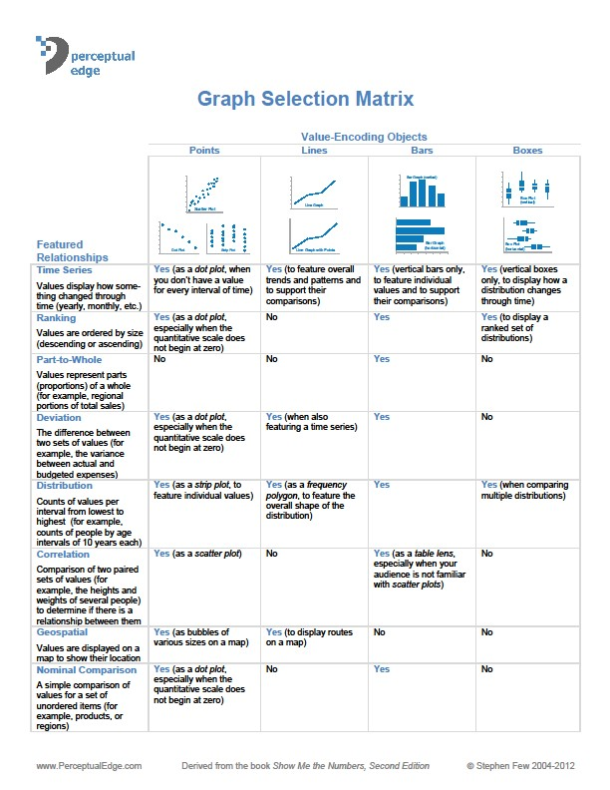

# Appendix 2 Consent and Disclaimer

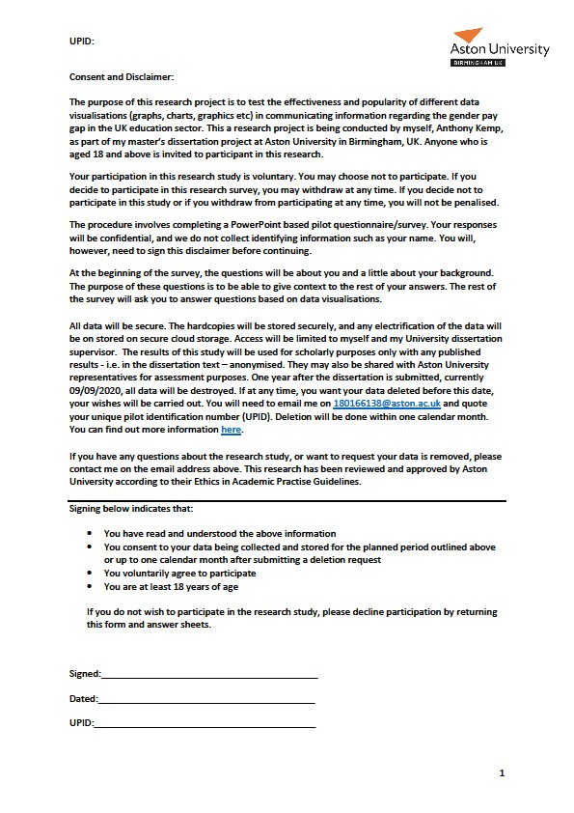

# Appendix 3 Pilot Study Presentation

Slide 1



Affectively Visualising

the Gender Pay Gap in

the UK Education

Sector

Pilot Study



Slide 2

|  |
| --- |
| Section 1   1. Which country are you from? 2. Is English your first language? (Yes/No) 3. Please select the gender identity you most identify with?   ➢Female, Male, Not Listed (please state), Prefer not to answer   1. Which category below includes your age?    1. 17 and younger,    2. 18-20,    3. 21-29,    4. 30-39,    5. 40-49,    6. 50-59,    7. 60 and above |

Slide 3

|  |
| --- |
| Section 1 - continued  5. What is the highest level of education you have completed? If currently enrolled, please select highest level received. For example, if enrolled on a master’s degree, select bachelor.   1. GCSE grades D-G (majority) 2. Majority GCSE grades A*-C or Intermediate Apprenticeship or O level A-C (majority) 3. A/AS Levels or International Baccalaureate Diploma or Advanced Apprenticeship 4. Certificate of Higher Education (CertHE) or Higher Apprenticeship 5. Diploma of higher education (DipHE) or Foundation Degree 6. Degree (including with honours (BA/Bsc hons) without honours or degree apprentice) 7. Master’s Degree (including integrated i.e. MA, MSc or MEng) or Postgraduate   Certificate (including in education PGCE)   1. Doctorate (for example PhD or DPhil) |

Slide 4

|  |
| --- |
| Section 1 - continued  6. What is the highest level of education you completed significant statistical content? This includes probability, distributions, averages, standard deviation and variances, correlations and regression, and histograms. If currently enrolled, please select highest level received.   1. GCSE grades D-G (majority) 2. Majority GCSE grades A*-C or Intermediate Apprenticeship or O level A-C (majority) 3. A/AS Levels or International Baccalaureate Diploma or Advanced Apprenticeship 4. Certificate of Higher Education (CertHE) or Higher Apprenticeship 5. Diploma of higher education (DipHE) or Foundation Degree 6. Degree (including with honours (BA/Bsc hons) without honours or degree apprentice) 7. Master’s Degree (including integrated i.e. MA, MSc or MEng) or Postgraduate   Certificate (including in education PGCE)   1. Doctorate (for example PhD or DPhil) |

Slide 5

|  |
| --- |
| Section 1 - continued  7. Which category best fits your current occupational status?   1. Management l. Personal care and service 2. Business and Financial m. Sales and related 3. Computer and Mathematical n. Office and administration support 4. Architecture and Engineering o. Farming, Fishing and Forestry 5. Life, Physical and Social Sciences p. Arts, Design, Entertainment, Sports 6. Community and Social Service and Media 7. Legal q. Healthcare practitioners and technical 8. Education, Training and Library r. Healthcare support 9. Protective service s. Installation, maintenance and repair 10. Food preparation and serving related t. Production 11. Building and grounds cleaning or u. Transportation and logistics maintenance v. Unemployed or Student   w. Other (please state) |

Slide 6

|  |
| --- |
| Section 1 - continued   1. Do you suffer from any of the visual deficiencies/impairments below? a. Colour vision (colour blindness)    1. Loss of vision that is corrected by glasses    2. Loss of vision NOT corrected by glasses other than Colour Vision    3. No, I don’t suffer from any of the above 2. Which type of device are you using to complete this survey? (Or would if this   was not paper-based pilot?)   * 1. Personal Computer (PC)/Desktop Computer/iMac   2. Laptop/Notebook/Chromebook/Macbook   3. Netbook/Tablet/iPad   4. PDA/Smartphone/iPhone   5. Other (please state) |

Slide 7

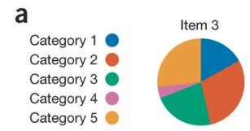

Section 2

. Which of the pie chart

1

segments is the largest?

a.

Category 1

b.

Category 2

c.

Category 3

d.

Category 4

e.

Category 5

Points of View: Bar charts and box plots

-

Scientific Figure on ResearchGate. Available from:

https://www.researchgate.net/figure/Variants

-

of

-

bar

-

charts

-

and

-

a

-

pie

-

chart

-

encoding

-

the

-

same

-

data

-

a

-

Values

-

in

-

different_fig1_263442787

[

accessed 28 May,

2019]

Slide 8



Section 2

. Which of the bars is

2

the highest for item 3?

a.

Category 1

b.

Category 2

c.

Category 3

d.

Category 4

e.

Category 5

Points of View: Bar charts and box plots

-

Scientific Figure on ResearchGate. Available from:

https://www.researchgate.net/figure/Variants

-

of

-

bar

-

charts

-

and

-

a

-

pie

-

chart

-

encoding

-

the

-

same

-

data

-

a

-

Values

-

in

-

different_fig1_263442787

[

accessed 28 May,

2019]

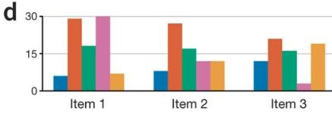

Slide 9



Section 2

. In what quarter in

3

2013

were the most goals

met only (i.e. not miss or

exceed)?

a.

Q1

b.

Q2

c.

Q3

d.

Q4

From ‘When Are 100% Stacked Bar Graphs Useful?’ a blog by Stephen Few.

Figure originally from “Storytelling with Data” by Cole

Nussbaumer

Knafic

Available from

https://www.perceptualedge.com/blog/?p=2239

[

accessed 28 May,

2019]

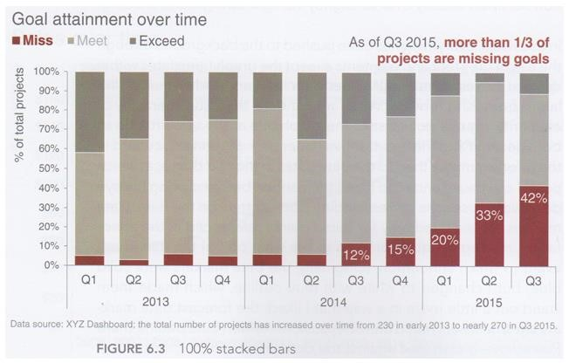

Slide 10



Section 2

4

. In which category do

women perform the

best?

a.

Governors

b.

Mayors

c.

State Legislators

d.

Voters

From ‘When Are 100% Stacked Bar Graphs Useful?’ a blog by Stephen Few.

Available from

https://www.perceptualedge.com/blog/?p=2239

accessed 28 May,

[

2019]

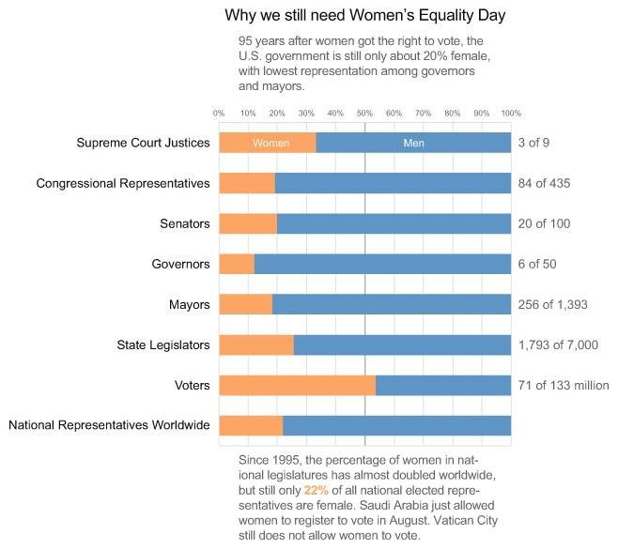

Slide 11



Section 2

. Which of the following is

5

true?

a.

French Riviera

revenues decline over

time

b.

French Riviera

revenues are

constant over time

c.

French Riviera

revenues increase

over time

From ‘A Design Problem’ a blog by Stephen Few.

Available from

http://www.perceptualedge.com/example3.php

[

accessed 28 May,

2019]

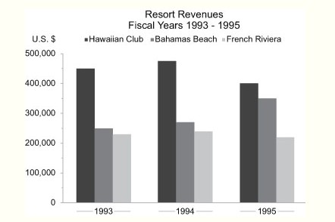

Slide 12



Section 2

6

. Which of the following is

true?

a.

French Riviera

revenues decline over

time

b.

French Riviera

revenues are

constant over time

c.

French Riviera

revenues increase

over time

From ‘A Design Problem’ a blog by Stephen Few.

Available from

http://www.perceptualedge.com/example3.php

[

accessed 28 May,

2019]

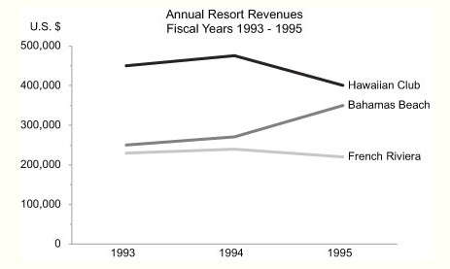

Slide 13



Section 2

7

. Which product is best?

a.

Product 1

b.

Product 2

From ‘Using a radar chart’ by

Packt

.

Available from

https://subscription.packtpub.com/book/big_data_and_business_intelligence/9781784391959/2/ch02lvl1sec28/using

-

a

-

radar

-

chart

2019]

accessed 28 May,

[

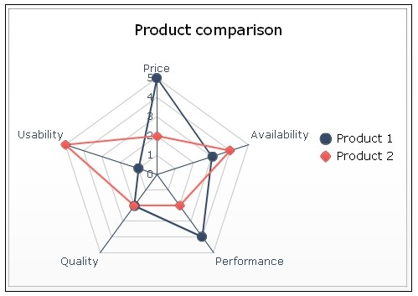

Slide 14



Section 2

8

. Which product

performs best on

usability?

a.

Product 1

b.

Product 2

From ‘Using a radar chart’ by

Packt

.

Available from

https://subscription.packtpub.com/book/big_data_and_business_intelligence/9781784391959/2/ch02lvl1sec28/using

-

a

-

radar

-

chart

accessed 28 May,

[

2019]



Slide 15



Section 2

. Which product

9

performs best on price?

a.

Product 1

b.

Product 2

From ‘Using a radar chart’ by

Packt

.

Available from

https://subscription.packtpub.com/book/big_data_and_business_intelligence/9781784391959/2/ch02lvl1sec28/using

-

a

-

radar

-

chart

[

accessed 28 May,

2019]



Slide 16



Section 2

. Which of these drinks

10

products has the least

amount of variability in

its sales?

a.

Alcoholic

b.

Carbonated

c.

Fruit Juice

d.

Other

From ‘Chart Type Guide’ by SAP Analytics.

Available from

https://www.sapanalytics.cloud/resources

-

chart

-

type

-

guide/

[

accessed 28 May,

2019]

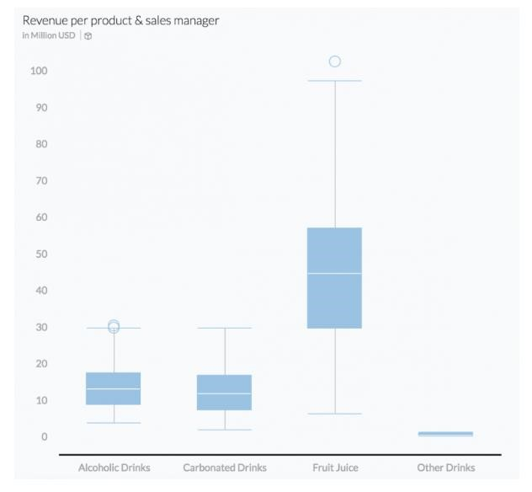

Slide 17



Section 2

11

. Which of these

statements is true in general

based on the graphs?

a.

Women are paid more

than men

b.

More men have higher

-

paid jobs than women

c.

There is an equal

distribution of genders

across the pay grades

d.

It’s impossible to tell

From ‘Gender pay gap: Six things we've learnt’ by Clara

Guibourg

, BBC.

Available from

https://www.bbc.co.uk/news/business

-

43668187

accessed 28 May,

2019]

[

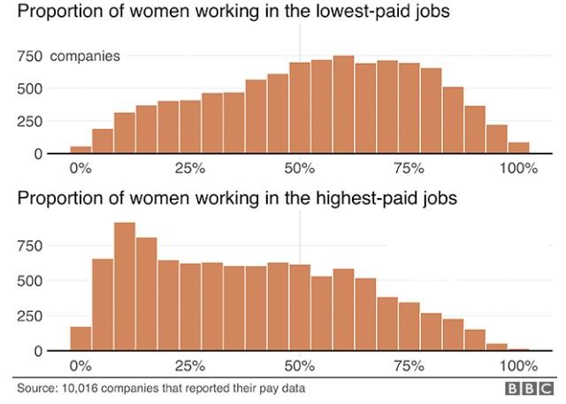

Distribution of Women in High and Low Paid Jobs

Slide 18

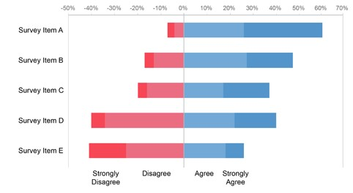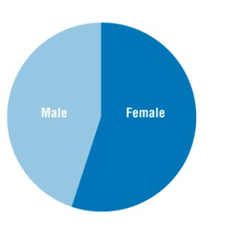

Section 2

. Which of these graphs/charts to

12

you prefer for comparing two

variables?

Charts from:

Pie Chart

a),

(

Stacked Bar

b),

(

Diverging Bar

c),

(

Unit

/Square (d).

[

accessed 28 May,

2019]

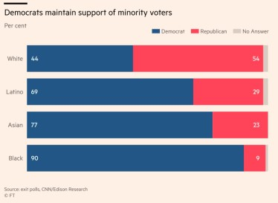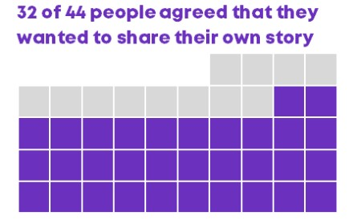

a.

b.

c.

d.

Slide 19

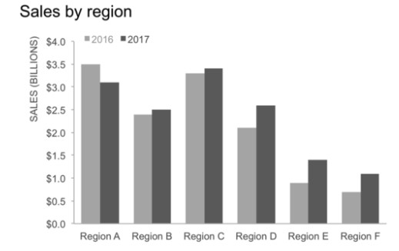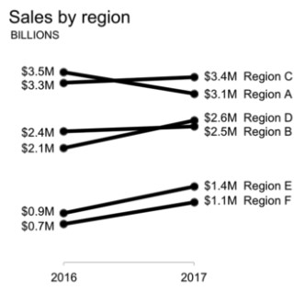

Section 2

13

. Which of these graphs/charts to

you prefer for time series data?

Charts from:

Slope Graph

a),

(

Line Graph

b),

(

Bar Graph

c)

(

Radar

d

(

).

[

accessed 28 May,

2019]

a.

b.

c.

d.

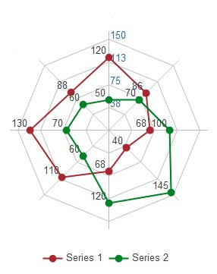

# Appendix 4 – Pilot Answer Sheets

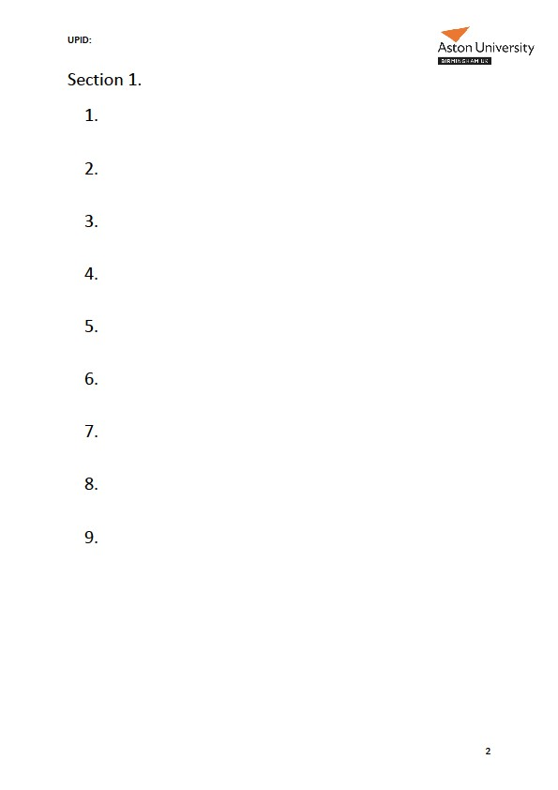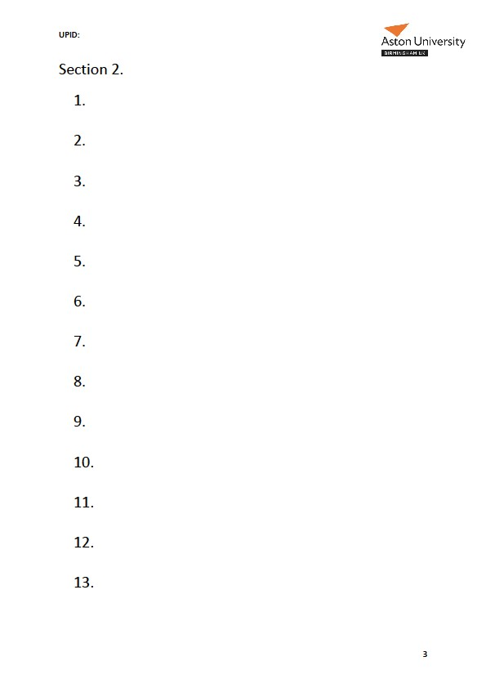

# Appendix 5 – Likert Questions

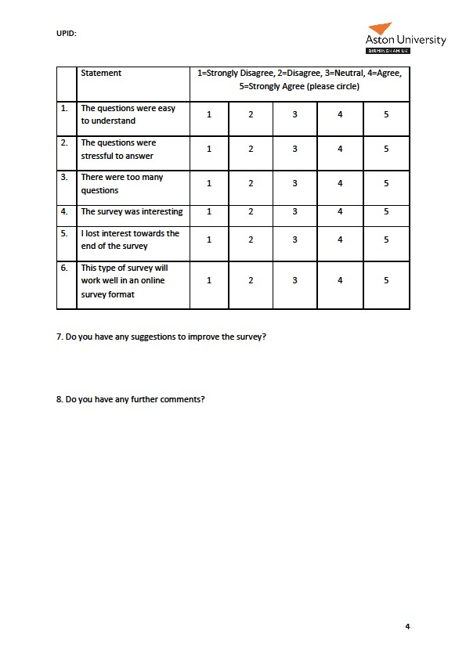

# Appendix 6 – Pilot Visualisation Results

|  |  |  |  |  |  |  |  |  |  |  |  |  |  |
| --- | --- | --- | --- | --- | --- | --- | --- | --- | --- | --- | --- | --- | --- |
|  |  |  |  |  |  | Section 2 - Visualisations | | |  |  |  |  |  |
| Question | 1 | 2 | 3 | 4 | 5 | 6 | 7 | 8 | 9 | 10 | 11 | 12 | 13 |
| Unique Pilot ID | **Pie**  **Segment** | **Highest Bar** | **Biggest quarter** | **Best**  **women** | **French**  **Riviera bar** | **French Riviera line** | **Best**  **Product** | **Best**  **Usability** | **Best Price** | **Box plot** | **Histogram** | **Best 2**  **Variables** | **Best**  **Time**  **Series** |
| 01 | E 5 | B 2 | D Q4 | B Mayors | B | B | B 2 | B 2 | B 2 | D | B | A | B |
| 02 | B | B | D | D | B | A | A | B | A | A | B | A | B |
| 03 | B | B | D | D | B | B | B | B | B | D | B | B | B |
| 04 | B 2 | B 2 | D | D | A | A | B | B | B | D | B | C | C |
| 05 | B | B | A | D | B | B | A | B | A | C | B | B | B |

# Appendix 7 – Web-Survey

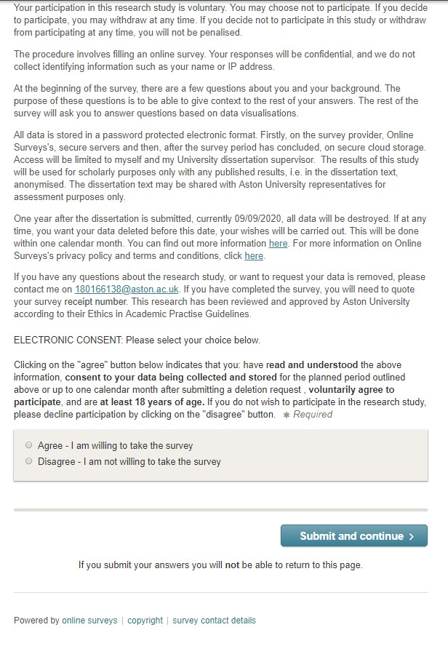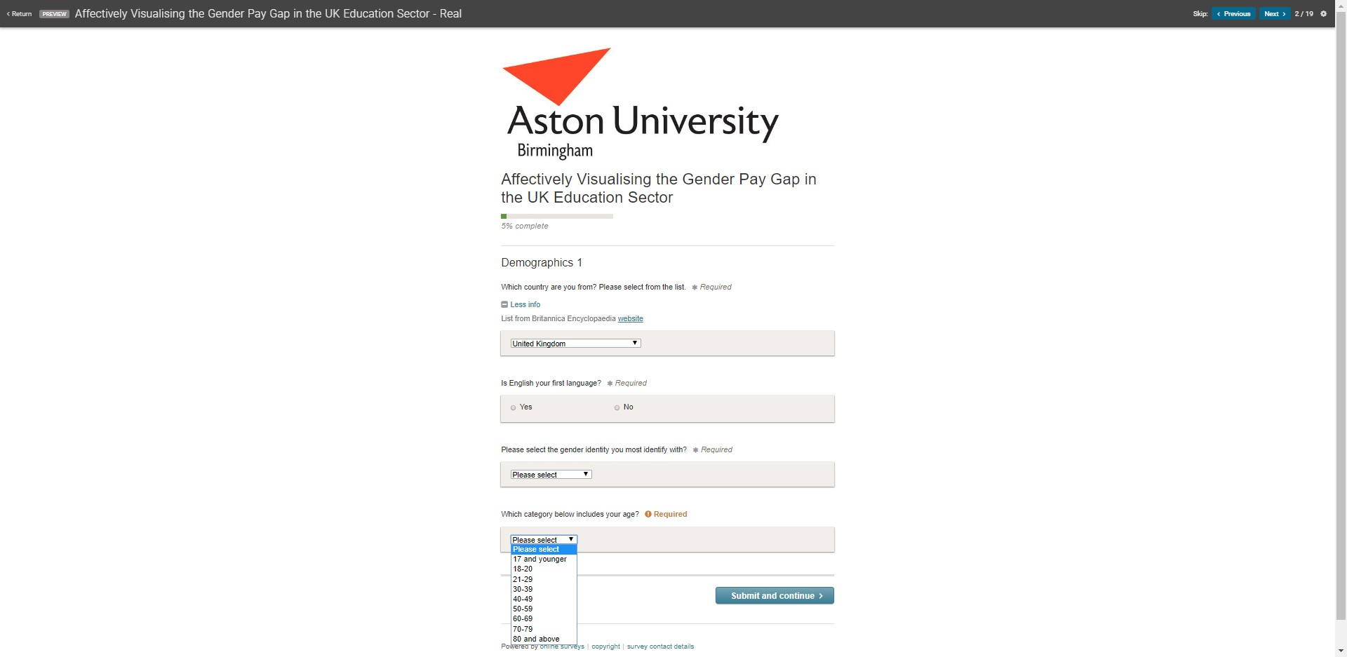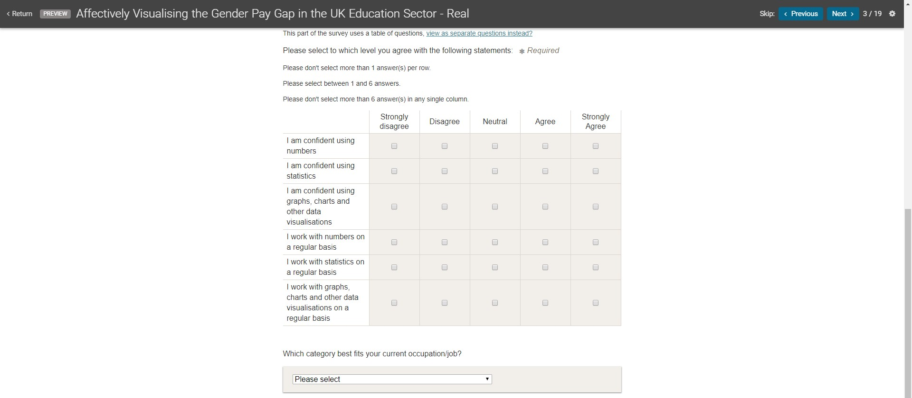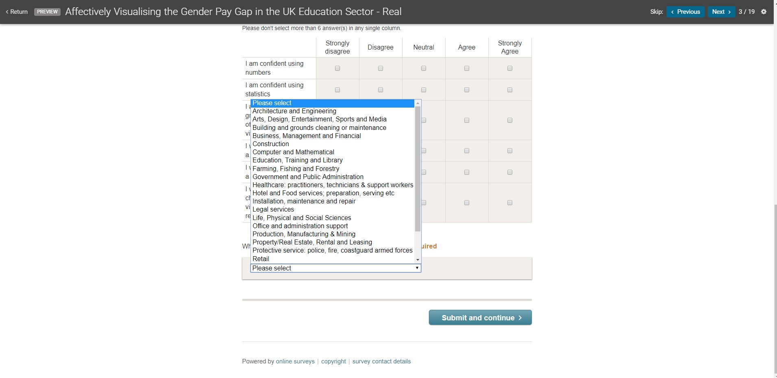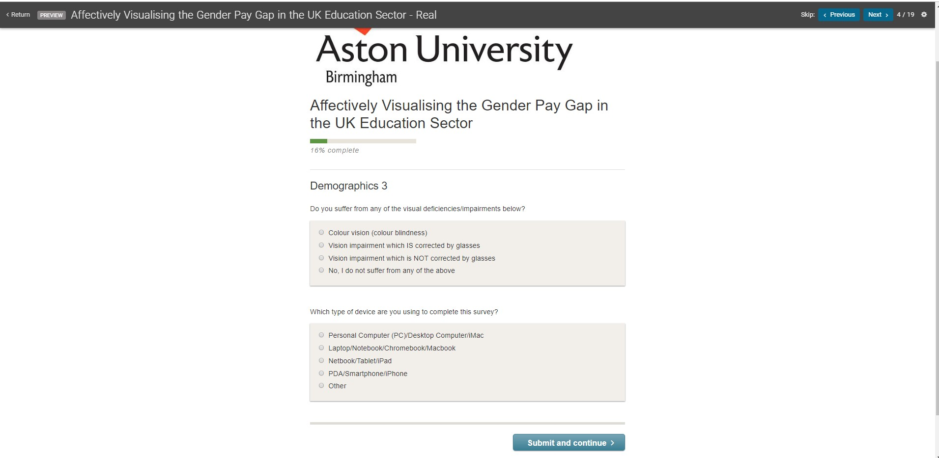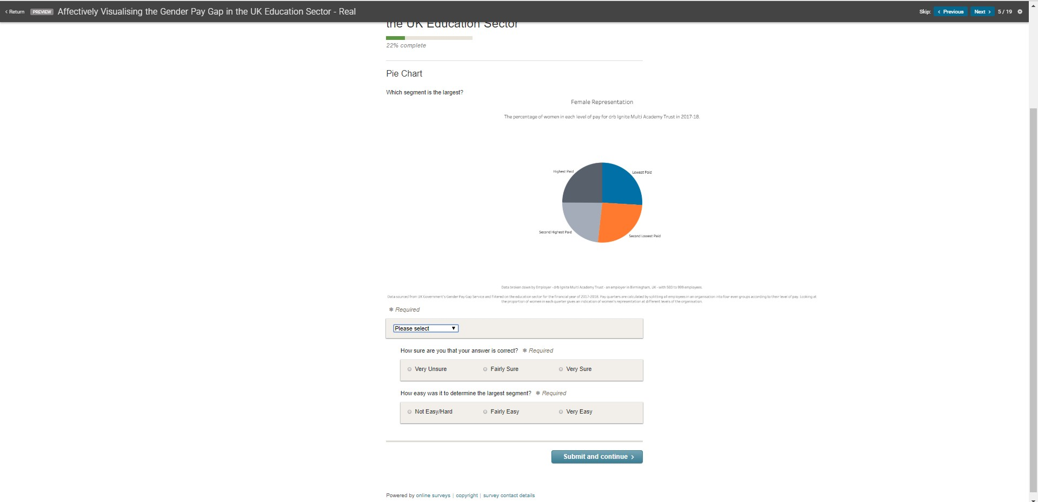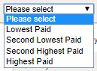

These were the options available for this and all questions

which asked a question about which quartile.

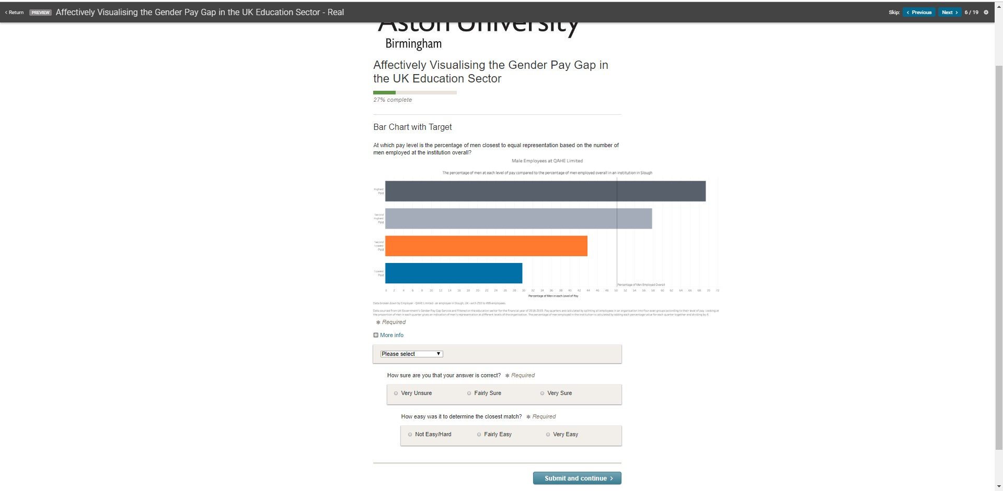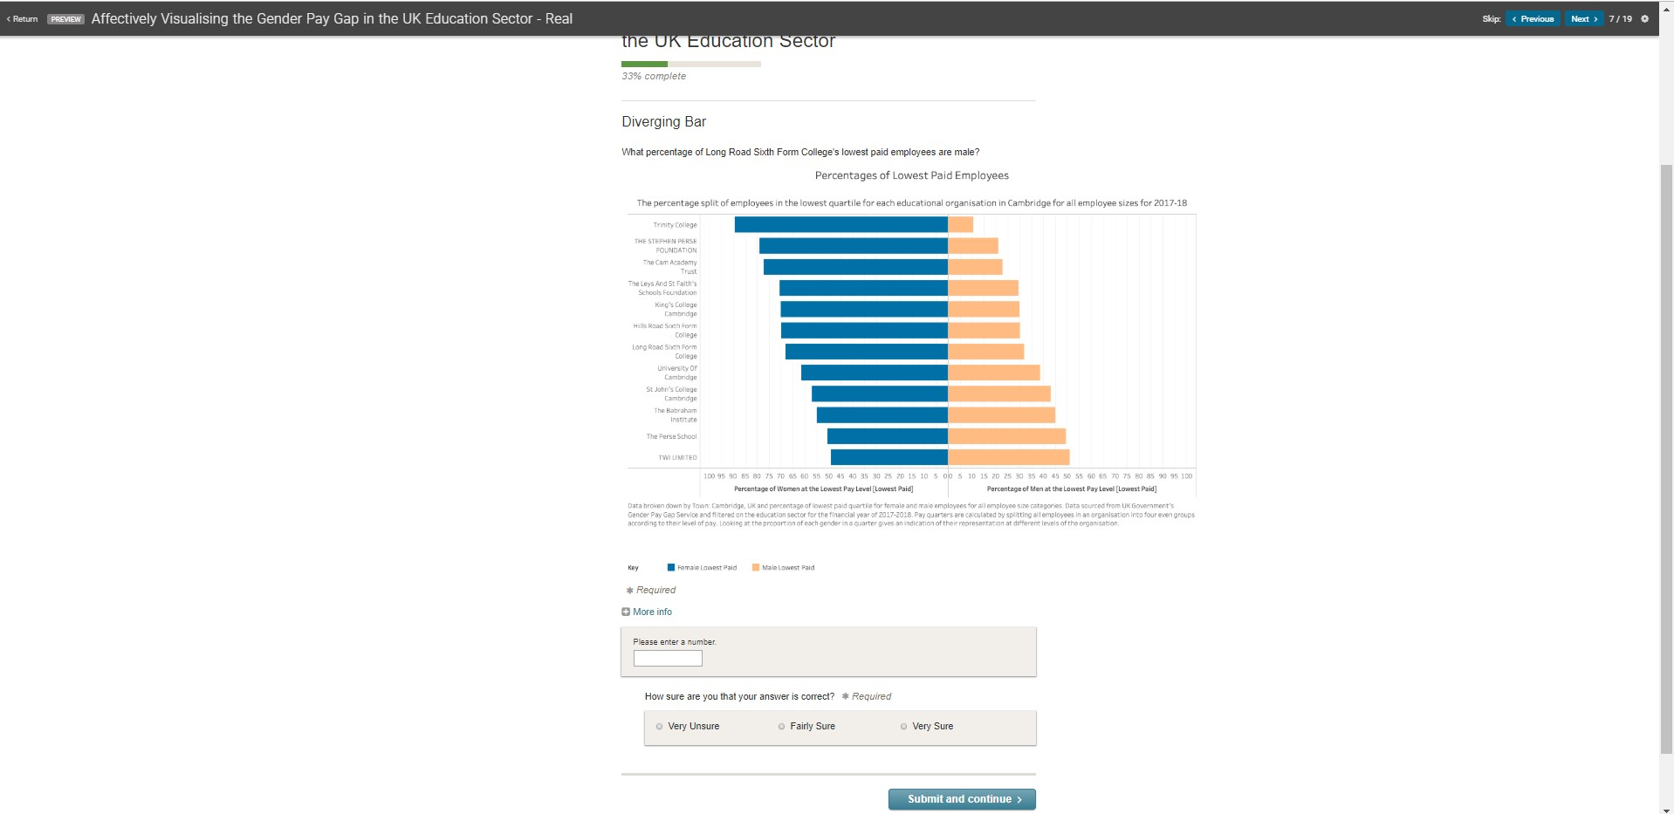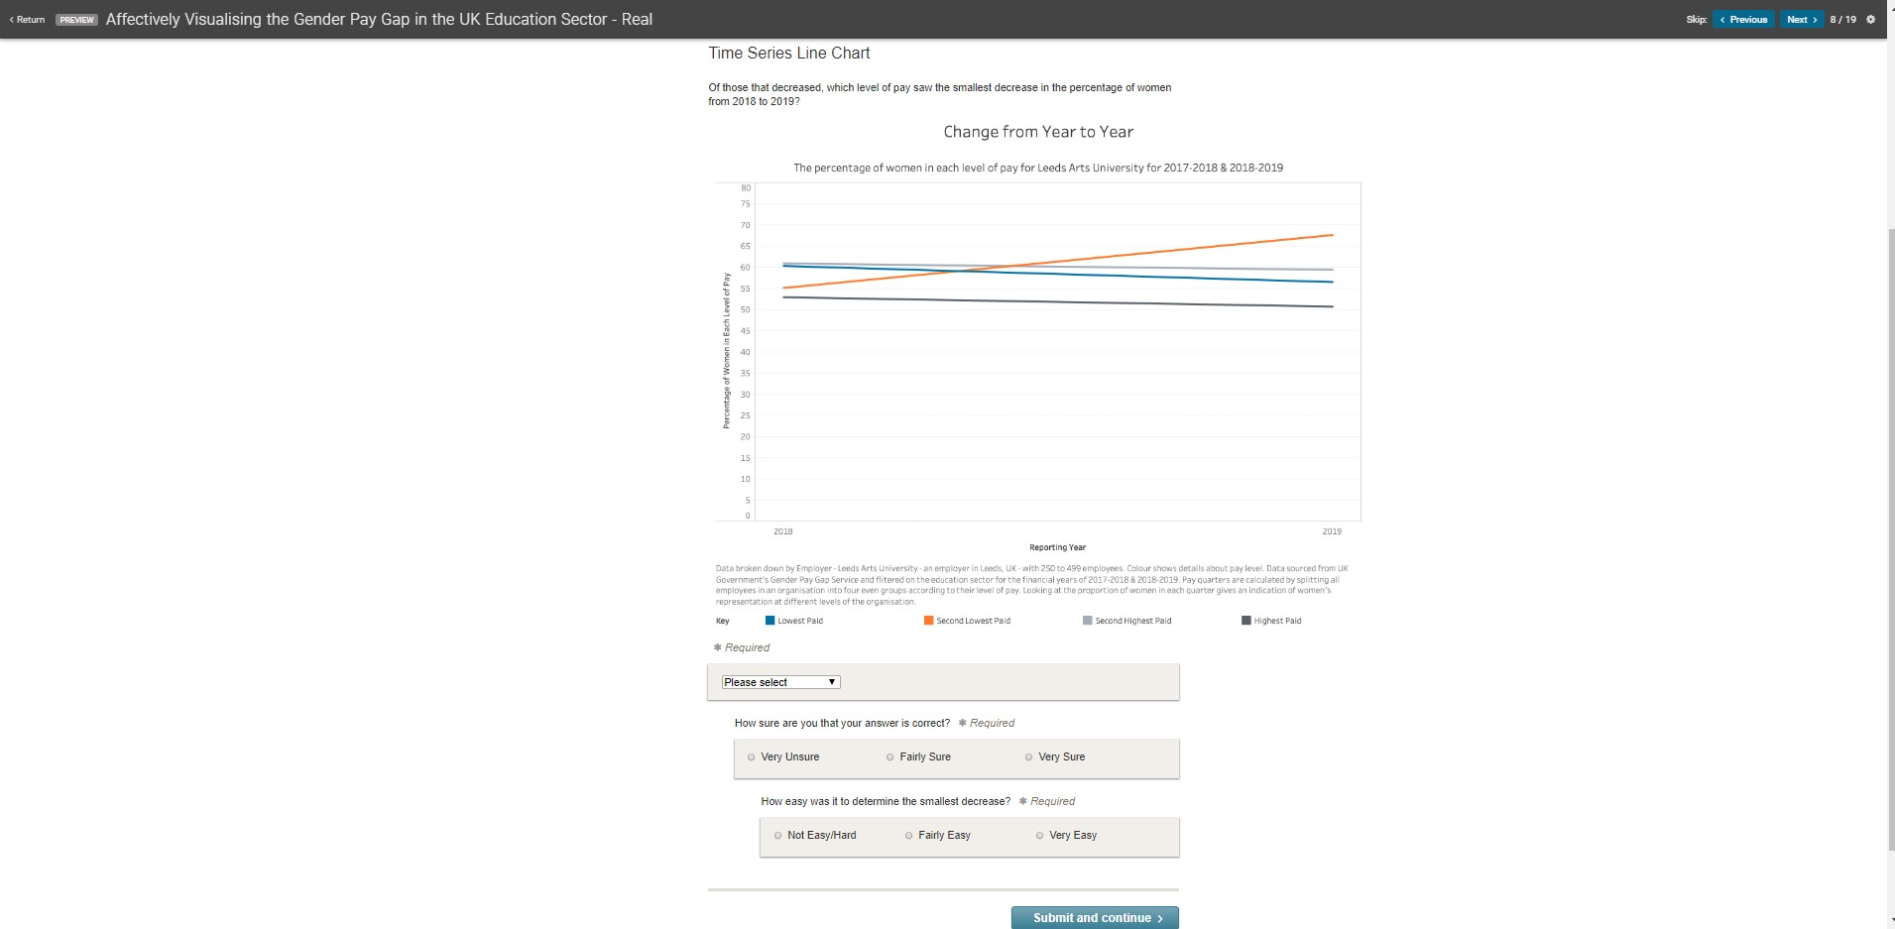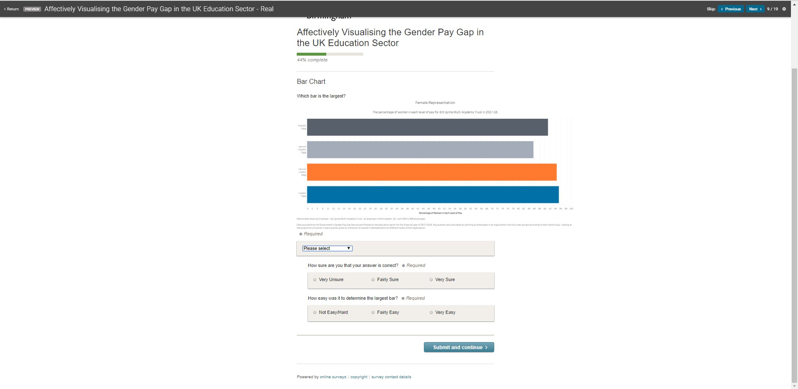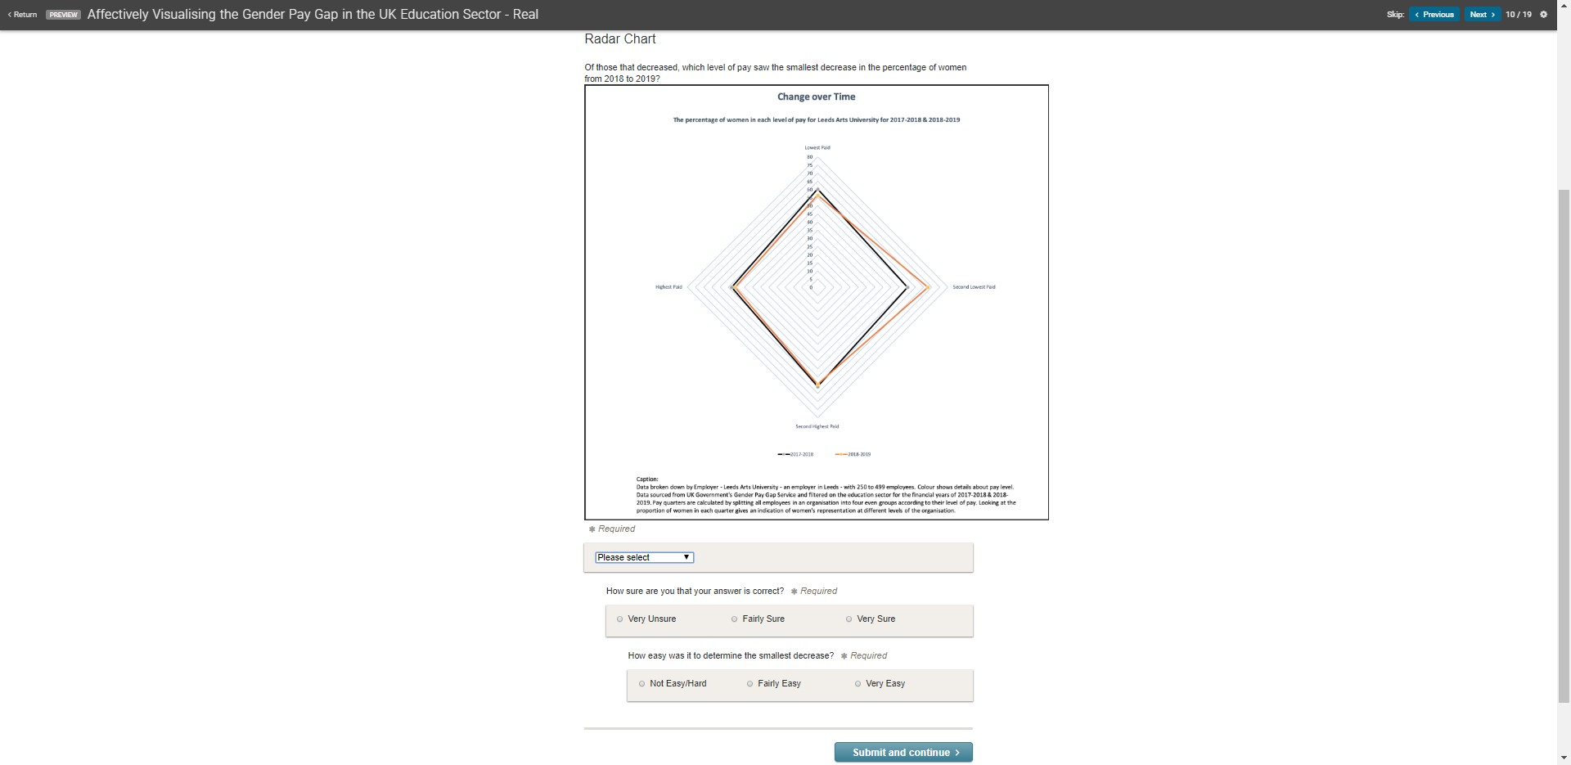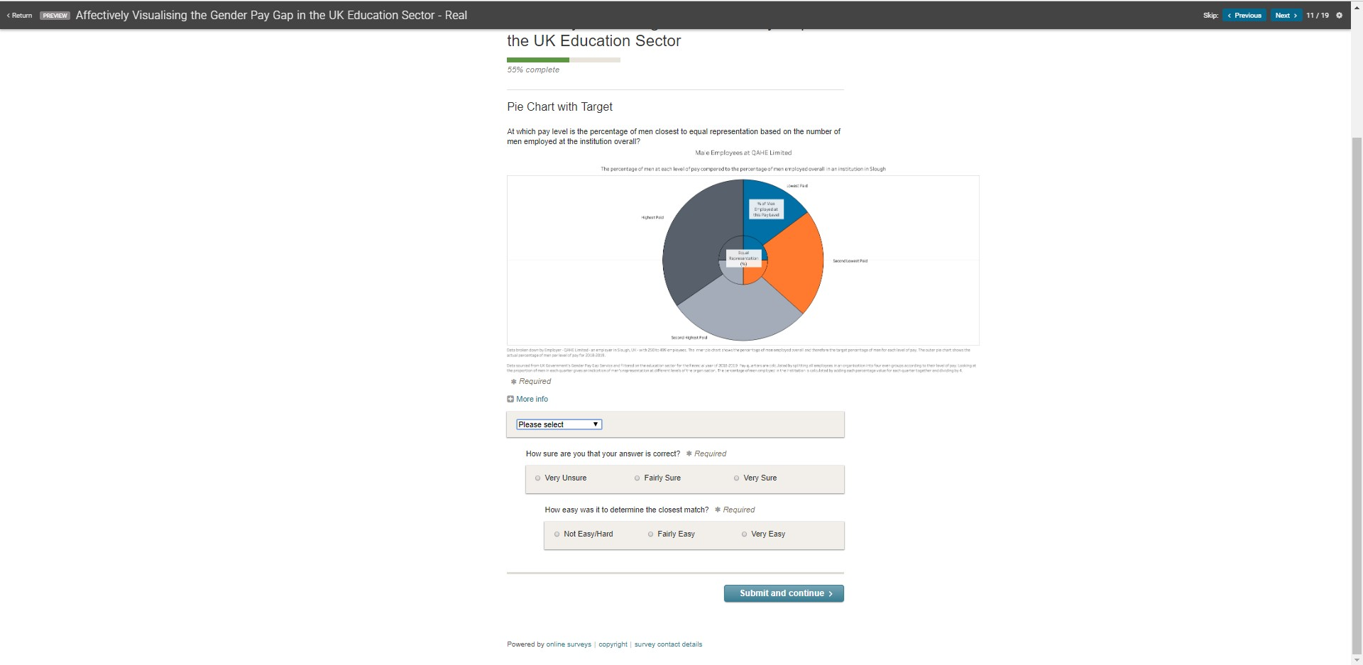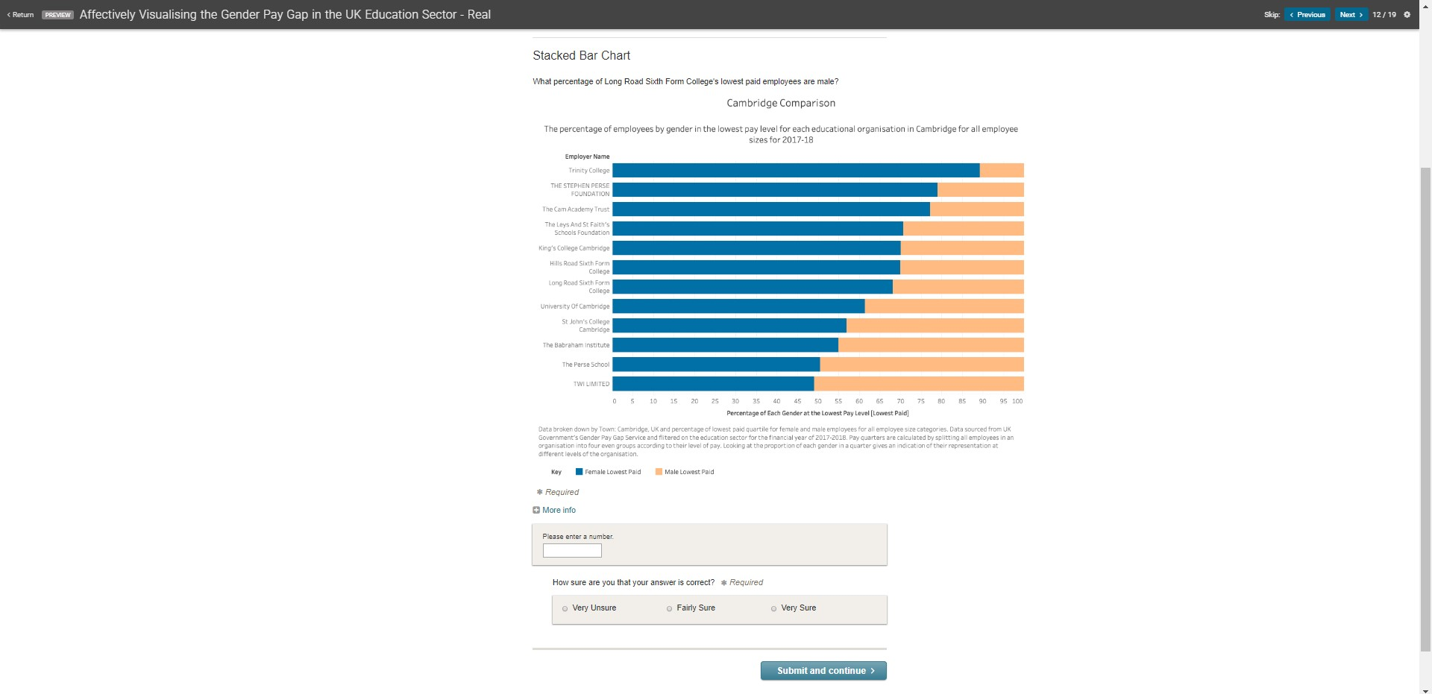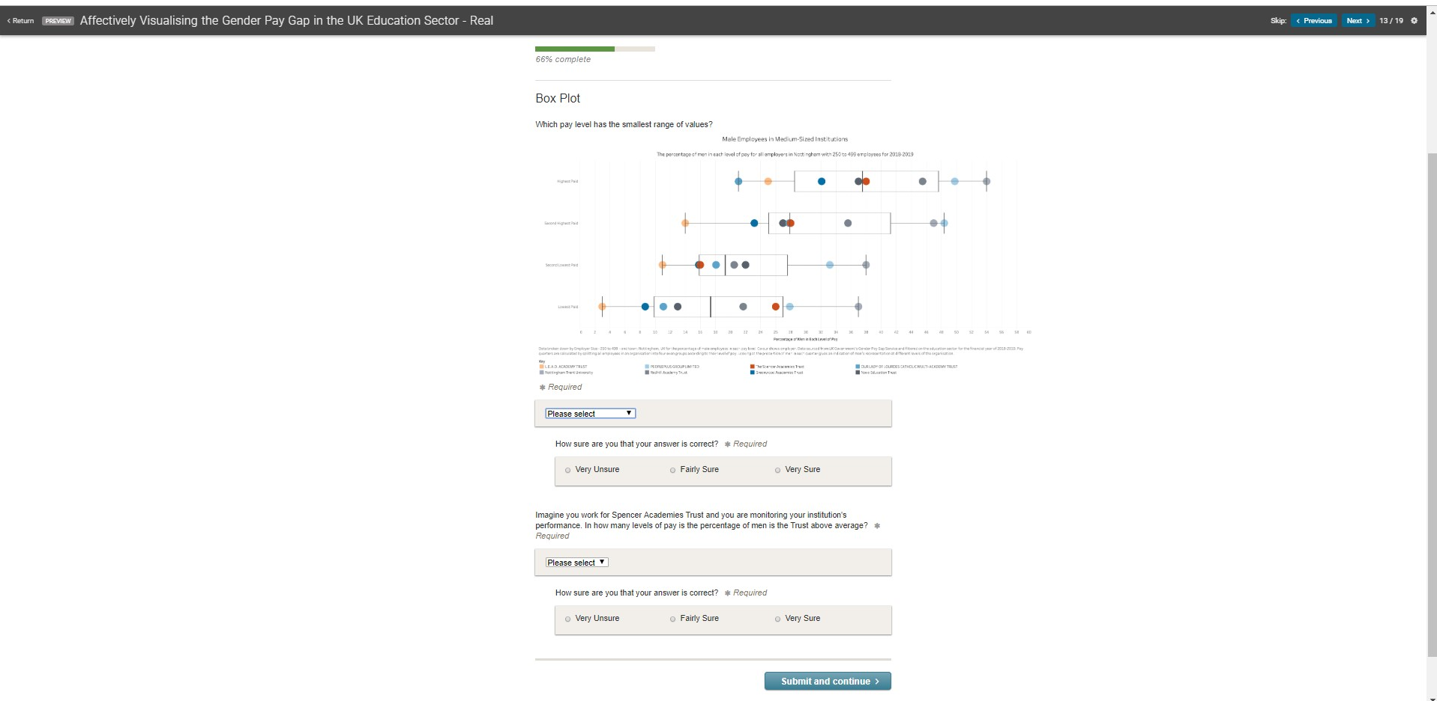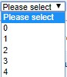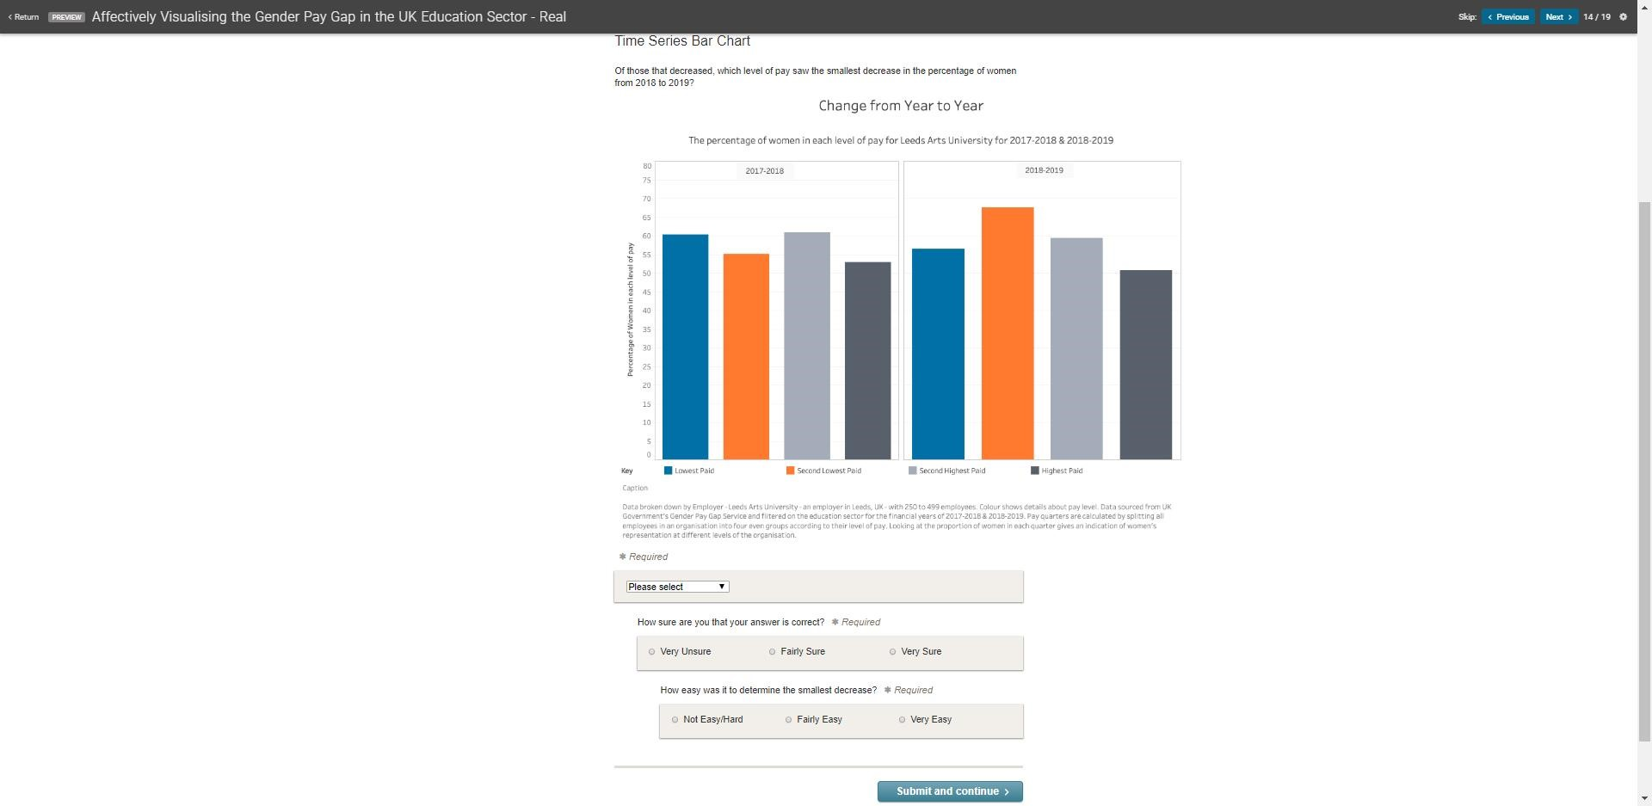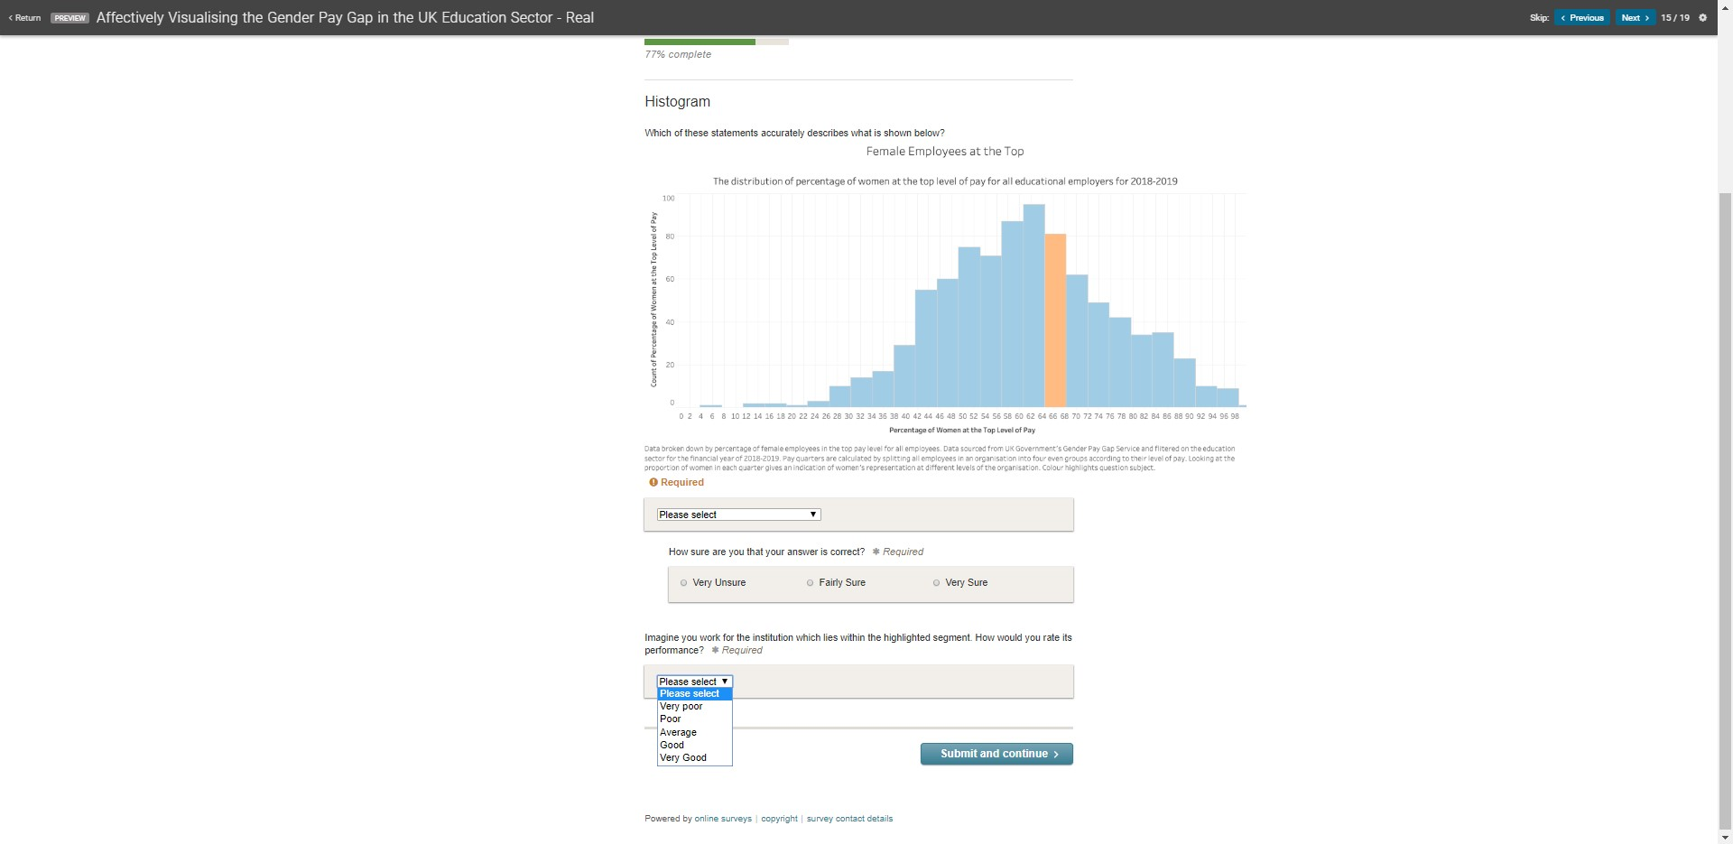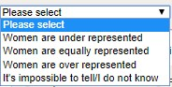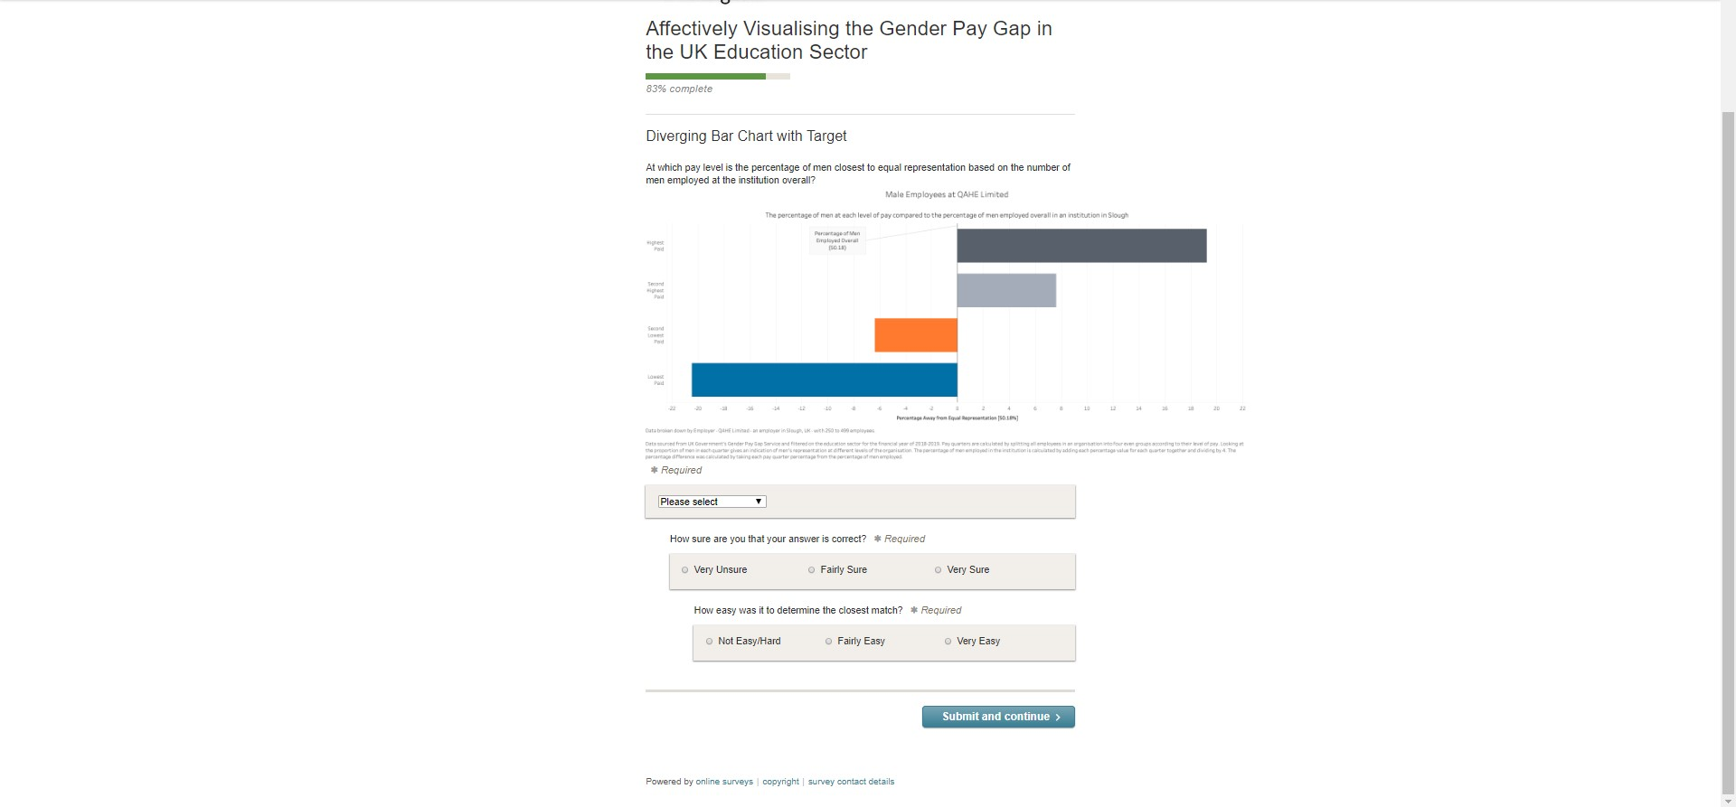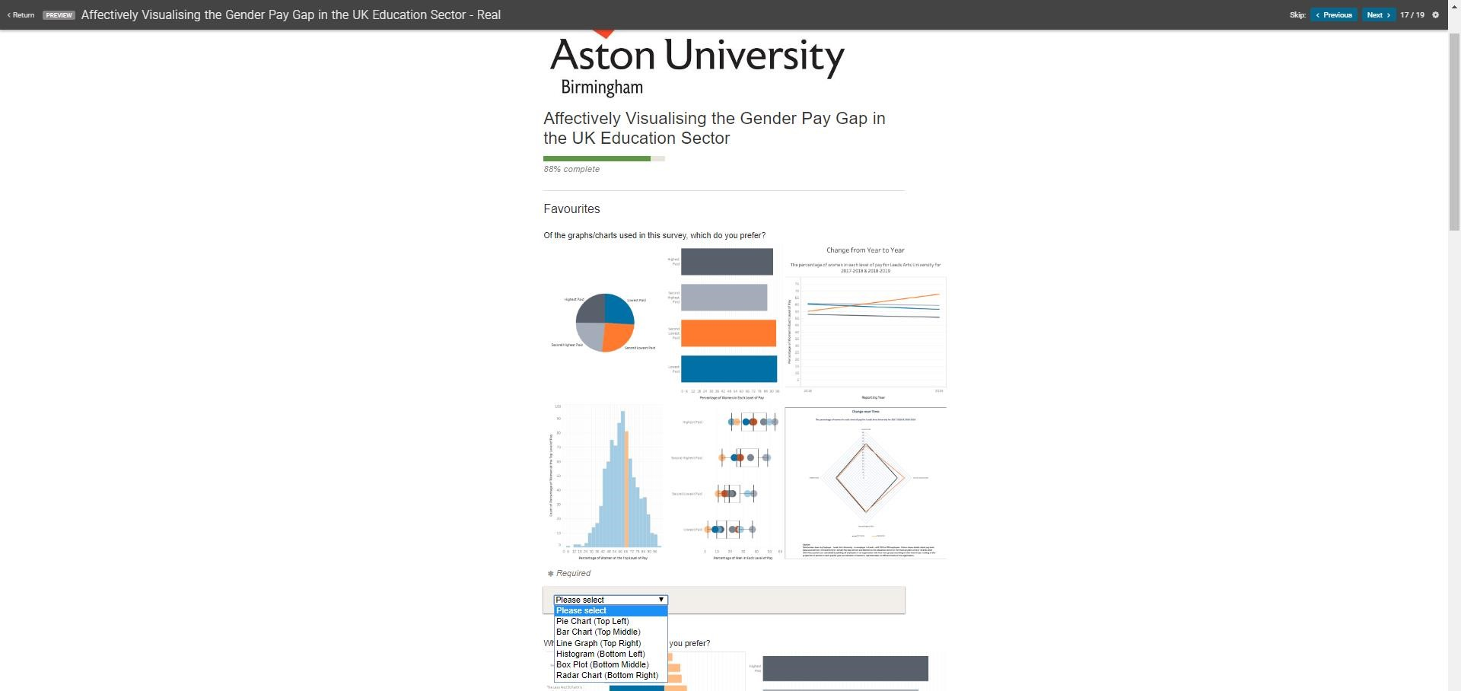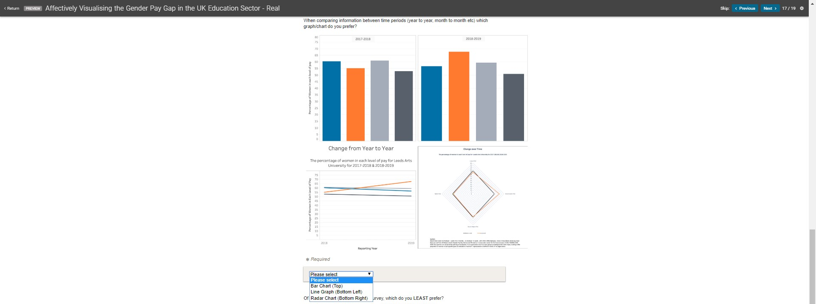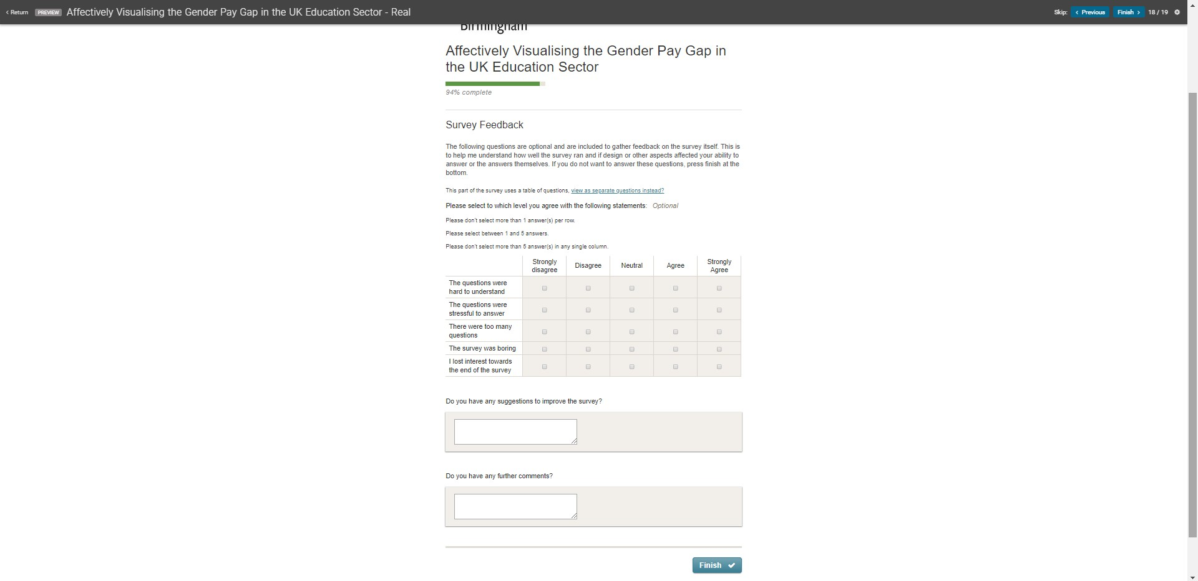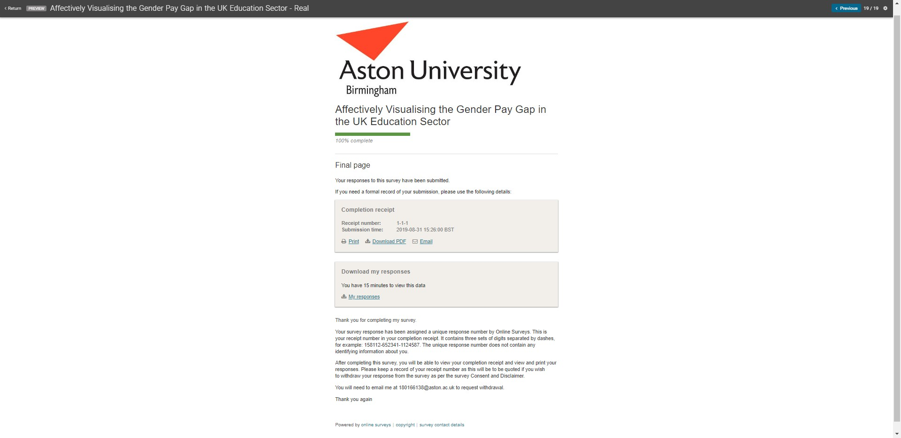

# Appendix 8 – Complete Results Confidence and Use of Numbers, Statistics and Visualisations

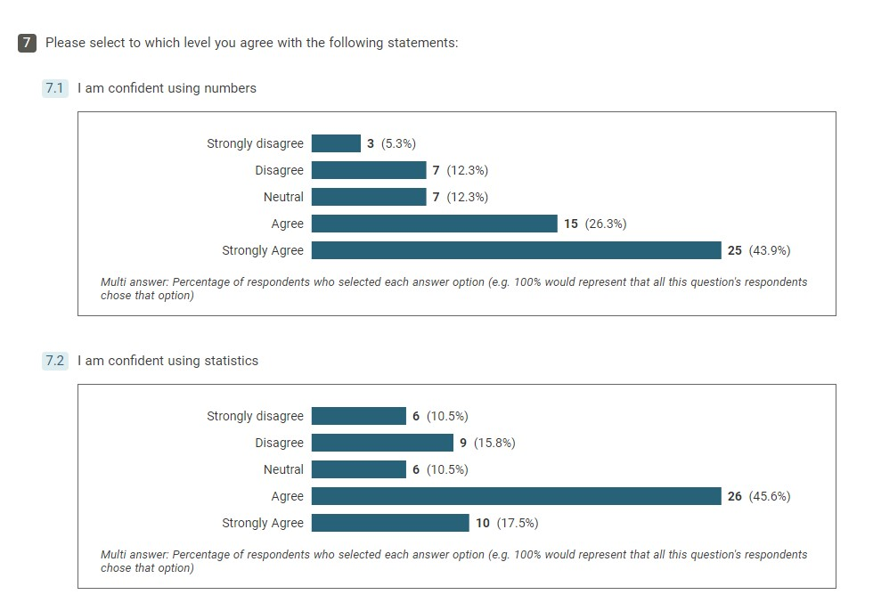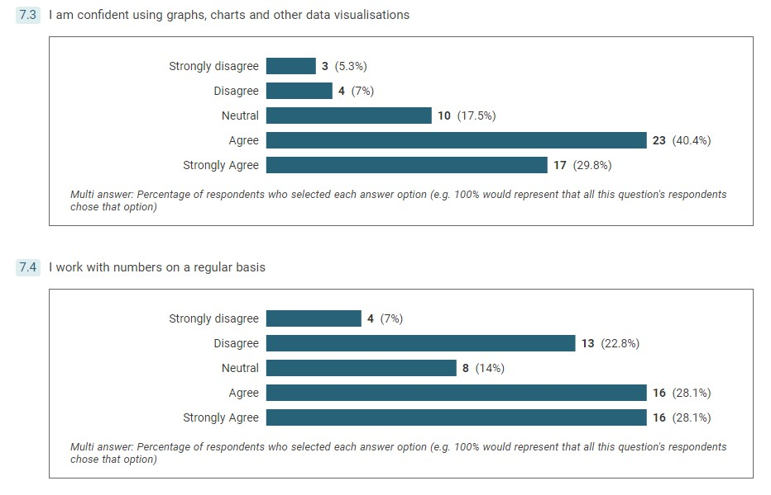

Page **163** of **164**

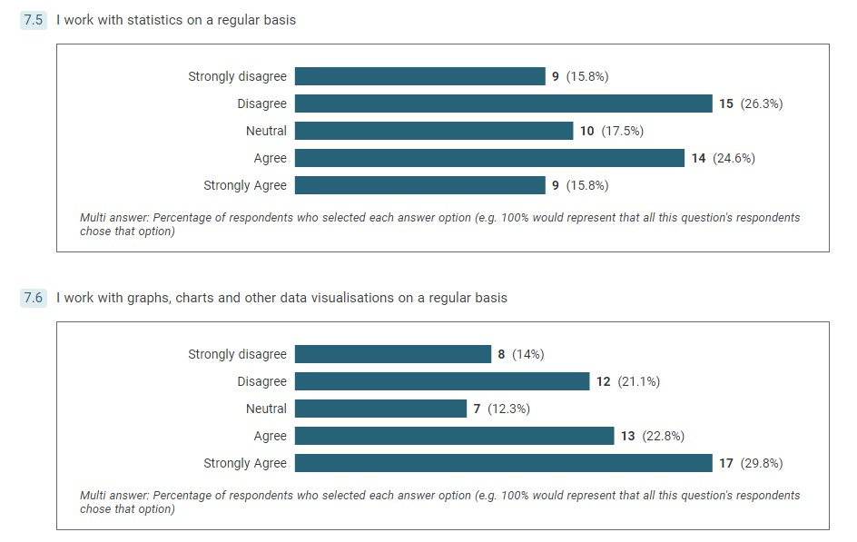

Page **164** of **164**